Communication and Language

This week we will be looking at the story The Odd Egg by Emily Gravett. We will be collecting animal names and discussing those animals that lay eggs. The children will be asking how and what questions.
Personal, Social and Emotion
During our PHSE lesson this week we will be talking about what the children worry about. The children will come up with a list of suggestions on how to tackle these worries.

Physical Development
On Monday, the children will be working on their gymnastic skills and on Friday they will be doing dance. In handwriting this week, we will be looking at how to write capital letters.

Understanding of the World
This week we will look at the different types of animals, insects and reptiles that lay eggs and those that have live births. The children will be using the computer to research their answers.

Hatchmere The Odd Egg Planning
Literacy
We will be writing simple information sentences about the animals that hatch out of eggs. In phonics we will be looking at the sounds oi, ure, er and ear. The children will all read in a Guided session with me.

5.3.2018
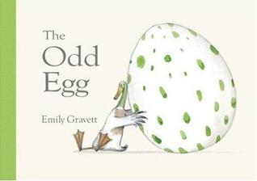
Mathematics
We will continue to work on number formation and recognition.
This week we are going to start using quantities and objects to add two single digit numbers together. The children will be using a simple line sums to work out these problems.
Expressive Arts and Design
The children will be designing their own odd eggs and creating them using oil pastels, paint and pen. The children will be encouraged to make their eggs as individual as possible.

Parental Involvement Ideas
This week we will be talking about ‘similarities and differences between themselves and others and among families’. Talk about what characteristics you share with your child or they share with siblings. Talk about like and dislikes. Discuss why they are just like Grandad or Mummy. Ask them who they think they are like and not just in looks but in character and temperament. Talk about how even though we have differences these are what makes us special and our similarities are what ties us together as a family.

