Personal, Social and Emotion

This week we will be talking about our emotions and how we can respond to them in a positive way. The children will be participating in Circle time where we will be discussing loneliness and how to reach out to friends.

Communication and Language

We will be going on a walk around school looking for signs of spring. Hopefully, the children will be able to relate this experience to our discussion about Spring. We will be asking questions about what happens in Spring and then researching the answers using a range of non-fiction books and the computer.

Physical Development

On Thursday, the children will continue to work on their balance and control on the bikes. In games this week we will be playing a variety of different tunnel games. The fine motor control activity this week will be using scissors. In handwriting we will be looking at forming the capital letters.

Understanding of the World

This week we are going to be looking at the seasonal changes in the world around us. We will be asking and answering questions about why these changes occur. We will be looking at plant growth and collecting signs of spring from the world around us. The children will start to look at the lifecycle of a seed and will be planting different seeds.

Literacy

This week we will be finishing our Hattie Peck story and writing about the different parts of the world that Hattie visits. In writing we are looking at finger spaces, capital letters and full stops. We will be looking at the sound oa and working on sounding out words containing these sounds.

Hatchmere Spring Plan

22.3.21

[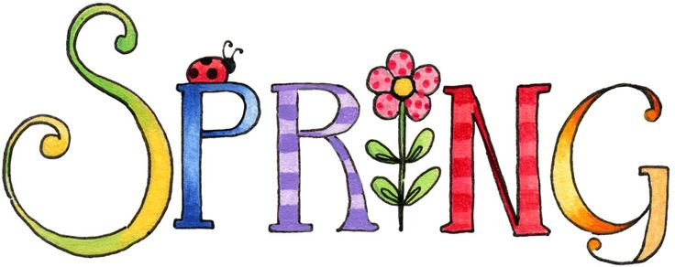](https://www.google.co.uk/url?sa=i&rct=j&q=&esrc=s&source=images&cd=&cad=rja&uact=8&ved=0ahUKEwianoiDtOPSAhWoAMAKHWogCCUQjRwIBw&url=http://www.clipartpanda.com/categories/spring-clip-art-free-images&bvm=bv.149760088,d.cGc&psig=AFQjCNHeRMBNSAlbAp7GFM91q3uxcUktcg&ust=1490041686127465)

[](https://www.google.co.uk/url?sa=i&rct=j&q=&esrc=s&source=images&cd=&cad=rja&uact=8&ved=0ahUKEwiTwvKGgo7KAhUD7xQKHS6CAMcQjRwIBw&url=http://www.clipartsheep.com/snow-scene-clipart.html&bvm=bv.110151844,d.d24&psig=AFQjCNGRcnr4ks_bifxpmVuaz3jmMkRbfQ&ust=1451923320794434)

Mathematics

We are continuing to work on number bonds to ten and forming numbers up to twenty. We will be looking at patterns in the world around us and making our own patterns.

Expressive Arts and Design

This week the children will be working on their observational drawing skills. They will be using pastels to draw a spring flower. They will be using their pattern skills to decorate their names.

Parental Involvement Ideas

As we are talking about Spring this week look at the world around you, in your garden, as you walk to and from school and see if you can spot any signs of Spring. Ask your child if they can tell you about the four different seasons and how they impact on the world around us. Ask what can you see that is different from last week? Find a tree or plant that you pass by regularly and watch it change over the next few weeks. Talk about the clocks going forward and discuss how that will affect them. Look out for insects especially flying ones as these are usually only seen on warmer days. Look for blossom on the trees and see how many trees they can spot with blossom on.