Communication and Language

The children will be talking about the life cycle of a plant and talk about what will happen with the seeds we planted. We will be collecting vocabulary related to plants and growth. We will continue to work on listening skills and why listening is important.

Physical Development

The children will need their PE kits for Thursday. Please check that everything fits. We will be going outside this term so if you wish to you can send in a warmer PE jumper. The children will be working on tunnel games in the Outside classroom.

Personal, Social and Emotion

We will be talking about our emotions and how we recognise them. We will talk about what makes us happy and what we can do to make other people happy.

Understanding of the World

We are going to look at family traditions associated with Easter. The children will look at how different communities celebrate Easter and discuss the similarities and differences. We will be looking at the lifecycle of a plant and observing our seeds for growth and change.

Literacy

The children will be looking at the Easter story and retelling it in their own words. The children will be using a simple story map to help them organise the story. We will be talking about full stops and capital letters. The children will be complete their Hattie Peck stories.

Hatchmere Easter Plan

[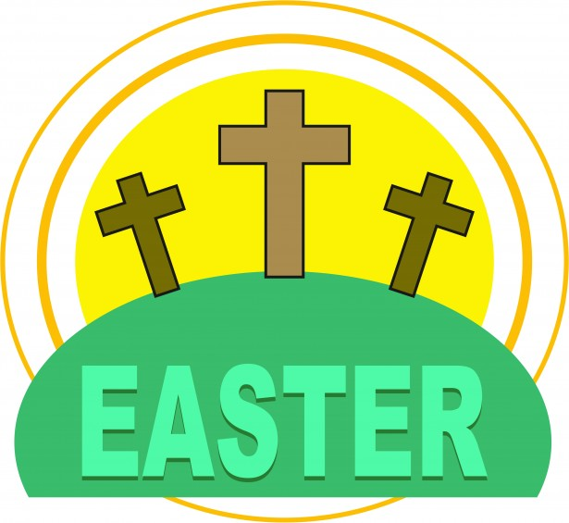](https://www.google.co.uk/url?sa=i&rct=j&q=&esrc=s&source=images&cd=&cad=rja&uact=8&ved=0ahUKEwianoiDtOPSAhWoAMAKHWogCCUQjRwIBw&url=http://www.clipartpanda.com/categories/spring-clip-art-free-images&bvm=bv.149760088,d.cGc&psig=AFQjCNHeRMBNSAlbAp7GFM91q3uxcUktcg&ust=1490041686127465)

[](https://www.google.co.uk/url?sa=i&rct=j&q=&esrc=s&source=images&cd=&cad=rja&uact=8&ved=0ahUKEwiTwvKGgo7KAhUD7xQKHS6CAMcQjRwIBw&url=http://www.clipartsheep.com/snow-scene-clipart.html&bvm=bv.110151844,d.d24&psig=AFQjCNGRcnr4ks_bifxpmVuaz3jmMkRbfQ&ust=1451923320794434)

Mathematics

We are continuing to work on recognising and forming numbers to twenty. The children will be developing their knowledge of number bonds to ten. This week’s counting rhyme will be Ten Green Bottles.

The children will be exploring 3d shapes and looking for the shapes within the shapes. They will build and explore how the shapes interact.

Expressive Arts and Design

The children will be performing their Easter prayer in our virtual Easter Service. The children will be given the opportunity to create their own Easter baskets.

Parental Involvement Ideas

This week we will be looking at how the children celebrate Easter at home. What Easter traditions do you have? Do you go for an Easter Egg hunt? Do you have a special family meal? Do you go to church or visit friends and family? Please talk with your child about your Easter traditions and write down your traditions.