[](https://www.google.co.uk/url?sa=i&rct=j&q=&esrc=s&source=images&cd=&cad=rja&uact=8&ved=0ahUKEwiTwvKGgo7KAhUD7xQKHS6CAMcQjRwIBw&url=http://www.clipartsheep.com/snow-scene-clipart.html&bvm=bv.110151844,d.d24&psig=AFQjCNGRcnr4ks_bifxpmVuaz3jmMkRbfQ&ust=1451923320794434)

**Literacy**

The children will be working on changing and altering the poem ‘Queen for a Day’. They will be using their knowledge of rhyming pairs to create funny and imaginative poetry.

In phonics my group we will be starting to look at Phase four which includes recapping on the sounds from phases three with particular focus on applying their phonetic knowledge. Mrs Monson’s group will start to work on Phase five.

**Personal, Social and Emotion**

During our circle time this week we will be looking at our friends. We will be talking about what makes a good friend and how we can be a good friend to others. We will talk about how friends show an understanding of different likes and dislikes.

**Understanding of the World**

The children will be talking about past and present events in their own lives and the lives of family members. The children will discuss similarities and differences between themselves and among families. We will look at how different cultures celebrate birthdays.

**Mathematics**

This week we will be introducing the number line as a way of calculating addition and subtraction sums. The children will be working on large scale number lines and using their whole bodies to move up or down the number line depending on the type of sum.

**Expressive Arts and Design**

The children will be creating their own crowns for the Queen’s birthday.

**Parental Involvement Ideas**

This week we will be talking about birthdays. If you have any photographs of the children’s birthdays or your birthdays they could bring in and share that would be lovely.

**Communication and Language**

This week we will be talking about the Queens birthdays and the children’s birthday. The children will be working on past and future forms accurately when talking about events that have happened or going to happen. They will discuss their experience of birthdays and those of their parents and grandparents. We will watch clips of birthdays through the last century and those around the world. We will share the story ‘The Birthday Crown’ and discuss the Queens choice.

The children will star the week by discussing what they did during the holiday.

**Physical Development**

Our PE day is Wednesday and hopefully with the improved weather we shall be working on our games skills in the Outside Classroom. Our Funky Fingers fine motor control is the Bed Bugs game where they have to catch little bugs with tweezers as they jump around.

**Hatchmere planning 6.6.2**

**The Queens Birthday**

[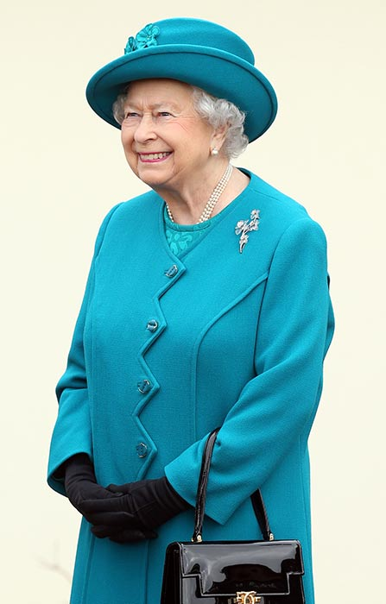](https://www.google.co.uk/url?sa=i&rct=j&q=&esrc=s&source=images&cd=&cad=rja&uact=8&ved=0ahUKEwim-rXX2ZHNAhWTF8AKHQuID1EQjRwIBw&url=http://www.hellomagazine.com/royalty/2016020429606/the-queen-90th-birthday-need-to-know/&bvm=bv.123664746,d.ZGg&psig=AFQjCNFpjlT8opTWTObAhfIucHTp8CMvZw&ust=1465244027245988)