Personal, Social and Emotion

During our circle time this week we will talking about Anti-Bullying and how differences should be celebrated. We are also asking the children to celebrate what they are good at. If your child has any certificates or items that they could bring in for show and tell that would be lovely.

Communication and Language

We will be talking about what the children did on our walk around Knights Grange. We will talk about the changes we have seen in the weather recently and discuss why this happens. We will be collecting autumn words and the children will be encouraged to use descriptive words. We will also be having some special prickly little visitors which the children will be learning and talking about.

Physical Development

The children will be working on their travelling skills in gymnastics on Monday and dancing on Friday. Our Funky Fingers fine motor control task this week will be peeling the leaves off the sticky surface. We will talk about the different ways to stay fit and healthy at this time of year.

**Hatchmere planning 14.11.2016**

[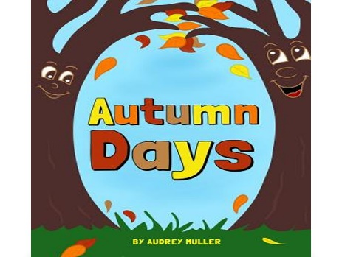](https://www.google.co.uk/url?sa=i&rct=j&q=&esrc=s&source=images&cd=&cad=rja&uact=8&ved=0ahUKEwjjo4Oxl5_QAhVHbBoKHeAMAFEQjRwIBw&url=https://www.snapdeal.com/product/autumn-days/687139687246&bvm=bv.138169073,d.ZGg&psig=AFQjCNHj4IIUP0gdSEAsOQpfVB6nP7SBNQ&ust=1478901385809228)[](https://www.google.co.uk/url?sa=i&rct=j&q=&esrc=s&source=images&cd=&cad=rja&uact=8&ved=0ahUKEwiTwvKGgo7KAhUD7xQKHS6CAMcQjRwIBw&url=http://www.clipartsheep.com/snow-scene-clipart.html&bvm=bv.110151844,d.d24&psig=AFQjCNGRcnr4ks_bifxpmVuaz3jmMkRbfQ&ust=1451923320794434)

Literacy

We will be learning the sounds g and o this week. The letter g is a very difficult letter to learn and it is important the children position it on the line when they write it. The children will be reading to Mrs Monsoon and Mrs Hodge this week and we will be talking about the setting of their books. We will be working on our word building skills and recognition of our high frequency words. The children will be writing a simple sentence about our walk.

Understanding of the World

The children will be walking to Knight Grange to have a look for signs of Autumn. The children will be talking about the seasons and how the world around us changes and why. We will be using the computer to research information and find answers to our questions.

Parental Involvement Ideas

This week we will be working on the children fastening up their own coats. Those children who can fasten up their own coats will receive a sticker. We will continue to do this till all the children can fasten up their own coats. One of the objectives I am looking to gather evidence for is ‘the children manage their own basic needs including getting dressed and undresses independently’.

This week we will also be sending out our class Teddy to spend the weekend with one child. Every child will get to take home Teddy at least once but if you wish to have the Teddy for a specific weekend please don’t hesitate to ask.

Expressive Arts and Design

This week we will be creating an Autumnal collage with the different finds we made on our walk to Knights Grange. The children will be making little hedgehogs with clay.

Mathematics

The children numeric focus will be on learning the numerals up to ten and we will be looking at one more and one less to ten.

The children will be looking at 3d shapes. We will name the shapes and talk about their properties. The children will be using the 3d shapes to build with.