Communication and Language

This week we will be looking at the Moon and learning about it. We will be sharing books, video clips and PPP to help us answer our own questions about the moon. The children will be collecting moon vocabulary and using them in their non-fiction writing. The children will be listening and responding to ideas expressed by others during conversations.

Personal, Social and Emotion

During our circle time this week we will talking about new starts and learning from past mistakes. We will talk about how many cultures see the New Year as a good time to change and alter something for the better. The children will come up with their own New Year resolutions.

Physical Development

Please make sure all the children’s PE kit is named and fits them properly. The children will be doing PE in the hall this term so will not need any other kit apart from shorts, t-shirt and pumps. On Monday, the children will be working on their ball skills in games and on Friday they will be working on their dance skills.

**Hatchmere planning**

**9.1.2017**

Understanding of the World

We will be looking at the patterns of change that moon goes through and why. We will be taking about why the moon has so many craters and how they occurred. The children will be using the computer to research information about the moon.

Literacy

We will be learning the sounds f, ff, l, ll and qu. The children will recap on the sounds already learnt and building simple CVC words. The children will be writing about their holidays, their wishes for the New Year and non-fiction sentences about the moon. The children will be reading with me this week so please make sure you have read at least five times during the holidays and that you have commented in their Reading Journal.

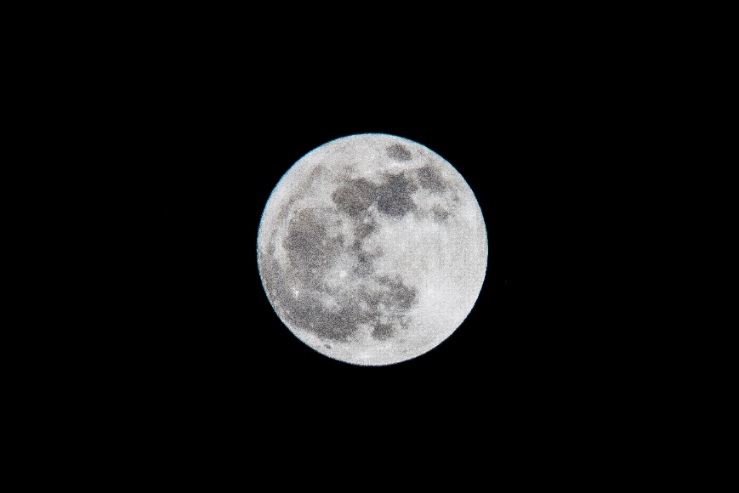

Mathematics

This week we will recap on numbers to ten and start to move onto numbers to fifteen. The children will work on recognising them and forming them.

We will be introducing the language of more and fewer to compare amounts and find the total of two amounts added together.

The Moon [](https://www.google.co.uk/url?sa=i&rct=j&q=&esrc=s&source=images&cd=&cad=rja&uact=8&ved=0ahUKEwiTwvKGgo7KAhUD7xQKHS6CAMcQjRwIBw&url=http://www.clipartsheep.com/snow-scene-clipart.html&bvm=bv.110151844,d.d24&psig=AFQjCNGRcnr4ks_bifxpmVuaz3jmMkRbfQ&ust=1451923320794434)

Expressive Arts and Design

This week we will be working to create different textures as we created a large moon for our classroom. The children will be learning songs and creating music with Mrs Smith on Thursday.

Parental Involvement Ideas

Please could you return any nativity costumes you still have.

This week we are talking about the moon. During the week when it is dark try to find the moon and look at how it changes. The Moon on Monday is in a Waxing Gibbous phase. This phase is when the moon is more than 50% illuminated but not yet a Full Moon. The phase lasts round 7 days with the moon becoming more illuminated each day until the Full Moon at the end of the week.