Communication and Language

This week we will be looking at the story ‘Man on the Moon’ by Simon Bartram. We will be using the events in the book for our inspiration for our discussions. We will be looking closely at the illustrations to predict events in the book. We will be looking at the questioning words what, why, where and how to help the children structure their questions.

Personal, Social and Emotion

During our PHSE lesson this week we will be talking about how to stay healthy. The children will talk about their favourite food and sort food into healthy and unhealthy groups. We will talk about what food we should eat to stay healthy.

Physical Development

On Monday, the children will be working on their ball skills in games and on Friday they will be working on their dance skills. The children will be playing a kerplunk game which requires the them to use the pincer grip and develop fine motor control for threading the straws. Also its really good fun!

Understanding of the World

Hopefully this week it will be a little less cloudy and we will be able to continue making observations of the moon as it changes. We will be talking about the season of Winter and how that changes the environment around us. We will look at winter around the world and discuss why they are different.

**Hatchmere planning**

**16.1.2017**

Literacy

We will be learning the sounds j, y and w. The children will recap on the sounds already learnt and building simple CVC words. The children will be writing about what they would need if they went to space for a day. The children will be reading with Mrs Hodge and Mrs Monsoon this week.

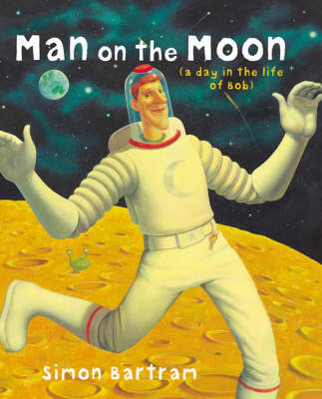

Mathematics

We will continue to work on number formation and recognition.

The children will be naming and talking about the properties of 3d shapes. The children will be sorting different shape and building models with the shapes. When the children are working on their Junk modelling spacecraft’s we will be using the 3d shape names to talk about the boxes.

[](https://www.google.co.uk/url?sa=i&rct=j&q=&esrc=s&source=images&cd=&cad=rja&uact=8&ved=0ahUKEwiTwvKGgo7KAhUD7xQKHS6CAMcQjRwIBw&url=http://www.clipartsheep.com/snow-scene-clipart.html&bvm=bv.110151844,d.d24&psig=AFQjCNGRcnr4ks_bifxpmVuaz3jmMkRbfQ&ust=1451923320794434)

Expressive Arts and Design

The children will be working on creating a 3d model of a spacecraft. The children will be learning songs and creating music with Mrs Smith on Thursday.

Parental Involvement Ideas

The Parental Involvement task this week will be to find and name 3d shapes in our environment. We will be looking for spheres, cubes, cuboids, cones, pyramids and cylinders. If your child could bring any of these shapes into school to share at ‘Show and Tell’ that would be lovely.