Personal, Social and Emotion
During our PHSE lesson this week we will be talking about respecting each other’s differences. The children will share the story ‘The Odd Egg’ and discuss how duck felt when the other birds were laughing at her. What could the other birds have done to help duck.

Communication and Language

Hopefully the children will be full of lovely news to share with the rest of the class. We will be looking for the children to be using the past and future forms accurately when they are talking. The children will be encouraged to listen to what others say and ask appropriate questions.
Physical Development
On Friday, the children will be working on their dance skills so please ensure they bring their PE kits back in by Thursday. The children will be recapping on all their letter formations and learning how to form capital letters.

Understanding of the World
This week we will look at the different types of animals, insects and reptiles that lay eggs and those that have live births. The children will be using the computer to research their answers. We will discuss what could possibly be in our ‘Odd Egg’ that appears in our classroom on Wednesday. (please keep that a surprise for the Children)

Hatchmere The Odd Egg Planning
Literacy
We will be recapping on all the sounds learnt so far and the diagraphs ch, sh and th. The children will be writing up their news in sentences that they have planned themselves. I will be hearing the children read this week and checking their new high frequency words. We will be sharing the book ‘The Odd Egg’ which is a beautifully illustrated book that gives the children plenty of chances to predict an ending.

28.2.2017
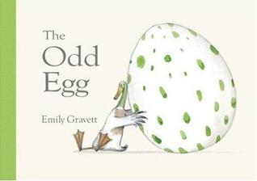
Mathematics
We will continue to work on number formation and recognition.
This week we are going to start using quantities and objects to add two single digit numbers together. The children might come home talking about the ‘add up dance’ which starts building the basic adding skills in a fun and physical way.
Expressive Arts and Design
The children will be designing their own odd eggs and creating them using oil pastels, paint and pen. The children will be encouraged to make their eggs as individual as possible.

Parental Involvement Ideas
This week we will be talking about ‘similarities and differences between themselves and others and among families’. Talk about what characteristics you share with your child or they share with siblings. Talk about like and dislikes. Discuss why they are just like Grandad or Mummy. Ask them who they think they are like and not just in looks but in character and temperament. Talk about how even though we have differences these are what makes us special and our similarities are what ties us together as a family.

