Physical Development

On Monday we are looking at mounting and dismounting a bench in the correct and safe way. In Dance on Friday morning we will be responding to music and moving like a puppets. The fine motor control activity this week will be using scissors. In handwriting we will be looking at forming the capital letters.

Personal, Social and Emotion

This week we will be talking about Mother’s Day and what that means to each child. We will be talking about what a mum’s job is and how we can help them.

Communication and Language

We will be going on a walk around school looking for the first signs of spring. Hopefully the children will be able to relate this experience to our discussion about Spring. We will be asking questions about what happens in Spring and then researching the answers using a range of non-fiction books and the computer. We will be collecting spring words to use in our writing.

Understanding of the World

This week we are going to be looking at the seasonal changes in the world around us. We will be asking and answering questions about why these changes occur. We will be looking at plant growth and collecting signs of spring from the world around us.

Literacy

We will be looking at a number of non-fiction books about Spring. The children will be going on a Spring walk and will be writing about that experience. In writing we are looking at finger spaces, capital letters and full stops. We will be looking at the sounds ai and ee and working on sounding out words containing these sounds.

Hatchmere Spring Plan

20.3.17

[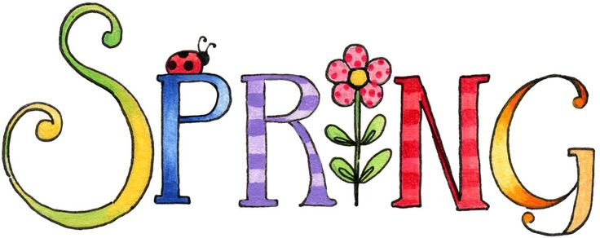](https://www.google.co.uk/url?sa=i&rct=j&q=&esrc=s&source=images&cd=&cad=rja&uact=8&ved=0ahUKEwianoiDtOPSAhWoAMAKHWogCCUQjRwIBw&url=http://www.clipartpanda.com/categories/spring-clip-art-free-images&bvm=bv.149760088,d.cGc&psig=AFQjCNHeRMBNSAlbAp7GFM91q3uxcUktcg&ust=1490041686127465)

[](https://www.google.co.uk/url?sa=i&rct=j&q=&esrc=s&source=images&cd=&cad=rja&uact=8&ved=0ahUKEwiTwvKGgo7KAhUD7xQKHS6CAMcQjRwIBw&url=http://www.clipartsheep.com/snow-scene-clipart.html&bvm=bv.110151844,d.d24&psig=AFQjCNGRcnr4ks_bifxpmVuaz3jmMkRbfQ&ust=1451923320794434)

Expressive Arts and Design

This week the children will be putting their artistic abilities into making a surprise.

Mathematics

We are continuing to work on our addition and subtraction skills using objects and this week the children will be recording their own sums and and showing their working out. We will continue to look at number recognition and formation.

The children will be looking at patterns.

Parental Involvement Ideas

This week we will be looking at the objective ‘They make observations of animals and plants and explain why some things occur and talk about changes’. As we are talking about Spring this week look at the world around you, in your garden, as you walk to and from school and see if you can spot any signs of Spring.