Communication and Language

This week we will be collecting and using bus and travel vocabulary. We will be talking about the children’s experience of bus journeys and using their imagination to plan a journey to somewhere special.

Personal, Social and Emotion

This week we will be looking and manners and how we should behave in class the children will help to create our class rules.

[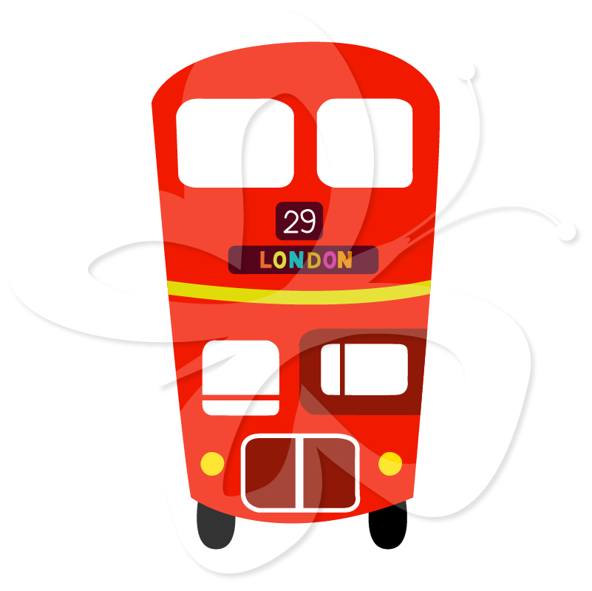](https://www.google.co.uk/url?sa=i&rct=j&q=&esrc=s&source=images&cd=&cad=rja&uact=8&ved=0ahUKEwiLttGzhaPWAhVKaFAKHUmYABoQjRwIBw&url=https://www.pinterest.com/pin/379991287283415927/&psig=AFQjCNHfjZH1S5axyM1U4Y4vLPqaWGFVqA&ust=1505422331429179)

Physical Development

We will be practising throwing and catching beanbags and looking at different ways of travelling in PE.

The children will be working 121 with a teacher to develop their pencil grip and control.

Literacy

This week we will be kick starting our transport topic with the book Naughty Bus by Jan and Jerry Oke.

The children will be learning the sounds i, s and a and will practise forming them.

Hatchmere Planning

The Naughty Bus

18.9.2017

[](https://www.google.co.uk/url?sa=i&rct=j&q=&esrc=s&source=images&cd=&cad=rja&uact=8&ved=0ahUKEwiLttGzhaPWAhVKaFAKHUmYABoQjRwIBw&url=https://www.pinterest.com/pin/379991287283415927/&psig=AFQjCNHfjZH1S5axyM1U4Y4vLPqaWGFVqA&ust=1505422331429179)

Understanding of the World

The Naughty bus goes through the streets of London. We will be looking at London and talking about how it differs from Winsford. If you have ever taken your child to London and have any photographs to share we would love to see them.

[](https://www.google.co.uk/url?sa=i&rct=j&q=&esrc=s&source=images&cd=&cad=rja&uact=8&ved=0ahUKEwiTwvKGgo7KAhUD7xQKHS6CAMcQjRwIBw&url=http://www.clipartsheep.com/snow-scene-clipart.html&bvm=bv.110151844,d.d24&psig=AFQjCNGRcnr4ks_bifxpmVuaz3jmMkRbfQ&ust=1451923320794434)

Mathematics

We will be looking at 2d and 3d shape and trying to spot it in our environment. The children will be looking at positional words, such as under, besides, in, over, on and by. We will look at numbers to five and work on recognising and forming these numbers.

Expressive Arts and Design

The children will be creating their own naughty bus and using them to help retell the story. We will be setting up a bus where the children can role play the different journeys we will be taking.

We will be making up our own version of the wheels on the bus and learning the song.

Parental Involvement Ideas

This week I would like you to look for shapes in your environment. These can be 2d shapes or 3d shapes. When you are walking around outside or even in your own home see what shapes your child can spot. If they are struggling to find any point them out yourself one day and see if they can remember them the next day. Talk about the shape of familiar objects and play spot the circle, spot the cylinder etc.

[](https://www.google.co.uk/url?sa=i&rct=j&q=&esrc=s&source=images&cd=&cad=rja&uact=8&ved=0ahUKEwiLttGzhaPWAhVKaFAKHUmYABoQjRwIBw&url=https://www.pinterest.com/pin/379991287283415927/&psig=AFQjCNHfjZH1S5axyM1U4Y4vLPqaWGFVqA&ust=1505422331429179)