Over St. John’s CE Primary School
‘Let your light shine before others.’ Matthew 5:16
Attendance and Punctuality Policy including Emotionally Based School Non-Attendance 2023/24

Introduction and Aim
Over St. John’s CE Primary School recognises the importance of good attendance and the impact it has on children’s progress, attainment, enjoyment of learning and relationships within school. Good attendance helps a child to realise their potential and ensure they are motivated, confident and enjoy a diverse range of curricular opportunities and experiences. Our school policy promotes good attendance, which is recognised and rewarded as an achievement. The school monitors attendance and ensures quick and early intervention if a problem is identified. We recognise that whole school preventative and proactive approaches are key to promoting children’s wellbeing and attendance. A child must attend school every day that they are required to do so unless an exceptional circumstance applies. The Attendance and Punctuality Policy is based on the premise of equal opportunities for all.

Legislation
- Section 7 of the Education Act 1996 states that “The parent of every child of compulsory school age shall cause him/her to receive efficient full-time education either by regular attendance at school or otherwise.”
- Section 444 (1) of the Education Act 1996 states that “if a child of compulsory school age who is a registered pupil at a school fails to attend regularly at the school his parent is guilty of an offence.”

Therefore, regular and punctual attendance at school is a legal requirement. Additionally, regular attendance is essential to enable children to maximise their educational attainment, opportunities and further development.

Section 576 Education Act 1996 - Meaning of “parent”

For the purposes of Education Law, the definition of a ‘parent’ and who is responsible for ensuring regular attendance to school is:
- all biological parents, whether they are married or not;
- any person who, although not a biological parent, has parental responsibility for a child or young person - this could be an adoptive parent, a step-parent, guardian or other relative;
- any person who, although not a biological parent and does not have parental responsibility, has care of a child or young person. This could be one parent, both parents and/or carer/s.

Procedure
Children are expected to attend school regularly, unless there is good reason for absence.
There are two types of absence:
- Authorised (where the school approves a pupil absence);
- Unauthorised (where school will not approve the absence).

The school has a duty to safeguard all its pupils. If a child is absent, the parents/carers should inform the school on the first day of absence and each following day of absence, stating the reason.

The school office will make contact with home when a child is absent and the parent/carer has not notified the school of the absence. If no contact can be achieved or the reason for absence is not accepted the absence will be unauthorised.

Absence Monitoring
School robustly monitor and analyse attendance data to promptly identify and address possible concerns and allow for early interventions to support the child/family’s underlying needs. This may include:
- Weekly attendance code analysis;
- Specific cohort and group monitoring – particularly for vulnerable groups e.g. children with a social worker;
- Monitoring of lesson attendance across all subjects;
- ‘Welcome back’ meeting for all pupils that have been absent for 5 days – to check wellbeing and ensure there are no ongoing needs that will impact on attendance.

Early Identification and Intervention: assess, plan, do and review
For any child/ child person who is absent from school it is essential to fully understand the reasons for this so that targeted, evidence-based interventions and support can be put into place. All staff have a part to play in promoting attendance. We recognise the importance of ensuring that key members of staff from across the school, including class teachers, attendance, pastoral and SEND staff work in collaboration to consider and identify the holistic needs of the child/young person and to overcome barriers to attendance. In accordance with the principles of early intervention, a graduated approach of assess, plan, do and review will be followed utilising a range of school-based resources, evidence-based interventions and seeking advice and support from external services at an appropriate stage, when needed.

Appropriate assessments will be important to help understand the underlying reasons that may be contributing to attendance difficulties. This may be an assessment that focuses on the individual child’s needs such as an SDQ, SEND assessments and wellbeing assessments or may include the holistic needs of the family, such as a TAF assessment. Assessments will include the views of the child/young person as well as parents/carers and identify strengths (what is working well) and needs (what is working less well).

Assessments undertaken may identify that a child/young person is experiencing underlying emotional based needs that are contributing to non-attendance. Cheshire West and Chester Council has developed guidance for schools: Emotionally Based School Non-Attendance: Good Practice Guidance for Schools (revised November 2021). This is a whole school framework with a graduated approach to support the early identification and intervention of children/young people who may struggle to cope in school/attend school.

Information from assessments will inform a SMART action plan with focussed targets developed in partnership with families and other services as appropriate. For example, Early Help and Prevention and Social Care may have a part to play in the delivery of support and intervention to promote engagement and attendance. SMART plans should be personalised to effectively meet a child/ young person’s needs and improve attendance and wellbeing outcomes.

Regular reviews of support and attendance plans are essential to monitor the impact of interventions and to adjust these accordingly. If, despite targeted support and intervention, attendance and wellbeing concerns persist, we may seek further advice and support from external services including mental health services, specialist teaching and education services.

Working in Partnership with Parents/ Carers
As a school, we recognise that building respectful relationships with families and working in collaboration is essential to ensuring the best outcomes for children/ young people. We require all parents to actively support the work of the school, including promoting attendance and engagement. The school is committed to ensuring that systems and processes are in place with regards to promoting attendance and would encourage parents to make contact if they have concerns about their child.

It is pertinent that school and parents/ carers work together with a shared plan and outcomes when supporting a child/ young person’s attendance and wellbeing. If despite persistent attempts to work with parents, there continues to be a lack of engagement, then legal procedures may be followed to secure engagement and school attendance.

Lateness and Punctuality
School begins 8.45am when the register is taken and all pupils are expected to be in school for registration at that time.
The school gate is opened at 8:35am and closed just before 8:45am

- Register taken at 8.45am
- Registers close 8.55am

Any child who arrives after the gates are closed must enter the school by the main entrance and report to the school office to sign in. If pupils are not in class when the register is taken, they will be coded as ‘L’. Any late arrivals after 8.55am will be coded as ‘U’ which is an unauthorised absence for that session.

In accordance with the ‘Education (Pupil Registration) (England) Regulations 2006’, if your child arrives after the registers close, they will receive a mark, code U, that shows them to be on site, but this will not count as a present mark and it will mean they have an unauthorised absence. This may mean that you could face the possibility of a Fixed Penalty Notice or other legal action if the problem persists.

Children who are consistently late for school are disrupting not only their own education, but also that of other children. Where persistent lateness gives cause for concern, you will be invited to a meeting to resolve the issues. If there is no improvement following this meeting, further action will be taken which may include referral to external agencies.

You may approach the school at any time for support and advice if you are having difficulty getting your child to school on time or maintaining regular attendance.

Registers
Registers provide the daily record of attendance of all pupils. They are legal documents and the register may be required in a court of law, for example, as evidence in prosecutions for non-attendance in school.

‘Education (Pupil Registration) (England) Regulations 2006’ (section 6)
Schools must take the attendance register at the start of the first session of each school day, morning (am) and once during the second session, afternoon (pm).

On each occasion they must record whether every pupil is:
- present;
- attending an approved educational activity;
- absent;
- unable to attend due to exceptional circumstances.

The school should follow up any absences to:
- ascertain the reason;
- ensure the proper safeguarding action is taken;
- identify whether the absence is approved or not; and,
- identify the correct code to use before entering it on to the school’s electronic register, or management information system as a priority and returned to the school office in a timely manner. This is used to download data to the School Census.
- consider early identification, assessment, intervention and support processes that may need to be implemented.

The register should be marked using the codes as advised by the Department for Education (DfE) ‘School Attendance Guidance for maintained schools, academies, independent schools and local authorities). (See appendix 3.)

Medical Absence
Absence due to sickness should be reported to the school by phone (01606 592608), using the office e mail address (admin@overstjohns.cheshire.sch.uk) or reporting absence via School Spider on the first day of absence. The school should be kept informed during longer periods of absence. School will contact parents during the first day if no satisfactory reason for absence has been received.

Any medical absences in excess of 5 days (10 sessions) per academic year will need to be supported by medical evidence. If no medical evidence is received, then the absence may be recorded as unauthorised. The school will work with all families on an individual basis if medical absences
exceed the maximum threshold.

If a medical absence is likely to be ongoing or long term, then we will offer support in accordance with the school’s policies and statutory guidance relating to Children with health needs. Supporting Pupils at School with Medical Conditions. As a school we need to plan how children can access Education and how and when the child will return to school. In accordance with the Equality Act 2010 the school must also demonstrate that reasonable adjustments are made to meet child’s Educational Needs.
For children who have a medical conditions who cannot attend school, the school will refer to the Cheshire West and Chester Council’s Medical Needs Team. CWAC Medical Needs Policy

Their policy states that referrals must come directly from the child’s school and must be supported by medical evidence from one of the following health professionals:
- consultant paediatrician or adolescent psychiatrist
- consultant child psychiatrist
- hospital consultant
Supporting evidence from a General Practitioner alone cannot be accepted.
Unauthorised Absence and Fixed Penalty Notice
An absence may be coded as ‘unauthorised’ if:
- no reason for absence has been given
- medical evidence is not received when requested
- a request for a leave of absence has been unauthorised
- a pupil arrives at school after registration has closed at 8.55am

Parents/carers should be aware that Over St. John’s may contact the Local Authority if a pupil has 10 or more unauthorised absences in the current term with a view to issuing a Fixed Penalty Notice or other legal action. The Fixed Penalty Notice is issued individually to each parent/carer who fails to ensure their child’s regular attendance at school. The Penalty is £60 per parent/carer per child if paid within 21 days rising to £120 if paid within 28 days. Non-payment of the Fixed Penalty Notice may result in prosecution in the Magistrates court (see appendix 1).

Application for Exceptional Circumstances
In September 2013, amendments to the Education (Pupil Registration) (England) Regulations 2006, make it clear that Head Teachers may not grant any Leave of Absence (holiday) during term time unless there are ‘exceptional circumstances.’

The Head Teacher and the Governing Body will determine what constitutes an exceptional
circumstance on an individual basis. If parents/carers need to request Exceptional Leave of Absence, they must complete an ‘Exceptional Leave of Absence’ form available from the school office. It should be noted that if any application is declined and absence occurs of a consecutive 5 or more unauthorised days, then school may apply to the Local Authority for a Fixed Penalty Notice to be issued to each parent/carer.

The following will not be deemed to be exceptional circumstances:
- family holiday;
- availability of less expensive holiday;
- availability of holiday accommodation;
- parent/carer’s working commitments;
- holiday pre-booked by another family member.

A child’s absence during term time seriously disrupts their continuity of learning. Not only do they miss the teaching on the days they are away but are less prepared for the lessons building on that teaching when they return to school. There is a consequent risk of under achievement, which we must seek to avoid.

The Governing Body is responsible for ensuring any attendance issues are dealt with in line with school policy.

Religious Observance
We recognise that some pupils may need to participate in days of religious observance.
Where a day of religious observance falls during school time and has been exclusively set apart for religious observance by the religious body to which the pupil belongs, we ask that parents/carers notify Over St. John’s in writing in advance where absence is required due to a religious observance.

Enforced School Closure
If Over St. John’s was forced to close for a period of time, we have the facility to operate an
online virtual school. The expectation is children will still engage with ALL activities when work is set. Procedures for online learning will be sent to parents as and when required.

What can parents/carers do to help?
Let the school know straight away why your child is absent. Home/school communication is
extremely important in supporting your child to achieve and feel settled in school. Try to make any dental/GP appointments outside of school time.

School will provide parents/ carers with information about Emotionally Based School Non-Attendance to discuss needs and strategies to support their child, as appropriate (see EBSN Parent Leaflet).

The table below sets out the attendance targets and at what stage parents/carers will be contacted about their child’s attendance.
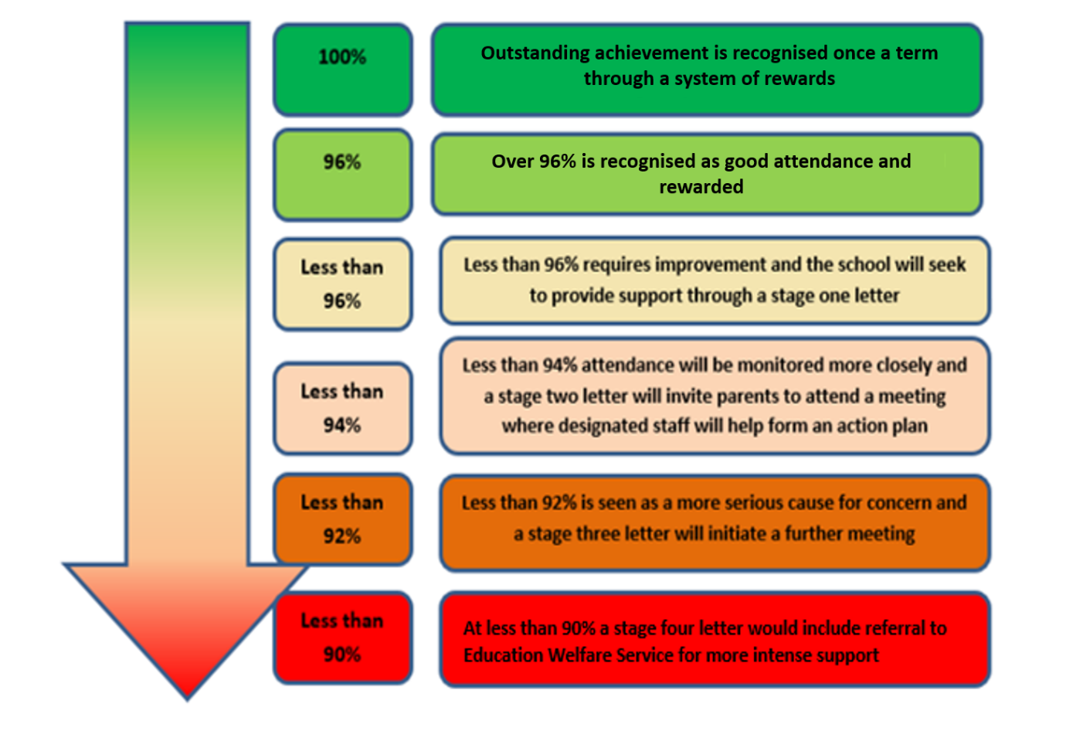
See appendix 2 for further breakdown of missed sessions.

Impact
All pupils will achieve well by developing knowledge and skills on their journey through school. Due to robust monitoring of attendance, all pupils, including vulnerable children and children with special educational needs and disabilities (SEND), will have fair and equitable access to school in order to achieve the best possible outcomes. Pupils will leave Over St. John’s ready for a successful transition to secondary education.

Appendix 1
Cheshire West and Chester
Code of Conduct for Education Fixed Penalty Notice (Unauthorised Leave of Absence and Irregular
Attendance)

1. A Fixed Penalty Notice (FPN) can only be issued in cases of unauthorised absence.

2. A maximum of two FPNs may be issued in an academic year and these FPNs may be issued against each parent/carer of a child. Once two FPNs have been issued, should there be further unauthorised absences, the Local Authority are able to move to prosecution immediately.

3. A FPN may be issued per parent per child.

4. Penalty Notices may be considered appropriate if:
- unauthorised absences of at least 10 consecutive school sessions (five school days);
- sessions either side of a weekend or school holiday will be counted as consecutive school days;
- for poorly attending learners, at least 10 sessions (five school days) lost due to unauthorised absence during a school term. These do not need to be consecutive;
- for poorly attending learners, persistent late arrive at school in a term. Persistent means at least 10 sessions of late arrival;
- the presence of an excluded child in a public place in the child’s first five days of exclusion.

6. The school must notify parents of the Attendance Policy and clearly state that parents may receive an FPN for an unauthorised leave of absence relating to holiday in term time.

7. Schools and the Education Welfare Services will take into account any exceptional circumstances when determining whether to issue a FPN.

Appendix 2

What does ‘percentage attendance’ mean?
Parents/carers should be advised that from September 2015 the Government have categorised those pupils who have attendance of 90% and below as ‘Persistent Absence’ pupils (P.A.). RSA will be specifically targeting this cohort of pupils, in an effort to improve their attendance in the future. The table below shows the learning time lost against percentage attendance figures.
Attendance during one school year | Equivalent  Days | Equivalent  Sessions | Equivalent  Weeks | Equivalent Lessons  Missed
95% | 9 Days | 18 Sessions | 1.4 Weeks | 45 Lessons
90% | 19 Days | 38 Sessions | 3.4 Weeks | 95 Lessons
85% | 29 Days | 58 Sessions | 5.4 Weeks | 145 Lessons
80% | 36 Days | 72 Sessions | 7.1 Weeks | 180 Lessons
75% | 48 Days | 96 Sessions | 9.3 Weeks | 240 Lessons

Appendix 3
Absence Codes
According to the DfE guidance the following codes are used on the register.

Code I | Illness | Schools can request medical evidence from parents/carers if they feel the authenticity of an illness is in doubt.
Code M | Medical or dental appointments | Parents/Carers are encouraged to arrange appointments out of school hours but the school will authorise if confirmation of the appointment is provided.
Code C | Other circumstances | This code will be used for any authorised non-medical reasons for a child’s absence from school, i.e. – family funeral.
Code D | Dual Registered | This code will be used if a pupil is registered at two schools.
Code J | Interview | This code will be used when it has been agreed that the pupil can miss school to attend an interview or entrance exam
Code P | Approved sporting activity | This code will be used in times of approved sporting activities in school times, i.e. – training sessions, trials and sporting events.
Code R | Religious Observation | This code is used to cover major religious festivals during term-time. The school will only authorise one day absence for religious events.
Code V | Educational visits and trips
Code W | Work Experience
Code G | Family holiday not authorised by the school or in excess of agreed period
Code U | Arrived late to school after 9.30am
Code N | Reason for absence not yet provided
Code O | Absent from school without authorisation
Code X | Not required to be in school (not compulsory school age)

