Personal, Social and Emotion

This week we will be looking at what makes a good friend. We will be role playing different situations and talking about what a good friend should do.

Communication and Language

This week we will collecting Autumn words and using them in our conversations. They will be talking about Autumn in small groups and responding to each other’s ideas.

Physical Development

We will be working on our hand to eye co-ordination and learning how to play golf this week. We have golf professional coming in to work with the children.

Literacy

This week we will writing simple labels for our Autumn finds. We will be focussing on finding the initial sound of each word.

The children will be learning the sounds e, c, d and will practise forming them.

Hatchmere Planning

Autumn.

9.0.2017

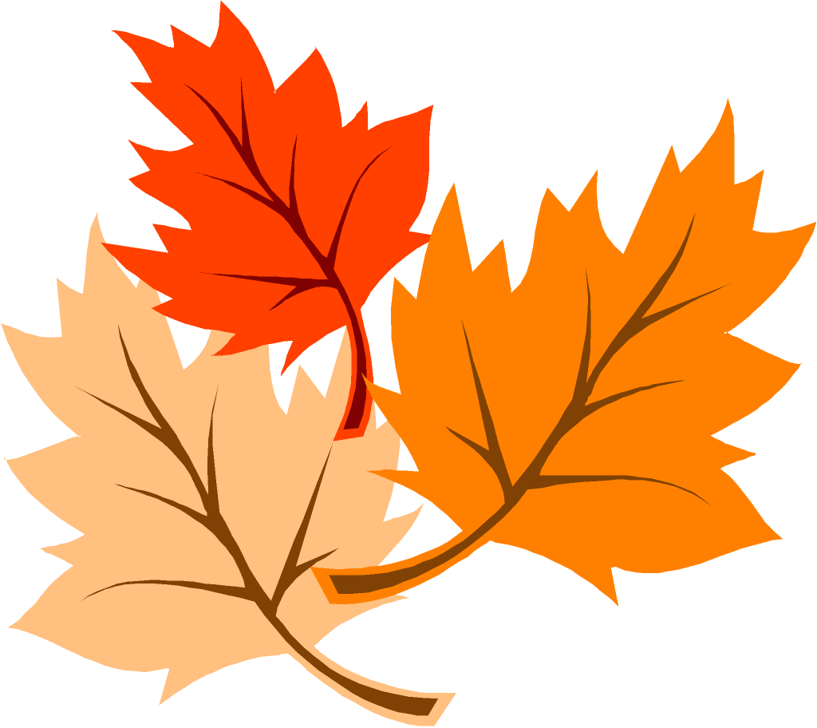

Understanding of the World

This week we will be looking at the changing seasons. We will be going on our Autumn walk to the park looking for signs of Autumn.

[](https://www.google.co.uk/url?sa=i&rct=j&q=&esrc=s&source=images&cd=&cad=rja&uact=8&ved=0ahUKEwiTwvKGgo7KAhUD7xQKHS6CAMcQjRwIBw&url=http://www.clipartsheep.com/snow-scene-clipart.html&bvm=bv.110151844,d.d24&psig=AFQjCNGRcnr4ks_bifxpmVuaz3jmMkRbfQ&ust=1451923320794434)

Parental Involvement Ideas

This week we are looking at Autumn and the changes we see in the world around us. As you walk around outside talk about the different signs of Autumn you see. Talk about the days getting colder and the nights getting longer. Compare what they wore in the summer to what they wear now. Look for the berries on the trees and the leaves falling. See if you can find any conkers or acorns. Please write down anything your child says about Autumn and send the slip back into school where it will be placed in your child’s learning Journey.

Mathematics

We will be looking at patterns and how to make them. The children will then make their own Autumn patterns. The children will be looking at the number five and working on forming the number correctly.

Expressive Arts and Design

The children will be using their Autumn finds to create collages with and weave with. We will look at doing leaf rubbing and printing, using what we have collected and created to form a piece of work.