Communication and Language

This week we will be talking about the children’s experiences during the holidays.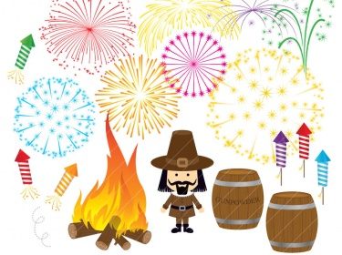

Personal, Social and Emotion

This week we will be talking about fire safety and what we can do to stay safe.

Physical Development

We will be doing PE on Friday so please make sure your child’s PE kit is returned by then. We will be doing gymnastics on Friday

Understanding of the World

This week the children will be creating their own fireworks using the kaleidoscope programme on the computer. 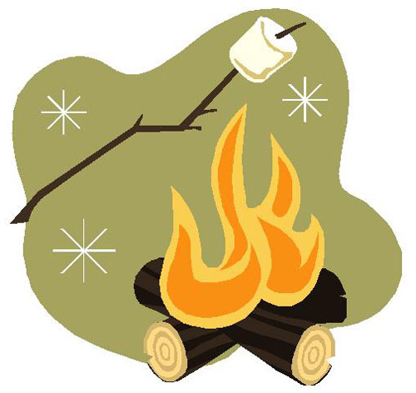

Hatchmere Planning

Bonfire Night

7.11.17

[](https://www.google.co.uk/url?sa=i&rct=j&q=&esrc=s&source=images&cd=&cad=rja&uact=8&ved=0ahUKEwiLttGzhaPWAhVKaFAKHUmYABoQjRwIBw&url=https://www.pinterest.com/pin/379991287283415927/&psig=AFQjCNHfjZH1S5axyM1U4Y4vLPqaWGFVqA&ust=1505422331429179)

Literacy

This week we will be looking at onomatopoeic words and sounding them out to use in our writing.

The children will be learning the sounds j, k and u and will practise forming them.

[](https://www.google.co.uk/url?sa=i&rct=j&q=&esrc=s&source=images&cd=&cad=rja&uact=8&ved=0ahUKEwiTwvKGgo7KAhUD7xQKHS6CAMcQjRwIBw&url=http://www.clipartsheep.com/snow-scene-clipart.html&bvm=bv.110151844,d.d24&psig=AFQjCNGRcnr4ks_bifxpmVuaz3jmMkRbfQ&ust=1451923320794434)

Mathematics

We will be moving onto doing numbers to ten. The children will be looking at capacity and talking about estimation.

Expressive Arts and Design

We will be making firework pictures and poppies. The children will be listening to a selection of classical firework songs including Handel’s Music for the Royal Firework, Dougherty’s Fire and Blood and of course Katy Perry’s Firework.

Parental Involvement Ideas

This week I would like you to talk to your child about Remembrance Sunday and why many people wear a poppy to mark the day. Perhaps you have someone in your family who has served in the armed forces and you could talk to your child about the important job they do. If appropriate you could watch the queen lay a wreath on the cenotaph and talk about why she does that. Perhaps look out for poppy wreaths at our war memorial. Please write down any comment your child makes and send it into school.