Personal, Social and Emotion

This week is anti-bullying week and the children will be talking about what this means. The children will discuss what bullying is and how to deal with it.

Physical Development

We will be playing golf with Ben on Monday and working on our gymnastic skills on Friday.

Communication and Language

The children will be finding out about Nocturnal animals and talking about why some animals are nocturnal. They will extend their vocabulary, especially by grouping and naming the animals.

Parental Involvement Activity This week we are going to be looking at the objective ‘knows that information can be retrieved from books and computers’. I would like you to research a nocturnal animal with your child. This can involve finding a videos or information on the internet or reading books about your chosen animal. Please write down what you did and what your child has learnt about their chosen animal.

Expressive Arts and Design

The children will be looking at night and day music with Mrs Smith. We will also be creating nocturnal animals using collage materials.

Mathematics

This week we will continue to look at capacity and measuring liquids. This week we will be moving onto work on the number seven.

Understanding of the World

This week we will be talking about what happens in the world around us at night time. The children will be introduced to our new Alexa and taught how to use it correctly.

Literacy

This week we will be asking questions about nocturnal animals and researching them using the computer and our new Alexa. We will be writing labels for our animals.

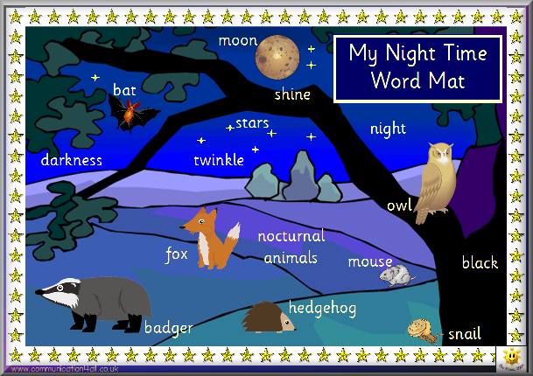

Nocturnal Animals Planning 13.11.17?