Communication and Language

This week we will asking questions about our nocturnal animals and researching the answers. characters in our story feel. We will look at what, why, when, where and how questions

Physical Development

The children will be continuing to work on their golf skills with Mr Derbyshire on Monday. The children will be working on their gymnastic skills with me on Friday.

Personal, Social and Emotion

This week we will be talking about our emotions and how we feel in different situations. We will also take the opportunity to talk to the children about what they should do if they become lost or separate from their parents.

Understanding of the World

This week will be talking about what we do in the day and what is done at night. We will be talking about the different jobs people do at night and why. We will be talking about why it is dark at night and looking at sources of light.

Literacy

This week we will be using our research to write information sentences about our nocturnal animal. We will be learning three more sounds this week. the children will be focussing on learning to build and read simple words.

[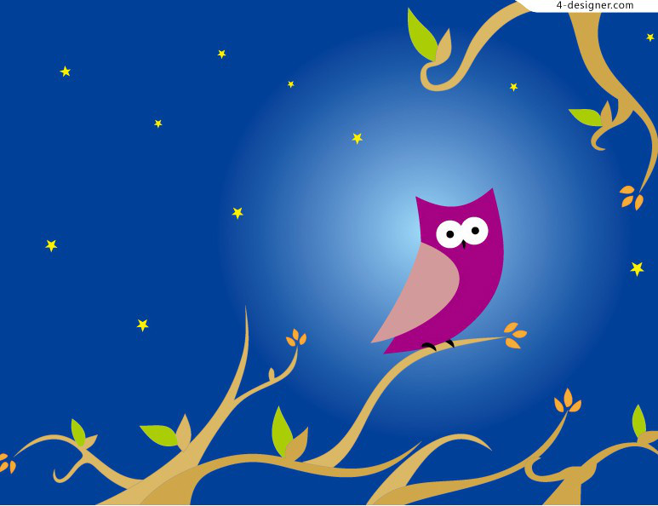](https://www.bing.com/images/search?q=harvest&view=detailv2&qft=+filterui:photo-clipart&id=8898978D02A523B460FB4B0876D69F165B2ACB33&selectedIndex=19&ccid=JlgBYFwH&simid=608030716870198999&thid=OIP.M265801605c07e24ce4d16eceba4c7d6co0)

Hatchmere Planning 20.11.15

Expressive Arts and Design

The children will be looking at night and day music with Mrs Smith. The children will be making their own clay owls this week.

Parental Involvement Task This week I would like you to look at the objective ‘Can order familiar events’. Talk about the routines you have in your home. What do you do after breakfast? What do you do when you get home from school? What is your bedtime routine? See if your child can order these events correctly. Please write down any comments your child makes and send it in to school. These observations are an important part of your child’s ongoing assessment.

Mathematics

This week we will be talking about different times of the day and what we do when. We will be using the vocabulary morning, midday, afternoon, evening and night. This week we will be looking at the number 8.