Personal, Social and Emotion

This week we will be talking about our British Values hand and talking about what the different fingers mean.

Communication and Language

This week we will following instructions on how to make a Christingle. The children will be looking at sequencing words next, then, after that and lastly.

Physical Development

The children will be continuing to work on their golf skills with Mr Derbyshire on Monday. The children will be working on their gymnastic skills with me on Friday.

Understanding of the World

We will be looking at the Advent traditions around the world. We will talk about what we do to count down to Christmas. On Friday, we will be introducing our Advent calendar. The children will be making simple Christingles.

Literacy

This week we will be writing instructions on how to make a Christingle. The children will be writing simple labels for the Christingle. The children will learn the letter x and z. This week I will be assessing how many sounds the children know.

[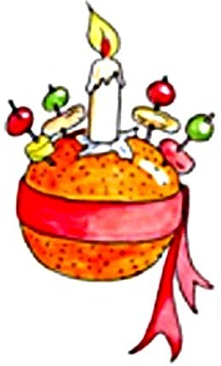](https://www.bing.com/images/search?q=harvest&view=detailv2&qft=+filterui:photo-clipart&id=8898978D02A523B460FB4B0876D69F165B2ACB33&selectedIndex=19&ccid=JlgBYFwH&simid=608030716870198999&thid=OIP.M265801605c07e24ce4d16eceba4c7d6co0)

Hatchmere Planning 27.11.17

Mathematics

This week we will be talking about different times of the day and what we do when. We will be using the vocabulary morning, midday, afternoon, evening and night. This week we will be looking at the number 9. The children will be learning to play dominoes.

Expressive Arts and Design

The children will be making simple Christingles and learning our Christingle poem for the service on Sunday. The children will be looking at night and day music with Mrs Smith.

Parental Involvement Task This week I would like you to look at the objective ‘Enjoys joining in with family customs and routines’. On Friday, it is the beginning of December and many of you will have advent calendars. When do the children open the calendar? What type of calendar do you have? Do you have any particular routine and traditions in your home to count down to Christmas? Perhaps you have a naughty elf in your house?