Personal, Social and Emotion

In circle time we will be sharing the ‘Big Bag of Worries’ and discussing what the children think the character is worried about

Communication and Language

This week we will be talking about what the children did during the half term break. The children will be encouraged to listen and ask questions.

Physical Development

The children will be continuing to work on their gymnastic skills with me on a Monday and dance skills with Mrs Pile on a Thursday.

**Hatchmere planning 27.2.18**

Mathematics

The children will be looking at addition using the book ‘How many Legs?’ The children will be looking at how we combine two amounts to make one.

Literacy

We will be introducing the sounds air, ear, oi and ow in our phonic sessions. The children will be looking at what makes rhymes work and collecting rhyming words.

[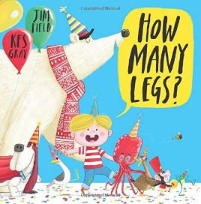](https://www.google.co.uk/imgres?imgurl=http://24.media.tumblr.com/tumblr_l5j1jgNL6K1qa2hhjo1_500.jpg&imgrefurl=http://mummyhoodandme.blogspot.com/2012/07/oliver-jeffers-childrens-author.html&h=460&w=450&tbnid=BRPK4_LrLssS0M:&docid=6lDaiTszJcEvKM&ei=BWuuVqmAPMPS-QGvlZeYCg&tbm=isch&ved=0ahUKEwjplrDE7tTKAhVDaT4KHa_KBaMQMwhEKBQwFA) [](https://www.google.co.uk/url?sa=i&rct=j&q=&esrc=s&source=images&cd=&cad=rja&uact=8&ved=0ahUKEwiTwvKGgo7KAhUD7xQKHS6CAMcQjRwIBw&url=http://www.clipartsheep.com/snow-scene-clipart.html&bvm=bv.110151844,d.d24&psig=AFQjCNGRcnr4ks_bifxpmVuaz3jmMkRbfQ&ust=1451923320794434)

**How many legs?**

Parental Involvement Ideas

On Thursday it is World Book Day and I would like the children to bring in their favourite story book to share with the class. Talk to your child about why it is their favourite book? What do thy like about it? Is it funny or just silly? Does it remind them of a special person or place?

Expressive Arts and Design

The children will be performing their dragon dance with the fierce Chinese dragon they have made.