Personal, Social and Emotion

The children will be talking about the changes that occur as we grow and develop.

Communication and Language

This week we will be reading and talking about the story Jaspers Beanstalk. The children will be using this book to help them sequence events in their own week. We will be talking about events using past, present and future tenses.

Physical Development

On Monday we will be working with Mr Pickering the sports coach. On Friday we will continue to work on our dance skills.

Understanding of the World

The children will continue their work in their Bean Diary. They will be making observations and measuring how tall our beans are growing. The children will be using the digital camera to record their bean growth.

**Hatchmere planning 30.4.18**

[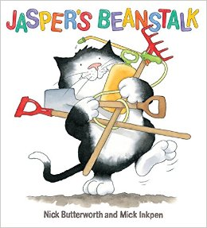](https://www.google.co.uk/url?sa=i&rct=j&q=&esrc=s&source=images&cd=&cad=rja&uact=8&ved=0ahUKEwi8kYWAjN3MAhWlK8AKHQjzCHoQjRwIBw&url=http://www.amazon.com/Jaspers-Beanstalk-Nick-Butterworth/dp/0340945117&psig=AFQjCNFUB4mOYw9yxTO51tpMKoJSraQmgQ&ust=1463436510334297)

Literacy

This week I will be assessing the children’s phonic levels and working on recording their observations of how their bean is growing. The children will be working on remembering their finger spaces between words as they write.

Mathematics

This week we will be looking at using the number lines to help do subtraction sums.

The children will be talking about the days of the week, month and seasons of the year.

[](https://www.google.co.uk/url?sa=i&rct=j&q=&esrc=s&source=images&cd=&cad=rja&uact=8&ved=0ahUKEwiTwvKGgo7KAhUD7xQKHS6CAMcQjRwIBw&url=http://www.clipartsheep.com/snow-scene-clipart.html&bvm=bv.110151844,d.d24&psig=AFQjCNGRcnr4ks_bifxpmVuaz3jmMkRbfQ&ust=1451923320794434)

Expressive Arts and Design

This week the children will be working collaboratively to create collage green bean leaves. They will be working with Mrs Pile on their music skills on Thursday morning.

Parental Involvement Ideas

This week we will be talking about what the children do each day and how they have different events on different days. If you could talk to the children about all the different things they do each day and help them get an idea of a normal week for them.