Personal, Social and Emotion

In the story this week the giant doesn’t have a friend because he is different. We will be talking about this and why the children are friends with their friends.

Communication and Language

This week we will be reading and talking about the story ‘Grandads Secret Giant’. The children will be collecting descriptive words. The children will be using positional language to describe where the giants are hiding.

Physical Development

This week the children will be working on their balancing skills in the Outside classroom. On Friday we will continue to work on our dance skills.

**Hatchmere planning 14.5.18**

[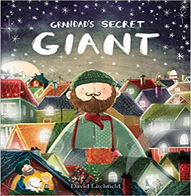](https://www.google.co.uk/url?sa=i&rct=j&q=&esrc=s&source=images&cd=&cad=rja&uact=8&ved=0ahUKEwi8kYWAjN3MAhWlK8AKHQjzCHoQjRwIBw&url=http://www.amazon.com/Jaspers-Beanstalk-Nick-Butterworth/dp/0340945117&psig=AFQjCNFUB4mOYw9yxTO51tpMKoJSraQmgQ&ust=1463436510334297)

Understanding of the World

This week the children will be looking at different types of material and what they are used for. The children will choose one of the materials for the giant’s new trousers and explain why they chose it.

Literacy

This week we will continue to work on using the phase three sounds in our writing. They will be writing a description of the giant. The children are working on planning out their sentences and writing using finger spaces.

[](https://www.google.co.uk/url?sa=i&rct=j&q=&esrc=s&source=images&cd=&cad=rja&uact=8&ved=0ahUKEwiTwvKGgo7KAhUD7xQKHS6CAMcQjRwIBw&url=http://www.clipartsheep.com/snow-scene-clipart.html&bvm=bv.110151844,d.d24&psig=AFQjCNGRcnr4ks_bifxpmVuaz3jmMkRbfQ&ust=1451923320794434)

Expressive Arts and Design

The children will be singing and moving with Mrs Pile on Thursday morning. They will be creating patterns to add to the giant’s patchwork pants using ink and watercolours.

Mathematics

We will be using the book ‘What time is it Mr Wolf? To introduce time to the children. We will be looking at sequencing the day and learning to use an analogue clock to tell the time.