Personal, Social and Emotion

This week it is anti-bullying week and we will be talking about what bullying means and how we deal with it. How we will choose respect.

Communication and Language

This week we will following instructions on how to make a Christingle. The children will be looking at sequencing words next, then, after that and lastly. We will be practising our poem for church on Sunday.

Physical Development

The children will be doing gymnastics on a Wednesday with Mrs Pie and dance with me on Thursday. The children will be practising their letter formation.

Understanding of the World

We will be looking at the Advent traditions around the world. We will talk about what we do to count down to Christmas. On Friday, we will be introducing our Advent calendar. The children will be making simple Christingles.

Literacy

This week we will be writing instructions on how to make a Christingle. The children will be writing simple labels for the Christingle. The children will be working on the sounds u, l, ll and m. We will be using these sounds to spell out simple words.

[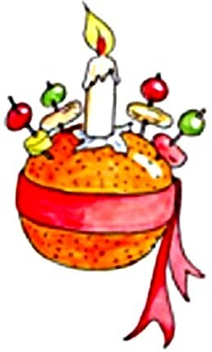](https://www.bing.com/images/search?q=harvest&view=detailv2&qft=+filterui:photo-clipart&id=8898978D02A523B460FB4B0876D69F165B2ACB33&selectedIndex=19&ccid=JlgBYFwH&simid=608030716870198999&thid=OIP.M265801605c07e24ce4d16eceba4c7d6co0)

Hatchmere Planning 26.11.18

Mathematics

This week we will be learning about the number 3. We will look at formation and the value of three. We will be introducing simple addition and subtraction sums with the children.

Expressive Arts and Design

The children will be making simple Christingles and learning our Christingle poem for the service on Sunday. The children will be looking at night and day music with Mrs Smith.

Parental Involvement Task This week I would like you to look at the objective ‘Enjoys joining in with family customs and routines’. On Saturday, it is the beginning of December and many of you will have advent calendars. When do the children open the calendar? What type of calendar do you have? Do you have any particular routine and traditions in your home to count down to Christmas? Perhaps you have a naughty elf in your house?