

Over St. John’s C.E. Primary School
Progression through Calculations for Subtraction

MENTAL CALCULATIONS
These are a selection of ongoing mental calculation strategies:

Mental recall of addition and subtraction facts
10 – 6 = 4 17 -  = 11
20 - 17 = 3 10 -  = 2

Find a small difference by counting up
82 – 79 = 3

Counting on or back in repeated steps of 1, 10, 100, 1000
86 - 52 = 34 (by counting back in ones and then in tens)
460 - 300 = 160 (by counting back in hundreds)

Subtract the nearest multiple of 10, 100 and 1000 and adjust
24 - 19 = 24 - 20 + 1 = 5
458 - 71 = 458 - 70 - 1 = 387

Use the relationship between addition and subtraction
36 + 19 = 55 19 + 36 = 55
55 – 19 = 36 55 – 36 = 19

MANY MENTAL CALCULATION STRATEGIES WILL CONTINUE TO BE USED. THEY ARE NOT REPLACED BY WRITTEN METHODS.

The following are standards that we expect the majority of children to achieve.

Reception

Using quantities and objects, children subtract two single digit numbers and count on or back to find the answer.

The children are introduced to a variety of models and images to support their learning and play a variety of games with physical objects. They develop ways of recording with pictures.

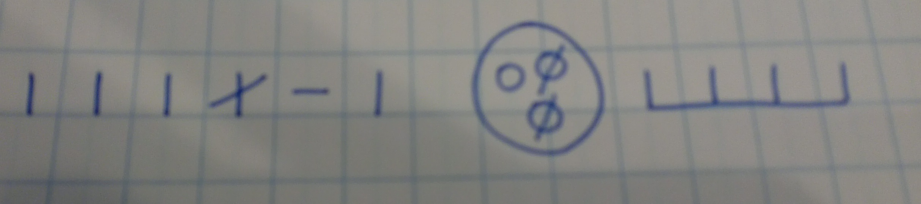

Year 1
Read, write and interpret mathematical statements involving subtraction (-) and equals (=) signs.
Represent and use number bonds and related subtraction facts within 20.
Subtract one-digit and two-digit numbers to 20, including zero.
Solve one-step problems that involve subtraction, using concrete objects and pictorial representations, and missing number problems such as 7 = - 9

Children are encouraged to develop a mental picture of the number system in their heads to use for calculation. They develop ways of recording calculations using pictures etc.

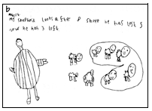

They use numberlines and practical resources to support calculation. Teachers demonstrate the use of the numberline.

6 – 3 = 3

-1
-1
-1

_______________________________________________________________
0 1 2 3 4 5 6 7 8 9 10

The numberline should also be used to show that 6 - 3 means the ‘difference between
6 and 3’ or ‘the difference between 3 and 6’ and how many jumps they are apart.

________________________________________________________________
0 1 2 3 4 5 6 7 8 9 10

Children then begin to use numbered lines to support their own calculations - using a numbered line to count back in ones.

13 – 5 = 8
-1
-1
-1
-1
-1

0 1 2 3 4 5 6 7 8 9 10 11 12 13 14 15

Bead strings, bead bars or multilink can be used to illustrate subtraction including bridging through ten by counting back 3 then counting back 2.

13 – 5 = 8

Year 2
Solve problems with subtraction:
- Using concrete objects and pictorial representations, including those involving numbers, quantities and measures.
- Applying their increasing knowledge of mental and written calculations.
Recall and use subtraction facts to 20 fluently and derive and use related facts up to 100.
Subtract numbers using concrete objects, pictorial representations and mentally, including:
- A two-digit number and ones.
- A two-digit number and tens.
- Two two-digit numbers.
Show that subtraction of one number from another cannot be done in any order.
Recognise and use the inverse relationship between addition and subtraction and use this to check calculations and solve missing number problems.

Children will use empty number lines to support calculations.

Counting Back
47 – 23 = 24
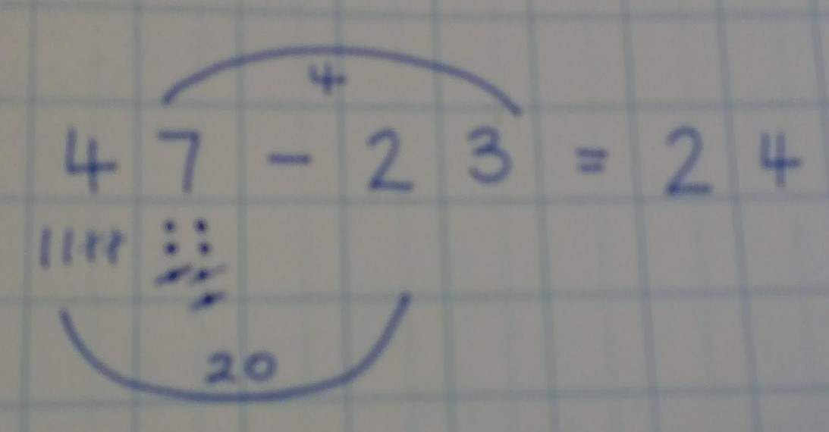

-3
-20

24 44 47

Where re-grouping is required for Greater Depth:
43 – 27 = 16
-7
20

16 36 43

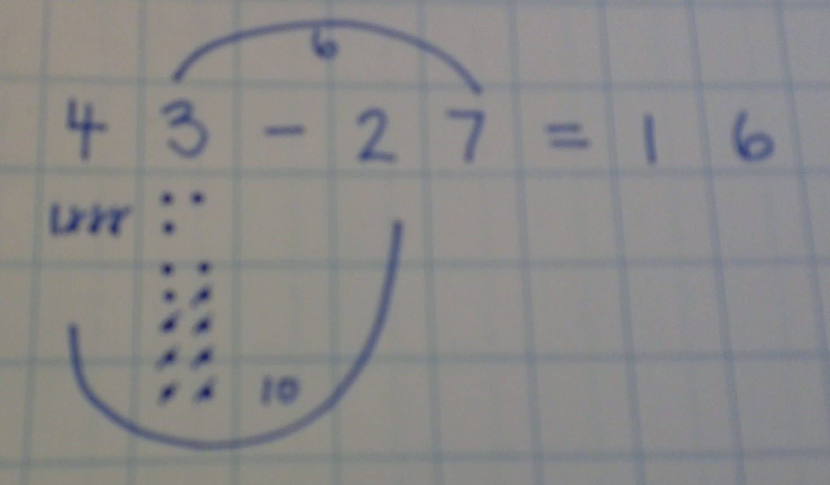

Partitioning and Decomposition
Children will begin to look at the informal methods of columnar subtraction, enabling them to understand the place value of the digits and the process, in preparation for the formal method. Initially, the children will be taught using examples that do not need the children to exchange.

89 – 57 =

 | 89 | = | 8 | 0 | + | 9
 | 57 | = | 5 | 0 | + | 7 | -
 | 32 | = | 3 | 0 | + | 2

Year 3
Subtract numbers mentally, including:
- A three-digit number and ones
- A three-digit number and tens
- A three-digit number and hundreds.
Subtract numbers with up to three digits, using formal written methods of columnar subtraction.
Estimate the answer to a calculation and use inverse operations to check answers.
Solve problems, including missing number problems, using number facts, place value, and more complex subtraction.

Partitioning and Decomposition
Children will begin to exchange. At first, this will be done using the informal method, but will quickly move onto writing the formal columnar method alongside.
This is time consuming at first, but it is important that the children understand what they are doing as opposed to just following a set method.

71 – 46 =

Step 1 | 71 | = | 7 | 0 | + | 1
 | 46 | = | 4 | 0 | + | 6 | -
Step 2 | 71 | = | 6 | 0 | + | 1 | 1
 | 46 | = | 4 | 0 | + |  | 6 | -
 | 25 | = | 2 | 0 | + |  | 5
Step 3 | 71 | = | 60  7 | 0 | + | 11 |  |  |  | 6  7 | 11
 | 46 | = | 4 | 0 | + | 6 |  |  |  | 4 | 6 | -
 | 25 | = | 2 | 0 | + | 5 |  |  |  | 2 | 5

Step 1 and Step 2 show the teaching method, but would be recorded as Step 3 by the children.
Children should begin to use increasingly large numbers, subtracting numbers with up to three digits. Children will continue to write the informal and formal method alongside each other until the teacher uses their professional judgement to realise that the child need only record the formal columnar method.

Counting On
Children should be taught to see that, where the numbers involved in the calculation are close together or multiples of 10 or 100, mental methods, such as counting on using a number line should be used.

102 – 89 = 13
+10

+1
+2

89 90 100 102

Year 4
Subtract numbers with up to 4 digits using formal written methods of columnar subtraction where appropriate.
Estimate and use inverse operations to check answers to a calculation.
Solve addition and subtraction two-step problems in contexts, deciding which operations and methods to use and why.

Partitioning and Decomposition
As in Year 3, children will continue to write the informal and formal method alongside each other until the teacher uses their professional judgement to realise that the child need only record the formal columnar method.

NB When children have reached the concise columnar stage they will then continue this method through into Years 5 and 6. They will not go back to using the expanded methods. Only children still insecure will continue with both methods.

Children to continue to work with increasingly large numbers, subtracting numbers with up to four digits.

2754 – 386 = 2368

Step 1 | 2000 | + | 700 | + | 50 | + | 4
 |  |  | 300 | + | 80 | + | 6 | -
Step 2 | 2000 | + | 700 | + | 40 | + | 14 |  | (Adjust from 10s)
 |  |  | 300 | + | 80 | + | 6 | -
Step 3 | 2000 | + | 600 | + | 140 | + | 14 |  | (Adjust from 100s)
 |  |  | 300 | + | 80 | + | 6 | -
 | 2000 | + | 300 | + | 60 | + | 8
Step 4 | 2000 | + | 6700 | + | 1450 | + | 14 |  |  |  |  |  |  | 2 | 67 | 145 | 14
 |  |  | 300 | + | 80 | + | 6 | - |  |  |  |  |  |  | 3 | 8 | 6 | -
 | 2000 | + | 300 | + | 60 | + | 8 |  |  |  |  |  |  | 2 | 3 | 6 | 8

Children should:
- be able to subtract numbers with different numbers of digits;
- using this method, children should also begin to find the difference between two three-digit sums of money, with or without ‘adjustment’ from the pence to the pounds;
- know that decimal points should line up under each other.

Children should be taught to see that, where the numbers involved in the calculation are close together or multiples of 10, 100 or 100, mental methods, such as counting on using a number line should be used.

511 – 197 = 314
+300

+3
+11

197 200 500 511

Year 5
Subtract whole numbers with more than 4 digits, including using formal written methods (columnar subtraction).
Subtract numbers mentally with increasingly large numbers.
Use rounding to check answers to calculations and determine, in the context of a problem, levels of accuracy.
Solve addition and subtraction multi-step problems in contexts, deciding which operations and methods to use and why.

Decomposition

22754 – 4286 = 18468

12 | 12 | 67 | 145 | 14
 | 4 | 2 | 8 | 6 | -
1 | 8 | 4 | 6 | 8

Children should:
- be able to subtract numbers with different numbers of digits;
- begin to find the difference between two decimal fractions with up to three digits and the same number of decimal places;
- know that decimal points should line up under each other.

Children should be taught to see that, where the numbers involved in the calculation are close together or multiples of 10, 100 or 100, mental methods, such as counting on using a number line should be used.

1209 – 988 = 221
+200

+12
+9

988 1000 1200 1209

Year 6
Use their knowledge of the order of operations to carry out calculations involving the four operations.
Solve addition and subtraction multi-step problems in contexts, deciding which operations and methods to use and why.

Decomposition
Children should continue to use the formal method of columnar subtraction as taught in previous years, increasing the size of the numbers whilst also increasing in confidence and applying to a range of contexts.

Children should:
- be able to subtract numbers with different numbers of digits;
- be able to subtract two or more decimal fractions with up to three digits and either one or two decimal places;
- know that decimal points should line up under each other.

Counting On
Where the numbers are involved in the calculation are close together or near to multiples of 10, 100 etc counting on using a number line should be used.

3002 – 1997 = 1005
+1000

+3
+2

1997 2000 3000 3002

By the end of Year 6, children will have a range of calculation methods, mental and written. Selection will depend upon the numbers involved.

Children should not be made to go onto the next stage if:

- they are not ready.
- they are not confident.

Children should be encouraged to approximate their answers before calculating.
Children should be encouraged to check their answers after calculation using an appropriate strategy.
Children should be encouraged to consider if a mental calculation would be appropriate before using written methods.

Signed: S McClellan Chair of Governors

E Snowdon Head Teacher

Date: January 2018
Review Date: January 2020

