

Over St. John’s C.E. Primary School
Progression through Calculations for Multiplication

MENTAL CALCULATIONS
Mental calculations are ongoing throughout primary years and below is a list (not exhaustive) of strategies that may be used.

Doubling and Halving
Applying the knowledge of doubles and halves to known facts.
e.g. 8 x 4 is double 4 x 4

Multiplication facts
Tables should be taught every day from Y2 onwards.

Year 2 2 times table
5 times table
10 times table

Year 3 2 times table
3 times table
4 times table
5 times table
8 times table
10 times table

Year 4 Derive and recall facts for multiplication tables up to 12 x 12

Year 5 & 6 Derive and recall quickly multiplication facts for all tables up to 12 x 12

Using and applying multiplication facts
Children should be able to utilise their tables knowledge to derive other facts.
e.g. If I know 3 x 7 = 21, what else do I know?
30 x 7 = 210, 300 x 7 = 2100, 3000 x 7 = 21 000, 0.3 x 7 = 2.1 etc

Use closely related facts already known
13 x 11 = (13 x 10) + (13 x 1)
= 130 + 13
= 143

Multiplying by 10, 100 or 1000
Knowing that the effect of multiplying by 10 is a shift in the digits one place to the left.
Knowing that the effect of multiplying by 100 is a shift in the digits two places to the left.
Knowing that the effect of multiplying by 1000 is a shift in the digits three places to the left.

Partitioning
23 x 4 = (20 x 4) + (3 x 4)
= 80 + 12
= 102

Use of factors
8 x 12 = 8 x 4 x 3

MANY MENTAL CALCULATION STRATEGIES WILL CONTINUE TO BE USED. THEY ARE NOT REPLACED BY WRITTEN METHODS.

The following are standards that we expect the majority of children to achieve.

Reception
Children solve problems, including doubling, halving and sharing.

Children to use a variety of models and images as well as physical objects to support their understanding. Lots of rich word problems will be used to support the children’s learning in context.
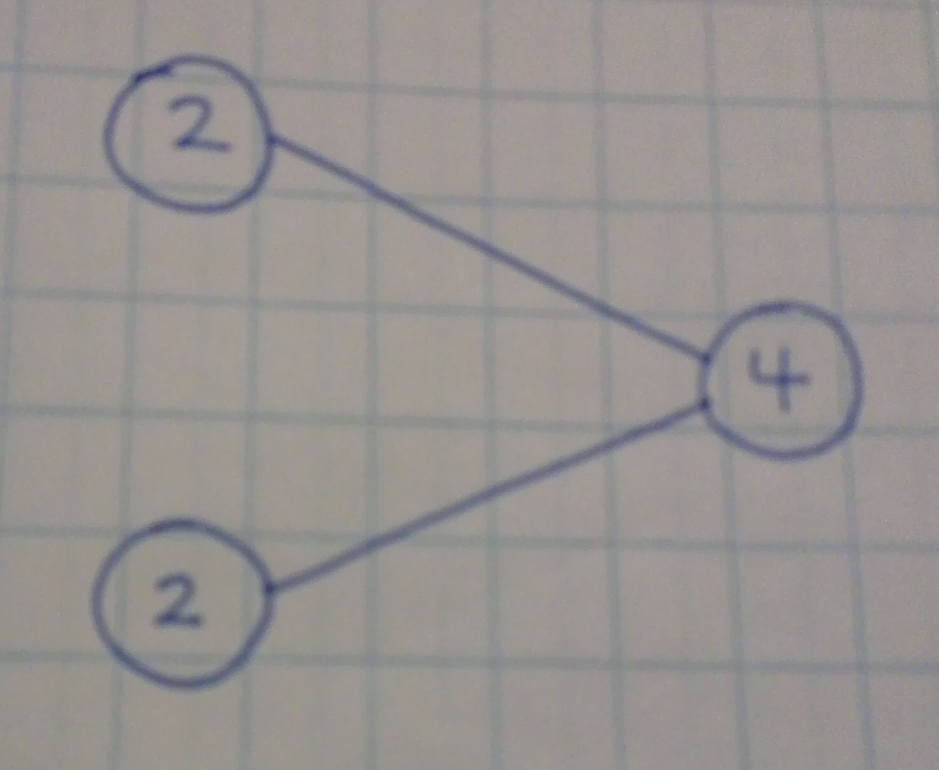

Year 1
Solve one-step problems involving multiplication by counting the answer using concrete objects, pictorial representations and arrays with the support of the teacher.

Children will experience equal groups of objects and will count in 2s, 5s and 10s. They will work on practical problem solving activities involving equal sets or groups.

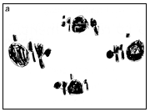
Year 2
Recall and use multiplication facts for the 2, 5 and 10 multiplication tables, including recognising odd and even numbers.
Calculate mathematical statements for multiplication with the multiplication tables and write them using multiplication (x) and equals (=) signs.
Show that multiplication of two numbers can be done in any order (commutative).
Solve problems involving multiplication using materials, arrays, repeated addition, mental methods and multiplication facts, including problems in context.

Children will develop their understanding of multiplication and use jottings to support calculation.

- Repeated addition
3 times 5 is 5 + 5 + 5 = 15 or 3 lots of 5 or 5 x 3

Repeated addition can be shown easily on a number line:
5 x 3 = 5 + 5 + 5
5
5
5

0 5 10 15
- Commutativity

Children should know that 3 x 5 has the same answer as 5 x 3. This can also be shown on the number line.
5
5
5

0 3 5 6 9 10 12 15

3
3
3
3
3

- Arrays
Children should be able to model a multiplication calculation using an array.

5 x 3 = 15

3 x 5 = 15

3 x 5 = 15

5 x 3 = 15

Year 3

From Year 3 onwards, it is imperative that children learn these strategies, practise them and then use them in a variety of problem solving contexts – do not continue to just use larger numbers if the method is not appropriate or if they are unfamiliar with how to use the strategies in a range of contexts.

Recall and use multiplication facts for the 3, 4 and 8 multiplication tables.
Write and calculate mathematical statements for multiplication using the multiplication tables that they know, including two-digit numbers times one-digit numbers, using mental and progressing to formal written methods.
Solve problems, including missing number problems, involving multiplication, including positive integer scaling problems and harder correspondence problems such as n objects are connected to m objects.

Children will continue to use

- Repeated addition using multiplication facts for Year 3 and Year 2.

4 times 6 is 6 + 6 + 6 + 6 = 24 or 4 lots of 6 or 6 x 4

Children should use number lines to support their understanding.

6
6
6
6

0 6 12 18 24

- Using symbols to stand for unknown numbers to complete equations using inverse operations

 x 5 = 20 3 x  = 18  x  = 32

- Partitioning

23 x 8
Children will approximate first
23 x 8 is approximately 25 x 8 = 200
 |  |  | 2 | 3 | x | 8 | = | 1 | 8 | 4
 |  |  |  | 3 | x | 8 | = |  | 2 | 4
 |  |  | 2 | 0 | x | 8 | = | 1 | 6 | 0 | +
 |  |  |  |  |  |  |  | 1 | 8 | 4

- Short Multiplication beginning to use Formal Methods
As children begin the formal methods, calculations should be written side by side to each other so that the children make the connections between the two and continue to develop their understanding of place value.

Formal – Step 1

 |  |  | T | O
 |  |  | 2 | 8
 |  |  |  | 3 | x
 |  |  | 2 | 4 |  |  |  | (8 | x | 3)
 |  |  | 6 | 0 | + |  | (2 | 0 | x | 3)
 |  |  | 8 | 4
Year 4
Recall multiplication and division facts for multiplication tables up to 12 x 12.
Use place value, known and derived facts to multiply mentally, including: multiplying by 0 and 1; multiplying three numbers together.
Recognise and use factor pairs and commutativity in mental calculations.
Multiply two-digit and three-digit numbers by a one digit number using formal written layout.
Solve problems involving multiplying, including using the distributive law to multiply two-digit numbers by one digit, integer scaling problems and harder correspondence problems such as n objects are connected to m objects.

TO x O and HTO x O
(Short multiplication – multiplication by a single digit)

As at Year 3, children should continue to see the relationship between the place value of the digits and their multiplication. Teachers will use their professional judgement to decide when the child is secure enough to write only the formal method.

Children will no longer be expected to write the steps of their calculations in brackets at the side, if they are now familiar with the method.

Formal – Step 1 Formal – Step 2

 |  |  | H | T | O |  |  |  |  |  |  |  |  |  | H | T | O
 |  |  |  | 3 | 7 |  |  |  |  |  |  |  |  |  |  | 3 | 7
 |  |  |  |  | 9 | x |  |  |  |  |  |  |  |  |  |  | 9 | x
 |  |  |  | 6 | 3 |  |  |  |  |  |  |  |  |  | 3 | 3 | 3
 |  |  | 2 | 7 | 0 | + |  |  |  |  |  |  |  |  |  | 6
 |  |  | 3 | 3 | 3

Formal – Step 1 Formal – Step 2

 |  | T | H | T | O |  |  |  |  |  |  |  |  |  |  |  | T | H | T | O
 |  |  | 2 | 5 | 3 |  |  |  |  |  |  |  |  |  |  |  |  | 2 | 5 | 3
 |  |  |  |  | 6 | x |  |  |  |  |  |  |  |  |  |  |  |  |  | 6 | x
 |  |  |  | 1 | 8 |  |  |  |  |  |  |  |  |  |  |  | 1 | 5 | 1 | 8
 |  |  | 3 | 0 | 0 |  |  |  |  |  |  |  |  |  |  |  |  | 3 | 1
 |  | 1 | 2 | 0 | 0 | +
 |  | 1 | 5 | 1 | 8

Year 5
Multiply numbers up to 4 digits by a one- or two-digit number using a formal written method, including long multiplication for two-digit numbers.
Multiply numbers mentally drawing upon known facts.
Multiply whole numbers and those involving decimals by 10, 100 and 1000.
.

THTO x O
(Short multiplication – multiplication by a single digit)
Children should extend the short multiplication method to numbers with up to four digits. Children should be confident to just use short multiplication method at the final Step 2.

1346 x 9

 |  | Th | H | T | O
 |  | 1 | 3 | 4 | 6
 |  |  |  |  | 9 | x
 | 1 | 2 | 1 | 1 | 4
 |  | 3 | 4 | 5

TO x TO
(Long multiplication – multiplication by more than a single digit)

24 x 16

Children will approximate first
24 x 16 is approximately 20 x 20 = 400

 |  | 2 | 4
 |  | 1 | 6 | x
 | 1 | 4 | 4
 | 2 | 4 | 0 | +
 | 3 | 4 | 4

124 x 26

 | 1 | 2
 | 1 | 2 | 4
 |  | 2 | 6 | x
 | 7 | 4 | 4
2 | 4 | 8 | 0 | +
3 | 2 | 2 | 4
1 | 1

Using similar methods, they will be able to multiply decimals with one decimal place by a single digit number, approximating first. They should know that the decimal points line up under each other.

Year 6

Multiply multi-digit numbers up to 4 digits by a two-digit number using the formal written method of long multiplication.
Perform mental calculations, including with mixed operations and large numbers.
Solve problems involving multiplication.

ThHTO x O
(Short multiplication – multiplication by a single digit)

4346 x 8

Children will approximate first
4346 x 8 is approximately 4346 x 10 = 43460

 |  |  | 4 | 3 | 4 | 6
 |  |  |  |  |  | 8 | x
 |  | 3 | 4 | 7 | 6 | 8
 |  |  | 2 | 3 | 4

ThHTO x TO
(Long multiplication – multiplication by more than a single digit)

1372 x 24

Children will approximate first
1372 x 24 is approximately 1400 x 25 = 35000

 |  |  | 1 | 2
 |  |  | 1 | 3 | 7 | 2
 |  |  |  |  | 2 | 4 | x
 |  |  | 5 | 4 | 8 | 8
 |  | 2 | 7 | 4 | 4 | 0
 |  | 3 | 2 | 9 | 2 | 8
 |  | 1 |  | 1

Using similar methods, they will be able to multiply decimals with up to two decimal places by a single digit number and then two digit numbers, approximating first. They should know that the decimal points line up under each other.

By the end of year 6, children will have a range of calculation methods, mental and written. Selection will depend upon the numbers involved.

Children should not be made to go onto the next stage if:

- they are not ready.
- they are not confident.

Children should be encouraged to approximate their answers before calculating.
Children should be encouraged to check their answers after calculation using an appropriate strategy.
Children should be encouraged to consider if a mental calculation would be appropriate before using written methods.

Signed: S McClellan Chair of Governors

E Snowdon Head Teacher

Date: January 2018
Review Date: January 2020

