2D shapes – diagonals, obtuse, acute and right angles
Q1.
Here are five shaded triangles on a square grid.

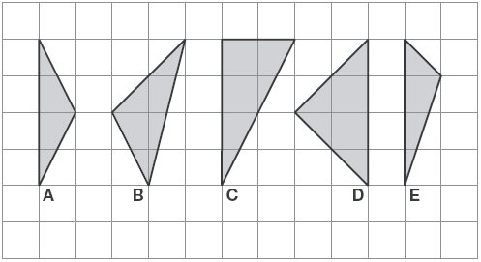

Write the letter of each triangle that has a right angle.
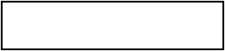
1 mark

Write the letter of each triangle that has two equal sides.
1 mark

Q2.
The diagonals of this quadrilateral cross at right angles.
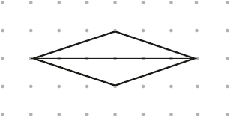
Tick all the quadrilaterals that have diagonals which cross at right angles.
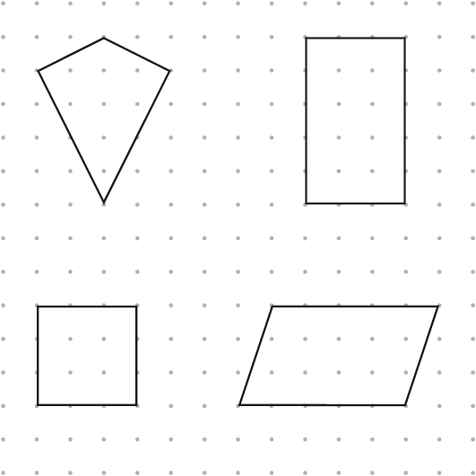
2 marks

Q3.
Here are four shapes.
They each have a different number of right angles.
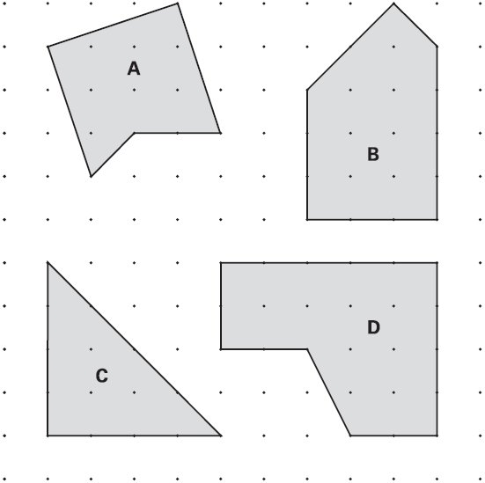

Write the letter for each shape in the correct order.
One has been done for you.
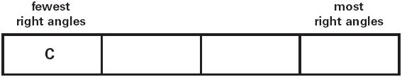
1 mark

Q4.
Here are some shaded shapes on a square grid.

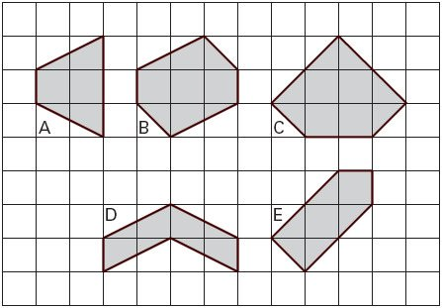
Write the letters of the two shapes which are hexagons.
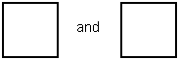
1 mark
Write the letters of the two shapes which have right angles.
1 mark

Q5.
Look at this shape.
Tick (✔) each angle that is less than a right angle.

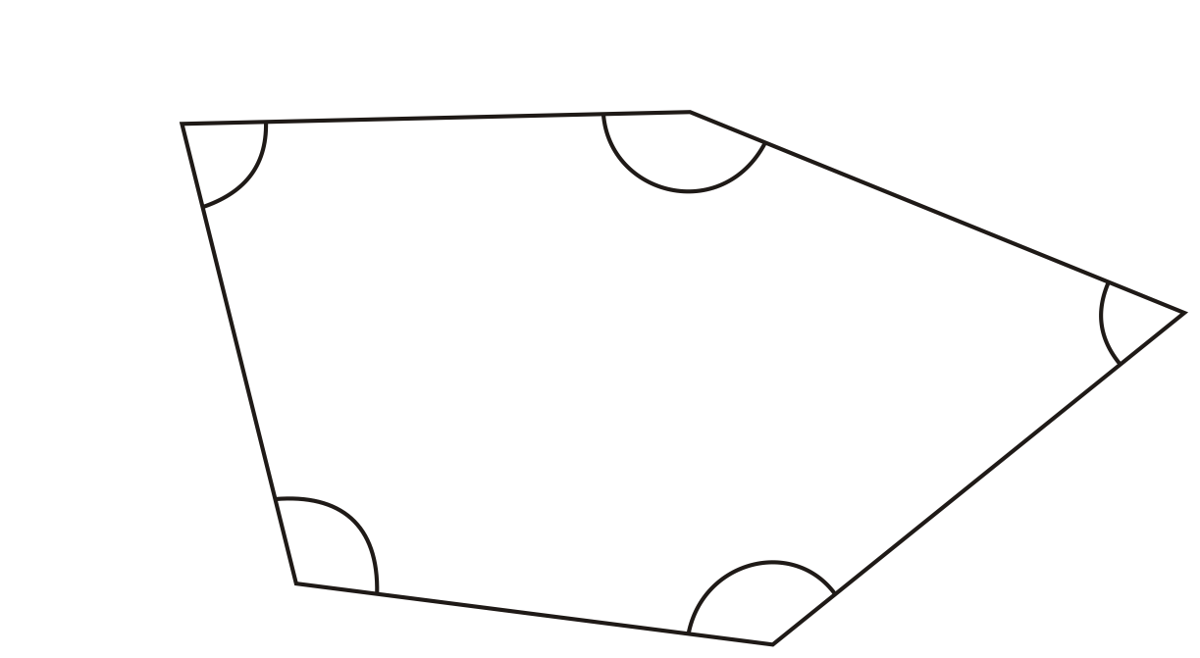
1 mark

Q6.
This diagram has four angles marked A, B, C and D.

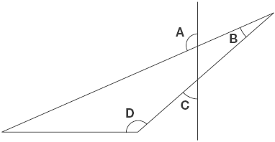
Write the letters of the angles that are obtuse angles.
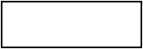
1 mark

Q7.
The diagram shows a shaded octagon on a square grid.
Line A joins two vertices of the octagon.
Join two other vertices to draw a line parallel to line A.
Use a ruler.

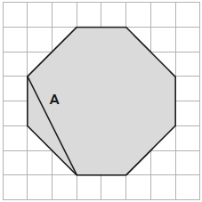
1 mark

Join two vertices to draw a line perpendicular to line A.
Use a ruler.

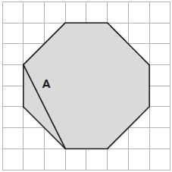
1 mark

Q8.
Here are five angles marked on a grid of squares.
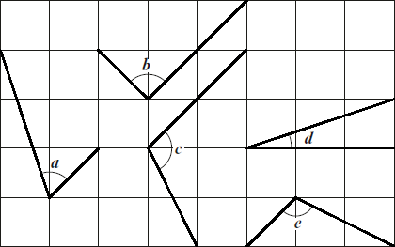
Write the letters of the angles that are obtuse.
________________________
1 mark
Write the letters of the angles that are acute.
________________________
1 mark

Q9.
In this shape, one of the angles is obtuse.
Tick (✔) the obtuse angle.8
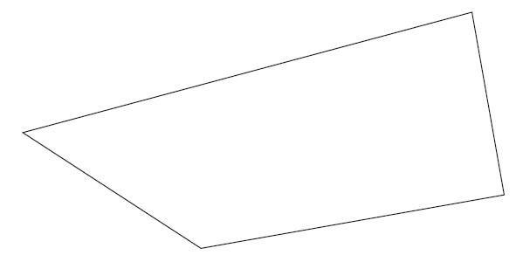
1 mark

Q10.
Join dots on the grid to make a quadrilateral that has 3 acute angles.

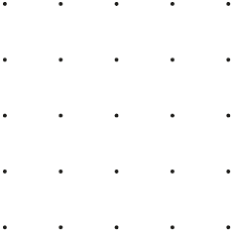
1 mark

M1. (a) C AND D
Letters may be given in either order.
1

(b) A AND D
Letters may be given in either order.
1
[2]

M2.
Award TWO marks for both kite AND square ticked as shown.
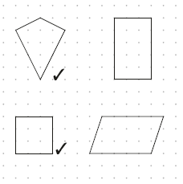
If the answer is incorrect, award ONE mark for:
• kite AND square and not more than one incorrect shape ticked.
OR
• one correct shape only ticked.
Accept alternative unambiguous positive indications, e.g. shapes circled.
Up to 2m
[2]

M3. Letters written in order as shown:
fewest  right angles |  |  | most  right angles
C | A | B | D

Letters must be in the correct order.
Accept the correct number of right angles written instead of letters, eg
fewest  right angles |  |  | most  right angles
C | 2 | 3 | 4

[1]

M4. (a) B AND D
Both letters must be given.
Letters may be given in either order.
1
(b) C AND E
Both letters must be given.
Letters may be given in either order.
1
[2]

M5. Two angles ticked as shown:
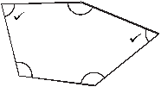
Do not award the mark if additional incorrect angles are ticked.
Accept alternative unambiguous indications of the correct angles, eg angles circled.
[1]

M6. A AND D
Letters may be given in either order.
[1]

M7.(a) Line drawn parallel to A, as shown:
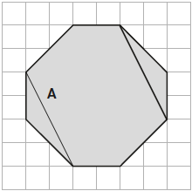
Accept slight inaccuracies in drawing, provided the intention is clear.
1

(b) Line drawn perpendicular to A, as shown:
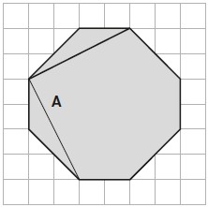

OR
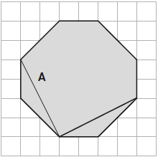
Accept slight inaccuracies in drawing, provided the intention is clear.
1
[2]

M8.
(a) c AND e
Letters may be given in either order.
1
(b) a AND d
Letters may be given in either order.
1
[2]

M9.Correct angle indicated as shown:
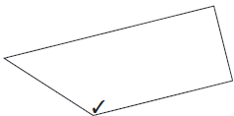
Accept alternative unambiguous indications, eg correct angle crossed or circled.
[1]

M10.A quadrilateral with three acute angles, e.g.
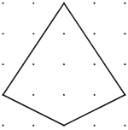

OR
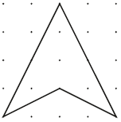

OR
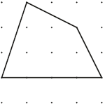
Accept inaccurate drawing provided the intention is clear.
[1]

