LINE GRAPHS
Q1.
These two graphs convert pounds (£) to Deutschmarks (Dm) and pounds (£) to dollars ($).

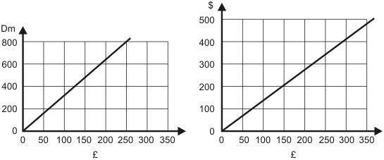
Use the graphs to complete the table.

 | number of  £ | approximate  number of Dm | approximate  number of $
 | 0  200 | 0 | 0

2 marks
Use the information in your table to draw a conversion graph for $ into Dm.

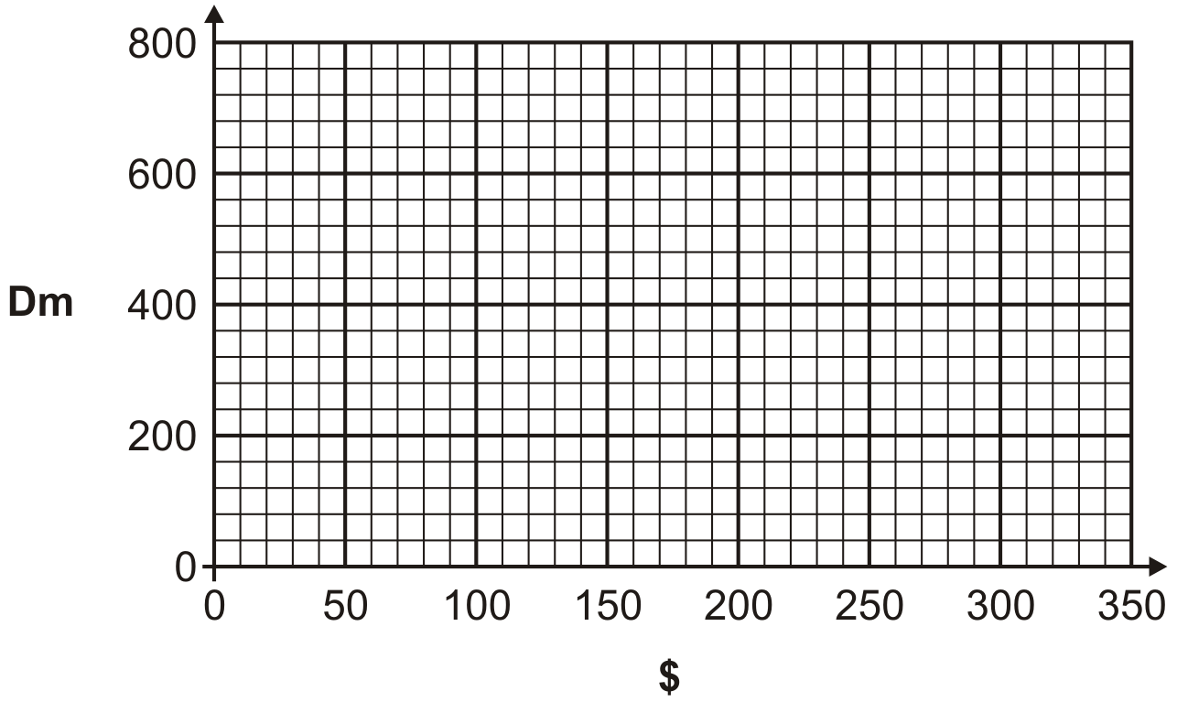
1 mark

Q2.

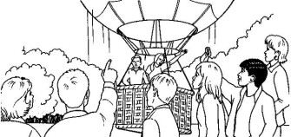
This graph shows the height of a balloon at different times.

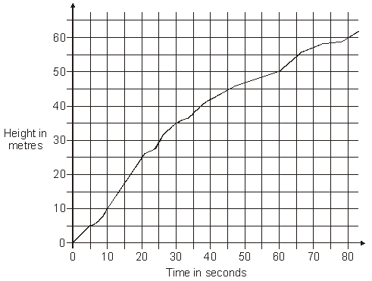

From the graph, find the height of the balloon at 50 seconds.

1 mark
Use the graph to find out how long it took the balloon to rise from 30 metres to 60 metres.
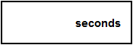
1 mark

Q3.
Jim draws a graph to show how high two rockets go during their flight.

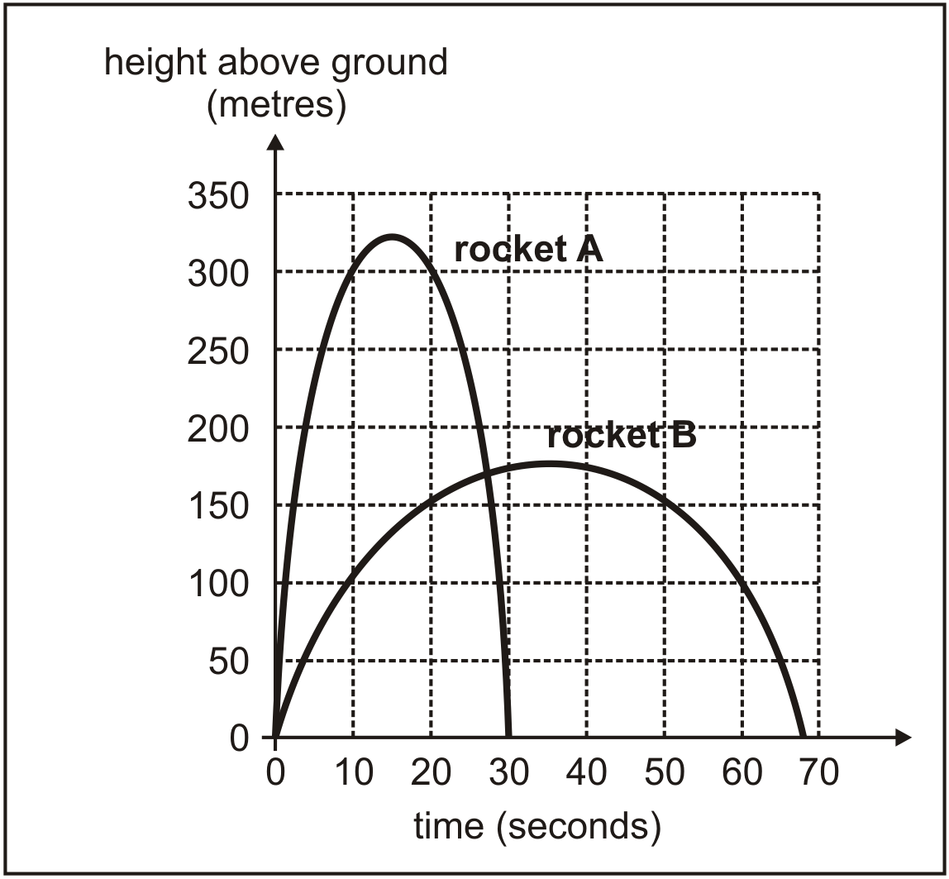
Estimate how much higher rocket A reaches than rocket B.
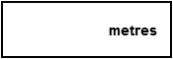
1 mark
Estimate the time after the start when the two rockets are at the same height.
Jim says,
"The graph shows that rocket A was more than 200 m above the ground for about 23 seconds."
Explain how the graph shows this.

1 mark

Q4.
Gavin was ill in March.

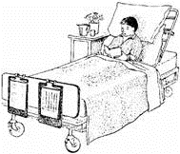 This is his temperature chart.

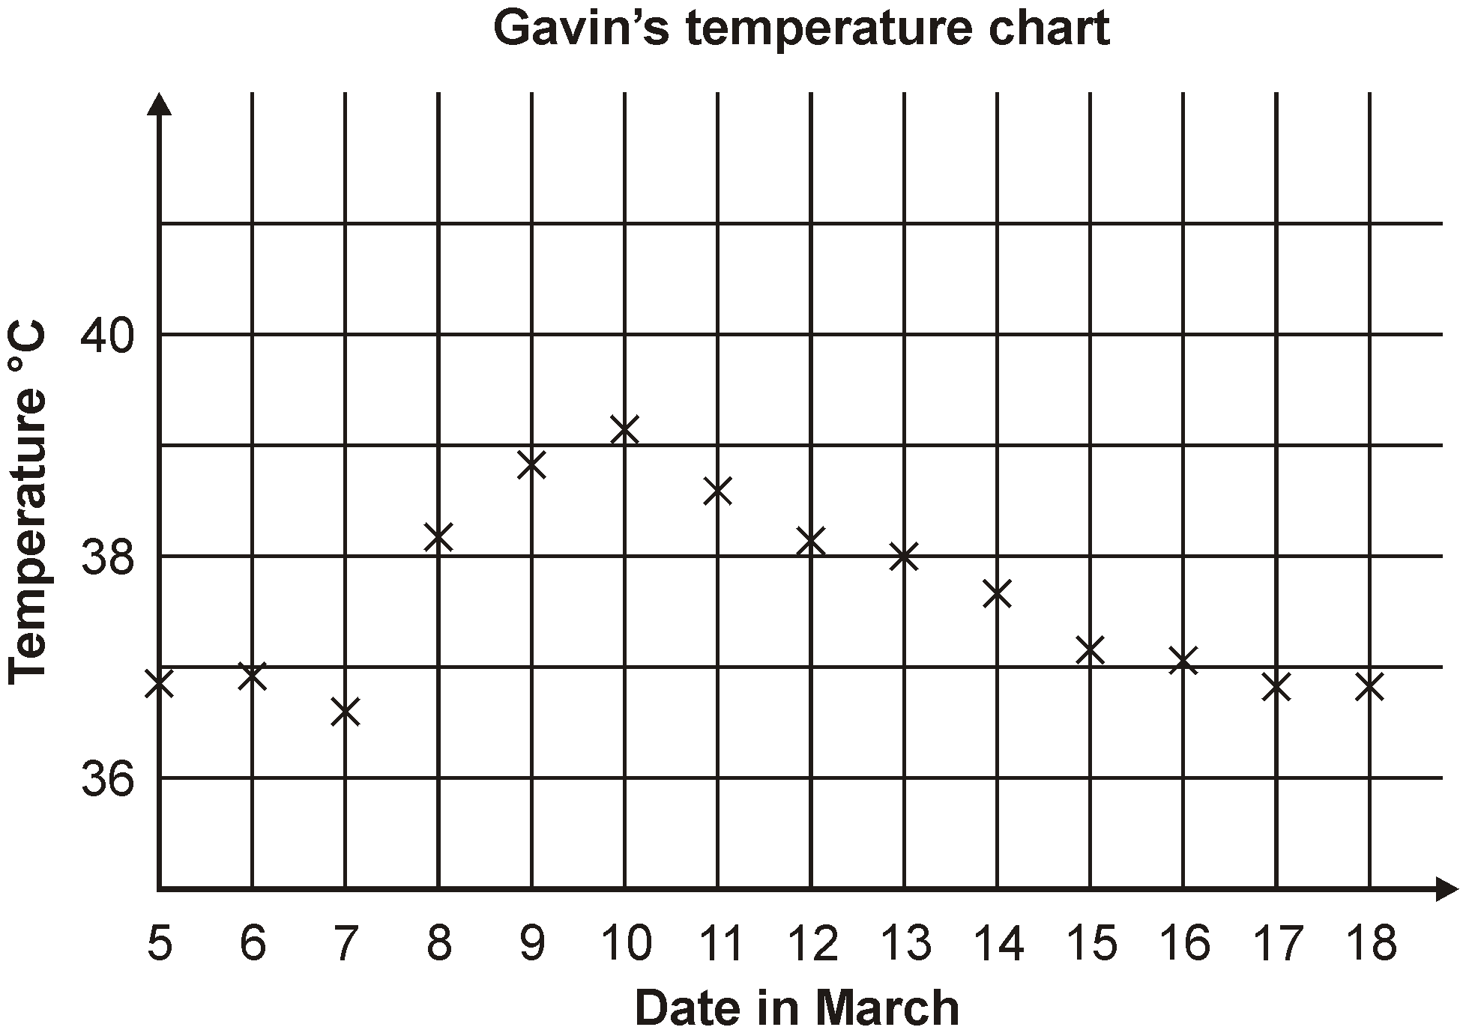
For how many days was his temperature marked as more than 37°C?

1 mark
Which date showed the largest change in temperature from the day before?
1 mark
Estimate Gavin’s highest temperature shown on the graph.
Give your answer to 1 decimal place.
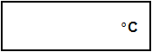
1 mark
Q5.
Kevin measures his height in inches and then in centimetres.
These are his measurements.

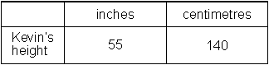
The cross on the grid shows Kevin’s height in inches and centimetres.
Draw a line on the grid to make a conversion graph for inches and centimetres.

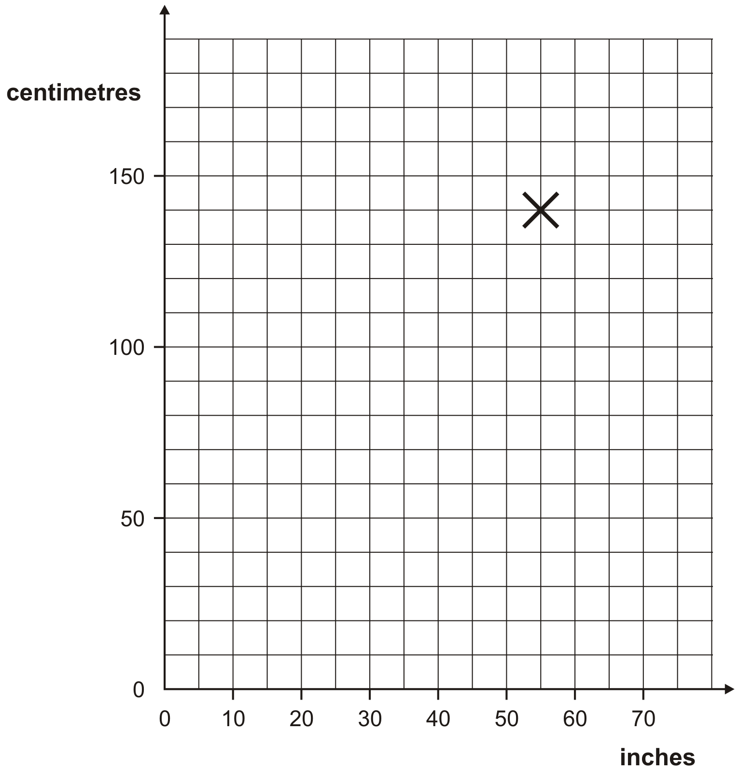
1 mark
Sally is 168cm tall.
Use the graph to estimate Sally’s height in inches.

1 mark

Q6.
Carol went on a 40-kilometre cycle ride.
This is a graph of how far she had gone at different times.

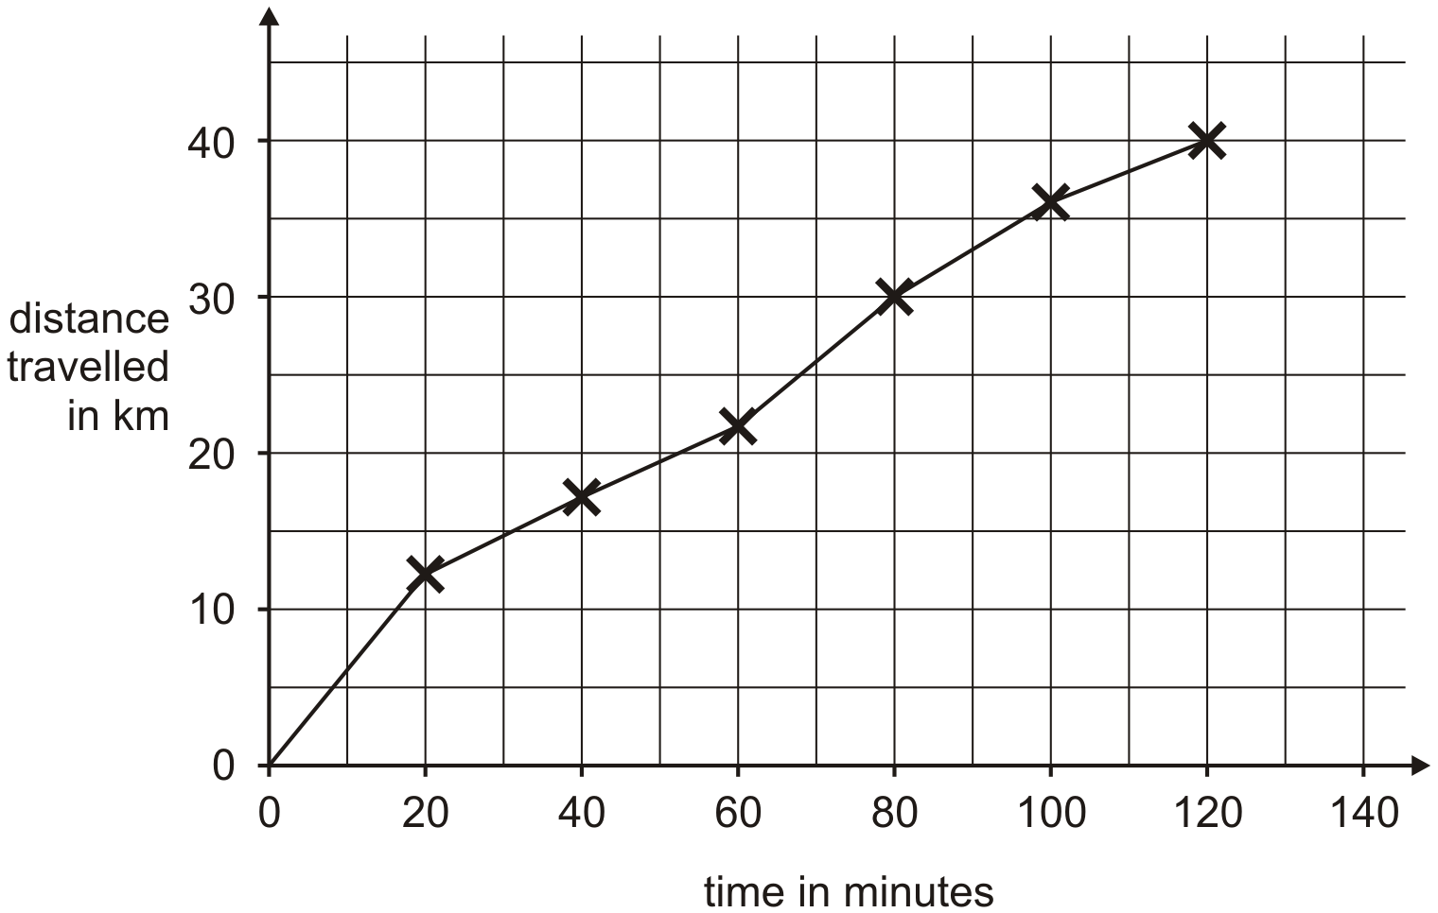
How many minutes did Carol take to travel the last 10 kilometres of the ride?

1 mark
Use the graph to estimate the distance travelled in the first 20 minutes of the ride.
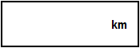
1 mark
Carol says,
'I travelled further in the first hour than in the second hour'.
Explain how the graph shows this.


1 mark

Q7.
Two telephone companies, Supertalk and Quickline, have different charges for long distance calls.
This graph shows the charges for different lengths of calls.

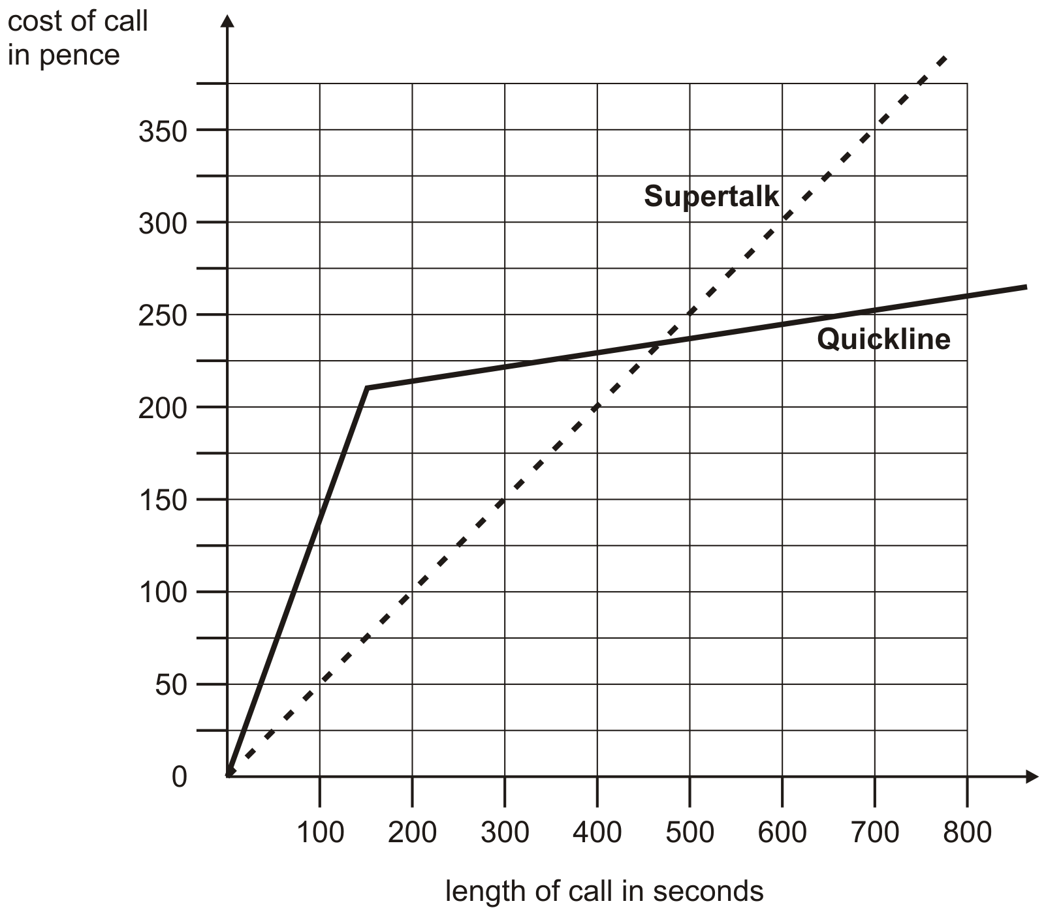

Estimate from the graph how many seconds longer a £2 call lasts with Supertalk compared to Quickline.
1 mark
Estimate from the graph the length of a call when Quickline becomes cheaper to use than Supertalk.
Give your answer to the nearest 10 seconds.
1 mark

Q8.
This is a graph of a firework rocket, showing its height at different times.

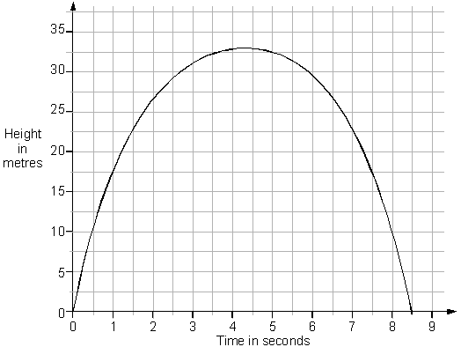

Estimate from the graph for how many seconds the rocket is more than 20 metres above the ground.
1 mark
Estimate from the graph how many metres the rocket falls in the last second of its flight.
1 mark

Q9.
A hot liquid is left to cool in a science experiment.
This graph shows how the temperature of the liquid changes as it cools.
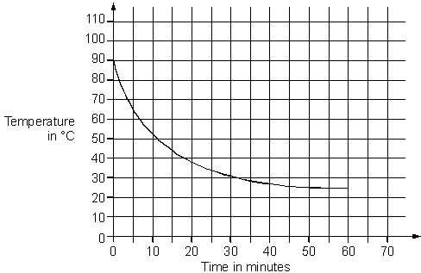

Read from the graph how many minutes it takes for the temperature to reach 40°C
1 mark
Read from the graph how many minutes the temperature is above 60°C
1 mark

Q10.
150 people take part in a walk.
This chart shows the number of people still walking at different times.

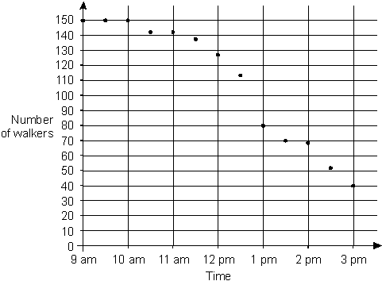

Use the chart to estimate the time when two-thirds of the people are still on the walk.
1 mark

What percentage of the people who started are still on the walk at 3pm?

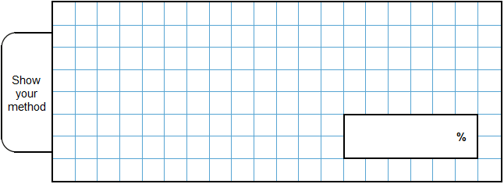
2 marks

Q11.
This graph shows how the weight of a baby changed over twelve months.

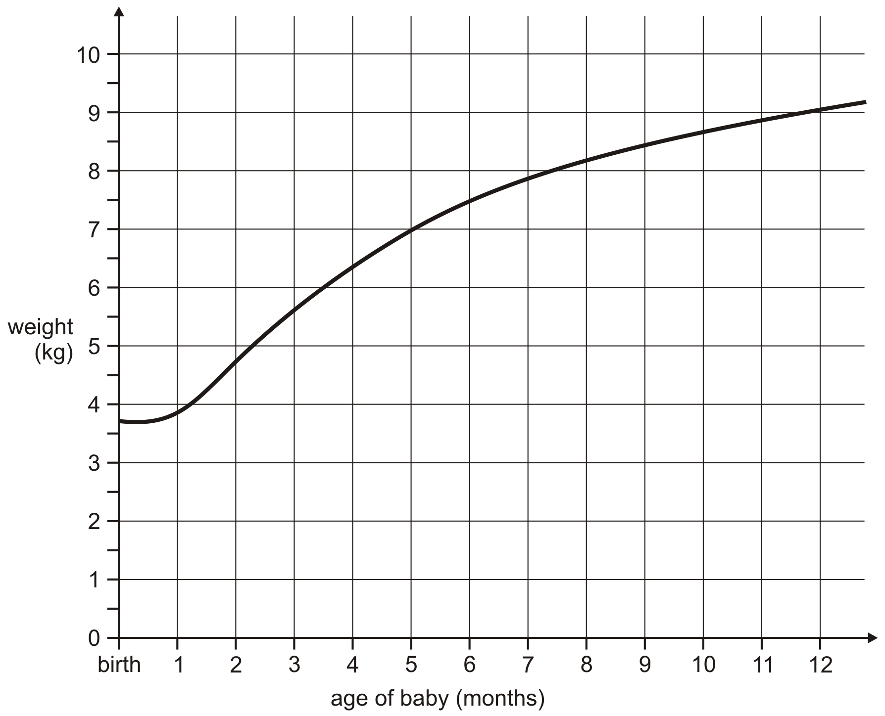

From the graph, what was the weight of the baby at 10 months?
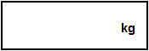
1 mark
How much more did the baby weigh at 5 months than at birth?
1 mark

Q12.
This graph shows the cost of phone calls in the daytime and in the evening.

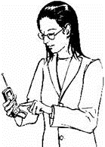
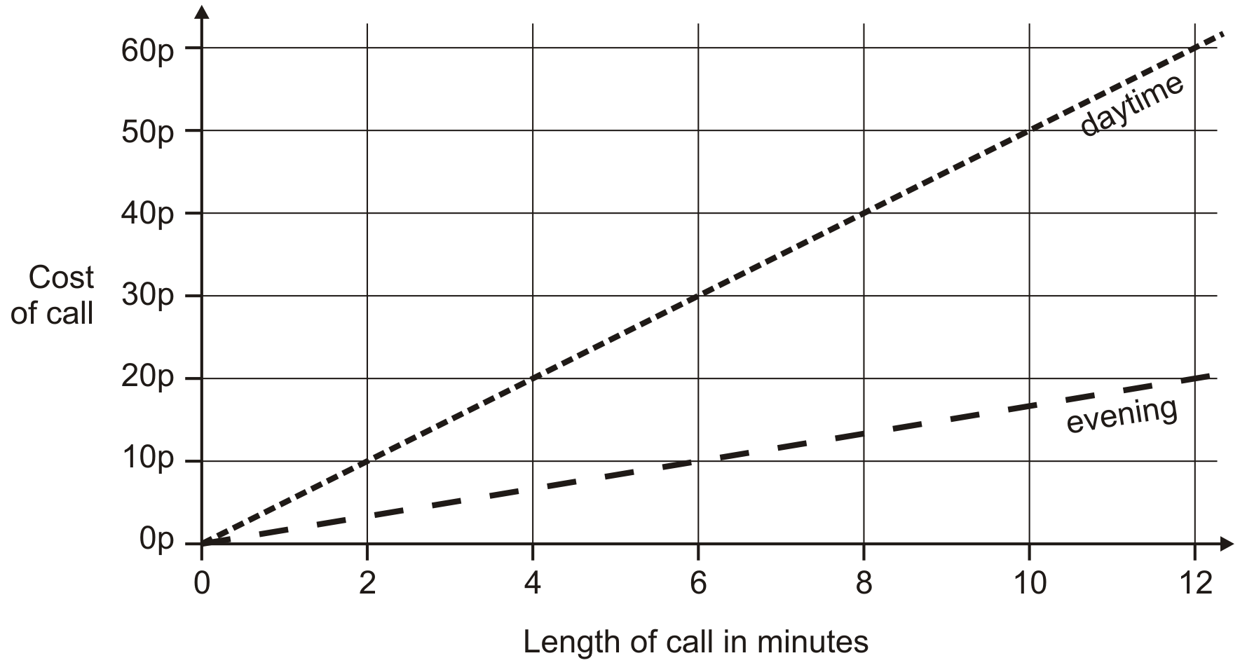

How much does it cost to make a 9 minute call in the daytime?

1 mark
How much more does it cost to make a 6 minute call in the daytime than in the evening?
1 mark

Q13.
The London Eye is a big wheel with pods to carry passengers.
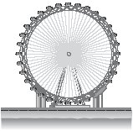
It takes 30 minutes for the wheel to make a complete turn.
This graph shows the height of a pod above the ground as the wheel turns.
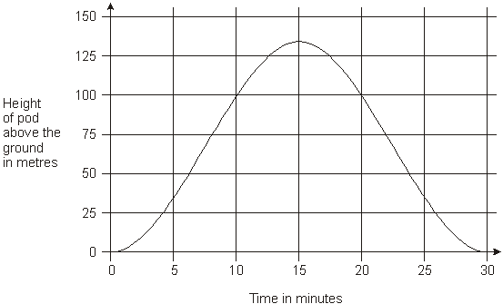
How long from the start does it take the pod to reach a height of 75 metres?
1 mark

How many metres above the ground is the pod at its highest point?
1 mark

Q14.
This graph shows the temperature in a greenhouse.

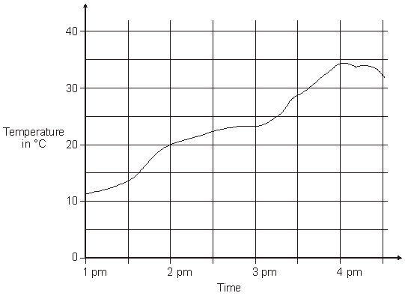

Use the graph to find the time when the temperature was 25°C.
1 mark

Use the graph to find the difference between the temperature at 2pm
and the temperature at 4pm.

1 mark

Q15.
This graph shows the outside temperature from 4pm to 10pm on a day in winter.

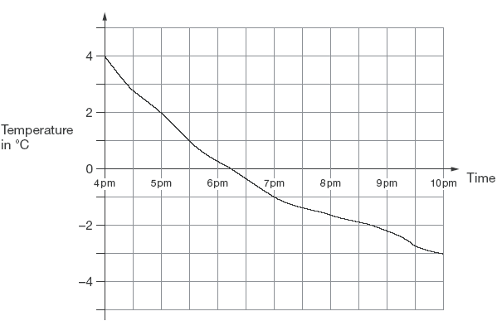

At what time was the temperature –2°C?
1 mark

How many degrees did the temperature drop from 5pm to 7pm?

1 mark

Q16.
This graph shows the number of people living in a town.

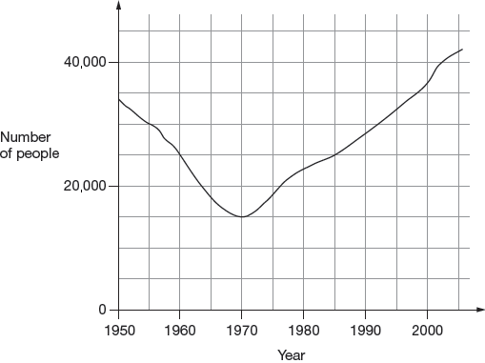
Look at the graph.
How many people lived in the town in 1985?
1 mark

In which year was the number of people the same as in 1950?
1 mark

Find the year when the number of people first went below 20,000
1 mark

Q17.
500 children started a 20 kilometre sponsored cycle ride.
This graph shows how far they cycled.

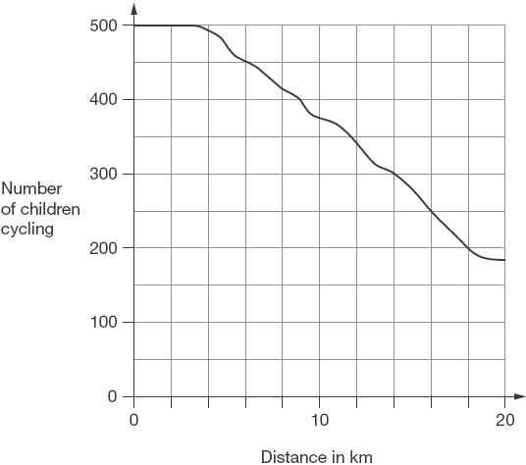
At what distance were exactly half of the children still cycling?
1 mark

Estimate how many children completed the 20 kilometre cycle ride.
1 mark

Q18.
This chart shows the population of Cornwall from 1950 to 2010.

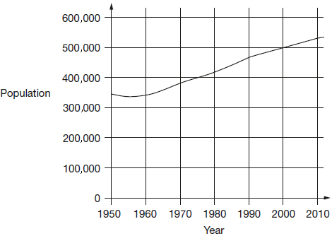
Look at the chart.
In which year did the population first reach 400,000?
1 mark

How much did the population increase from 1950 to 2000?
1 mark

What was the population of Cornwall in 2010?
1 mark

Q19.
Nik uses this graph to change between pounds (£), dollars and euros.

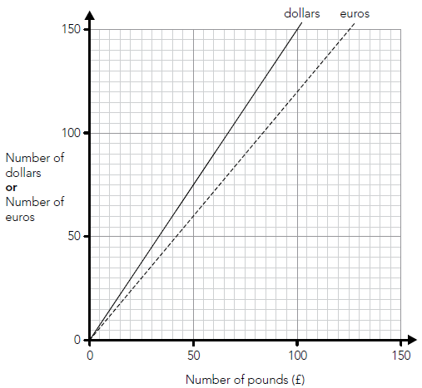

Use the graph to work out the missing numbers below.

The first one is done for you.

 | £70 | is about the same as | 84 euros
 | £70 | is about the same as | ________dollars
 | 120 dollars | is about the same as | £________
 | 120 euros | is about the same as | ________dollars

2 marks

Q20.
The graph shows the average heights of girls in the UK from age 6 – 11 years.

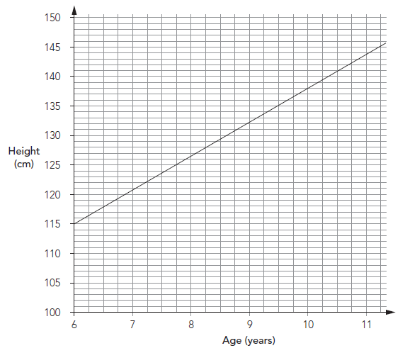
Emily is 1.38 m tall.
She is the average height for her age.
How old is she?
1 mark
Zoe is years old.
She is also 1.38 m tall.
How much taller than average is she?
Give your answer in centimetres.

1 mark

Q21.
How fast you can type accurately is called your typing speed.
The regions of the graph show information about different typing speeds.
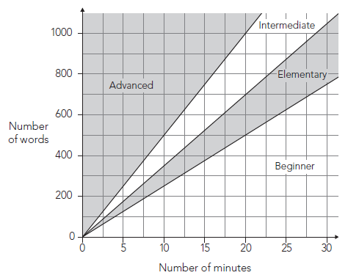
Darren’s level of typing is elementary.
In 20 minutes he should be able to type between 500 and 700 words.
Jo’s level of typing is intermediate.
How many words should she be able to type in 20 minutes?

Between ________________ and _________________
1 mark
Kath’s typing speed is 30 words per minute.
What level is Kath’s typing?

 |  | Advanced |  | Intermediate |  | Elementary |  | Beginner

Explain how you know.

1 mark

Q22.
Kirsty measured the length of her shadow every hour on one sunny day.
She plotted her results on this graph.

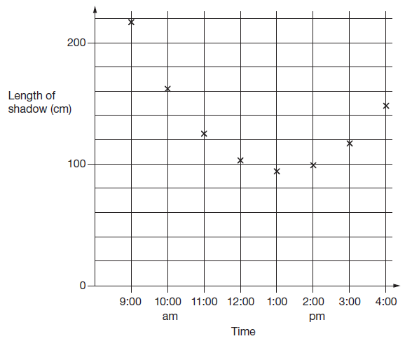
Look at the graph.
Estimate the length of Kirsty’s shadow at 3:30pm.
1 mark

Estimate a time when her shadow was 180 centimetres long.

1 mark

Q23.
This graph shows the distance Alfie and Chen walked in an afternoon. They started at 1:45pm and had two breaks.

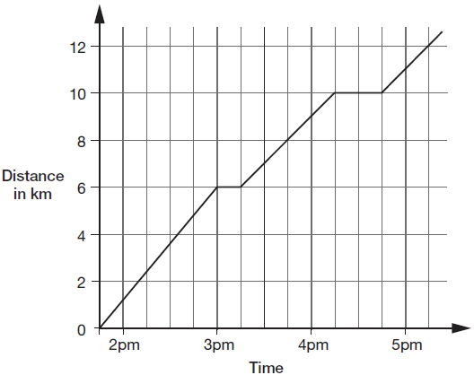

How many kilometres did they walk between the first and second breaks?
1 mark

At what time did Alfie and Chen start their second break?
1 mark

Q24.
Two companies sell toys online. They charge to deliver.
Describe the delivery cost of the second company.
The first company is done for you.
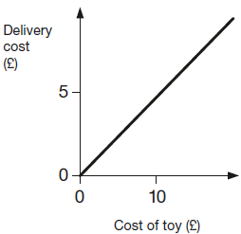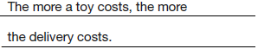
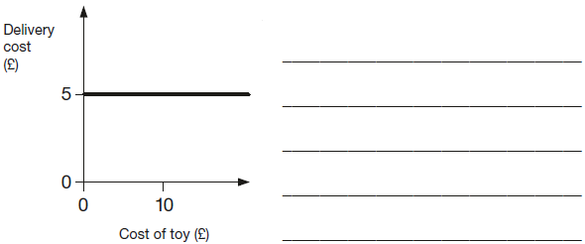
1 mark

Q25.
Alfie and his brother walked from home to their school.
Their school is 2 kilometres from home.
The graph shows information about Alfie’s journey.

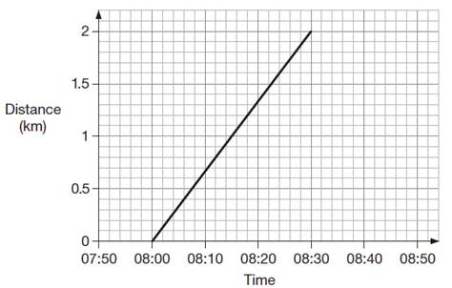

(a) How does the graph show that Alfie walked at a constant speed for all of his journey?
______________________________________________________________
1 mark

(b) Alfie’s brother left home 10 minutes before Alfie.
He arrived at school 20 minutes after Alfie.
He walked at a constant speed for all of his journey.
At what time did Alfie overtake his brother?
1 mark

Q26.
This graph shows how the temperature changed in Liam’s room one afternoon.

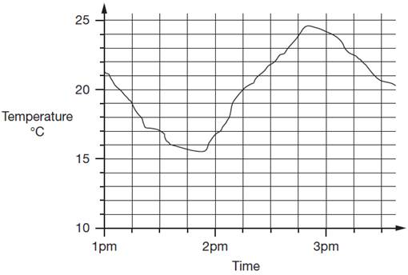
Estimate the temperature at 3:15pm.
1 mark

Estimate the time when the temperature was highest.
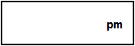
1 mark
How much did the temperature change from 2pm to 2:30pm? Give your answer to the nearest degree.
1 mark

M1. (a) Number of DM in the range 630 to 670, inclusive.
1
(b) Number of $ in the range 270 to 280, inclusive.
1

(c) Correct drawing of line through origin and point plotted according to
answers given in (a) and (b), eg:
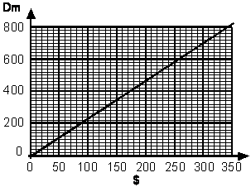
To be awarded the mark, the point must be correctly plotted (within range described below) AND the line must pass through both the origin and the point. The point must be plotted within ± 20DM and ± $10 of the answers given in (a) and (b)
1
[3]

M2. (a) Answer in the range 46 m to 47 m inclusive
1
(b) 55
1
[2]

M3. (a) Any answer in the range 145m to 175m inclusive.
1
(b) A time in the range 27 to 29 seconds inclusive.
1

(c) Evidence of awareness that the time interval between the points where the
200m line cuts the graph for rocket A has been used, eg:
• “He could have checked when the rocket went above 200m and when it went under 200m and worked out the time between.”
• “Look how high it goes until it gets to 200m then look along the horizontal line until it drops below 200m.”
An appropriate drawing on the graph, identifying the
intersection of the 200m line with the curve is acceptable a
part of explanation, eg, award mark for:
• “Subtract the two dots” if dots are marked indicatin
correct intersections.
Do not accept vague statements or ones which only repea
information, eg:
• “You can draw the graph then draw the things then work it out.”
• “Because on the graph the rocket is above 200m for 23
seconds.”
1
[3]

M4. (a) 9
1
(b) 8th of March
Accept 8
Accept ‘7th – 8th’ or similar.
Do not accept 7th.
1

(c) 39.1 OR 39.2
1
[3]

M5. (a) Straight line drawn on the graph from the origin to the given point or beyond.

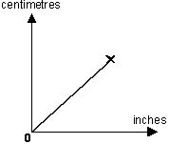
The line drawn must be straight AND connect the given point
with the origin.
Accept a straight line which misses the given point and/or the
origin by up to 1 mm.
1

(b) Answer in the range of 65 to 67 inclusive OR answer consistent with the line
drawn on graph in 2a.
Accept answers apparently based upon calculation, provided
the answer lies within the given range.
1
[2]

M6. (a) 40
1
(b) Answer in the range 12 to 13km inclusive.
1
(c) An explanation which indicates that after 1 hour she has travelled more
than 20km and/or she has travelled less than 20km in the second hour, eg
• ‘She did about 40 km and it was about 22 in the first hour’;
• ‘Half and half would be 20-20, but she does more than 20 then less than 20’;
• ‘It goes to 23 in the first hour’.
Do not accept vague or arbitrary explanations, eg
• ‘She got tired in the second half’;
• ‘It’s marked on the graph’;
• ‘There’s more crosses in the first hour than the second’;
• ‘The gaps are further apart’.
1
[3]

M7. (a) Answer in the range 250 to 270 inclusive.
1
(b) Answer in the range 460 to 480 inclusive.
1
[2]

M8. (a) Answer in the range 5.9 to 6.2 seconds inclusive.
1
(b) Answer in the range 17.5 m to 18.5 m inclusive.
1
[2]

M9. (a) Answer in the range 18 minutes to19 minutes inclusive.
1
(b) Answer in the range 6 minutes to 7½ minutes inclusive.
1
[2]

M10. (a) Answer in the range 12:30pm to 1:00pm exclusive.
Accept answers with or without ‘pm’.
1

(b) Award TWO marks for the correct answer of 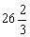% OR 26.6%
Accept 26.6% OR 26.7% OR 26.6 ... % OR 27%
Accept for ONE mark 26%
If the answer is incorrect, award ONE mark for evidence of an
appropriate method, eg
40 ÷ 150 × 100
Answer need not be obtained for the award of the mark.
Up to 2
[3]

M11. (a) Any value in the range 8.6 to 8.8 inclusive.
1
(b) Any value in the range 3.2 to 3.4 inclusive.
1
[2]

M12. (a) Answer in the range 44p to 46p inclusive.
1
(b) 20p
Accept £0.20p OR £0 20
Do not accept 0.20p OR £20p
1
[2]

M13. (a) Answer in the range 7.5 minutes to 9 minutes exclusive.
Accept an answer in the range 21 minutes to 22.5 minutes exclusive.
1
(b) Answer in the range 130m to 140m inclusive.
1
[2]

M14. (a) Answer in the range 3:10pm to 3:20pm inclusive.
1
(b) Answer in the range 13 degrees to 14 degrees inclusive.
The answer is a specific time (see page 5 for guidance).
1
[2]

M15. (a) Answer in the range of 8:40pm to 8:50pm inclusive
The answer is a specific time
1

(b) 3
Do not accept –3
1

M16. (a) 25000
Accept answers in the range 24500 to 25500 inclusive.
1
(b) 1996 OR 1997 OR 1998
1
(c) 1963 OR 1964
1
[3]

M17. (a) 16
1

(b) A whole number in the range 180 to 190 inclusive
1
[2]

M18.(a) 1974 OR 1975 OR 1976
1
(b) A whole number answer in the range 130 000 to 180 000 inclusive.
1
(c) A whole number answer in the range 510 000 to 550 000 exclusive.
Do not accept 510 000 OR 550 000
1
[3]

M19. 105 ± 1
then
80 ± 1
1
150 ± 1
1
U1
[2]

M20. (a) 10 years old
1
(b) 3 cm
Accept answers in the range of 2.9 – 3.1 inclusive
! Change of unit, eg 0.03 m
Condone, provided cm is replaced by m
1
[2]

M21. (a) Gives both correct values, ie
700 (or 701) and 1000 (or 999)
(in either order)
1

(b) Indicates Elementary and gives a correct explanation that places the speed clearly within the correct section on the graph, eg:
• 30 words in one minute is 300 words in ten minutes
• 30 wpm = 900 words in 30 minutes
• Darren is between 25 and 35 words per minute so she is the same as Darren
Accept minimally acceptable explanation, eg:
• 300 every 10
• Point equivalent to 30 words per minute (eg 300 words in 10 minutes) clearly indicated on the graph
• 25-35, same as Darren
• 20 × 30 = 600

! Small number of minutes used, where regions are closer together
Accept points equivalent to 30 words per minute where the number of minutes is 2.5 or greater
eg, accept
• 30 words in one minute is 75 words in minutes
eg, do not accept
• I looked at 1 minute on the graph and found where 30 words is on the graph

Do not accept incomplete explanation, eg:
• I read up from 10 minutes
• Between 25 and 30 words per minute
• Same as Darren
1
U1
[2]

M22. (a) Answer in the range 125 cm inclusive to 140 cm exclusive
Do not accept 140 cm.
1
(b) Answer in the range 9:30 am to 9:50 am inclusive
Accept an answer in the range 4:30pm to 4:50pm inclusive.
1
[2]

M23.(a) 4 km
1
(b) 4:15pm
The answer is a specific time
1
[2]

M24.Gives a correct description that indicates the delivery cost is constant, eg:
• The delivery cost is always £5
• The cost is always £5 no matter how much the toy costs
• Delivery stays the same as the cost of toy increases
Accept minimally acceptable explanation, eg:
• It is £5
Accept omission of the actual delivery cost, eg:
• It always costs the same
• The cost is the same
• The cost of the toy does not affect the delivery cost
! Condone correct response with the pound sign omitted, eg:
• It is always 5
! Condone explanations which refer to toys costing up to £20
Do not accept incomplete or ambiguous explanation, eg:
• They are equal amounts
[1]

M25.Gives a correct interpretation of the graph, eg:
• It is a straight line
• It goes up steadily
• The angle of the line stays the same

• The gradient of the line is constant
Accept minimally acceptable explanation, eg:
• It is straight
• It doesn’t bend
• It is a diagonal

Do not accept incomplete or ambiguous explanations that do not sufficiently imply a constant speed and /
or do not demonstrate the relationship holds for the
entire graph, eg:
• The line goes straight up
• It is not wobbly
• It is level
• Every 5 mins he walks the same distance
• He walks 1km in the first 15 mins and 1km in the second 15 mins

! Values read from graph
Accept, provided it is clear the relationship holds for the entire graph.
Values should be accurate within +/− 0.1km and /
or +/− 2 minutes, eg:
• 0.7km every 10 minutes
• Every 7.5 minutes he walks about half a km

! Calculation of kilometres per hour
Accept values in the range 3.7 to 4.3km per hour inclusive.
1

(b) 08:10
! Accept values between 08:09 and 08:11 inclusive
! Time
1
[2]

M26.(a) Accept answers in the range 22.2 to 22.8 exclusive.
Do not accept 22.2 or 22.8
1
(b) Accept answers in the range 2:48pm to 2:52pm inclusive.
The answer is a specific time.
1
(c) 5
1
[3]

