Missing Coordinates
Q1.
The diagram shows three identical shaded triangles on coordinate axes.

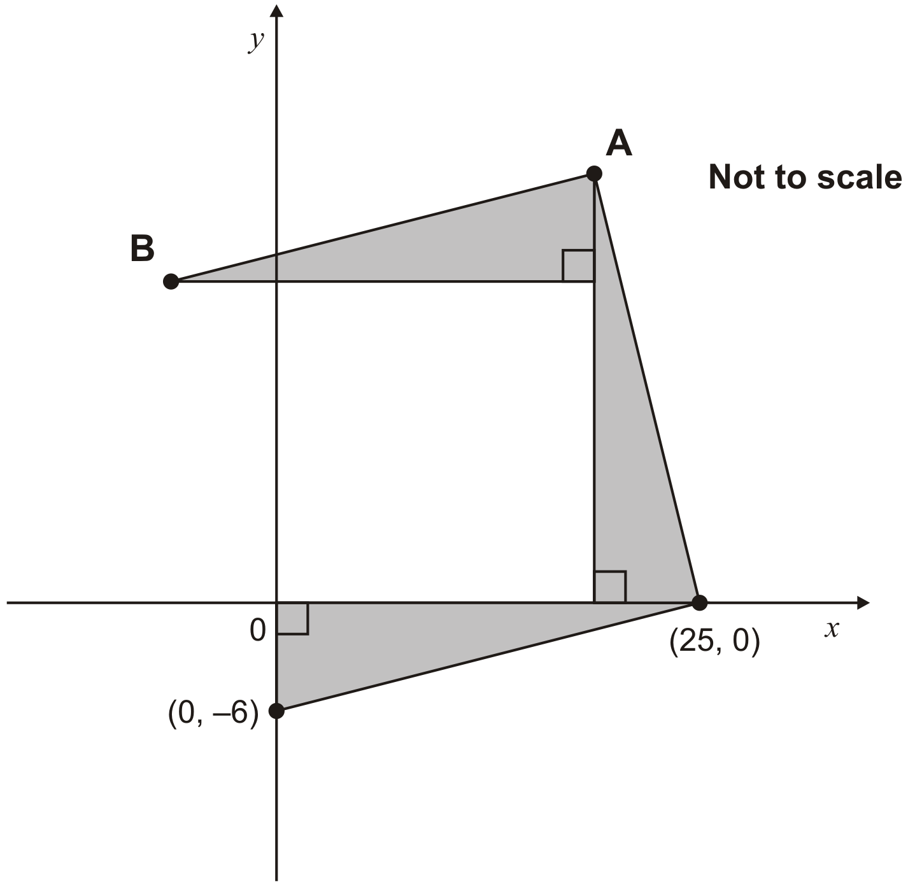
What are the coordinates of A and B?
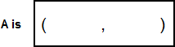
1 mark
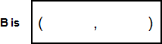
1 mark

Q2.
The diagram shows two identical squares.

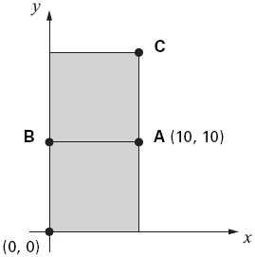

A is the point (10, 10)
What are the coordinates of B and C?
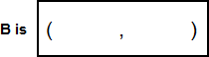
1 mark
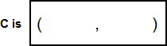
1 mark

Q3.
ABCD is a rectangle drawn on coordinate axes.
The sides of the rectangle are parallel to the axes.

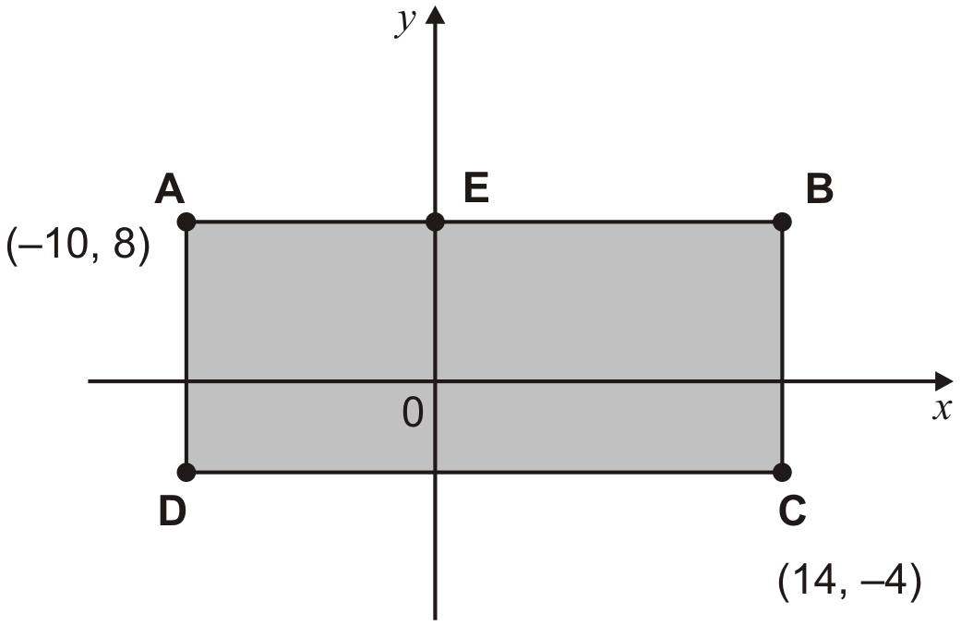

What are the coordinates of D and E?
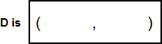
1 mark
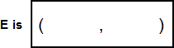
1 mark

Q4.
A and B are joined by a straight line on coordinate axes.

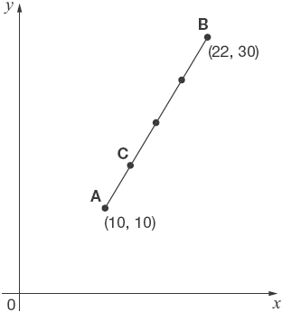
The dots on the line are equally spaced.
What are the coordinates of C?
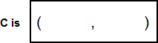
2 marks

Q5.
Here is a line on coordinate axes.
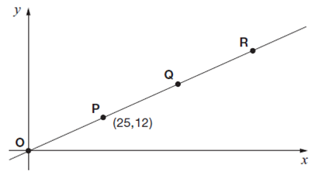
Points O, P, Q and R are equally spaced.
The coordinates of P are (25,12).
What are the coordinates of R?
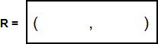
1 mark

Q6.
Here are two triangles drawn on coordinate axes.
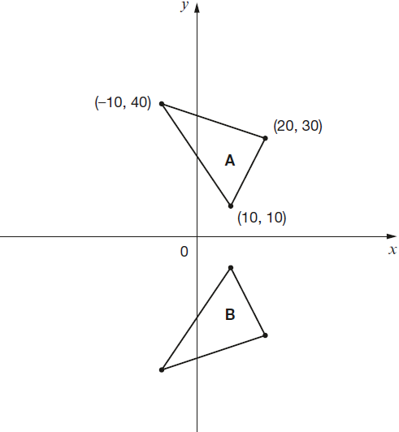
Triangle B is a reflection of triangle A in the x-axis.
Two of the new vertices of triangle B are (10, −10) and (20, −30).
What are the coordinates of the third vertex of triangle B?
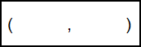
1 mark

Q7.
Alfie places three cubes on a coordinate grid.
The base of his shape is a rectangle.
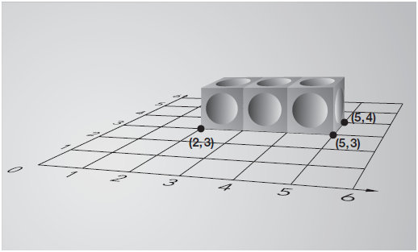
Complete this sentence:
The four vertices of the rectangle are

(2, 3), (5, 3), (5, 4) and

1 mark

Q8.
Here is a square on coordinate axes.
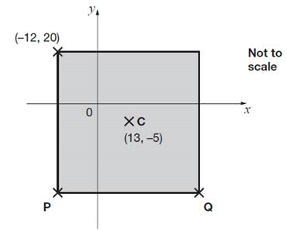

C is the centre of the square.
Find the coordinates of P and Q.
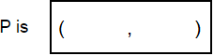
1 mark
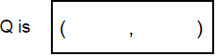
1 mark

Q9.
This diagram shows two identical rectangles on coordinate axes.
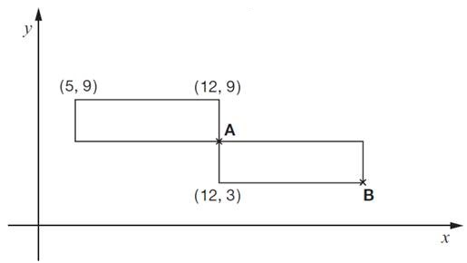
Write the coordinates of point A and point B.
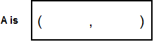
1 mark
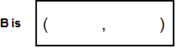
1 mark

Q10.
Here are two identical shaded triangles on coordinate axes.

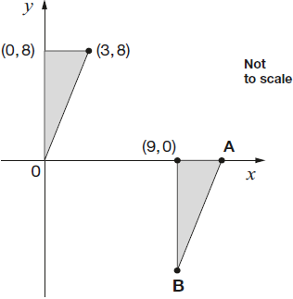
Write the coordinates of points A and B.

A =
B =

2 marks

Q11.
In this diagram R is an equal distance from P and Q.

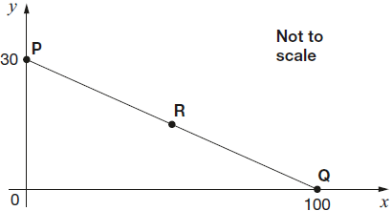
What are the coordinates of R?
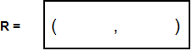
1 mark

M1.(a) (19, 25)
! Coordinates
1

(b) (–6, 19)
! Gives values for A and B transposed
Award 1m for part (b) only, ie:
• A is (–6, 19) and B is (19, 25)
1
[2]

M2. (a) (0, 10)
Coordinates must be written in the correct order.
Accept unambiguous answers written on the diagram.
1
(b) (10, 20)
If the answer for 15a is (10, 0) AND the answer to 15b is
(20, 10), award ONE mark only, in the 15b box.
1
[2]

M3. (a) (–10, –4)
Coordinates must be written in the correct order.
1
(b) (0, 8)
Accept unambiguous answers written on the diagram.
Award ONE mark if the answer to (a) is (0, 8)
AND the answer to b is (–10, –4).
1
[2]

M4. (a) 13 for the x coordinate
Accept unambiguous answers written on the diagram.
U1

(b) 15 for the y coordinate
Accept unambiguous answers written on the diagram.
1
If the answer to (a) is 15 AND the answer to (b) is 13, then award ONE mark for (b).
[2]

M5. ( 75, 36 )
Accept unambiguous answers written on the diagram.
[1]

M6.
(–10, –40)
[1]

M7.(2, 4)
[1]
Question Requirement Mark Additional guidance

M8.(a) P is (−12, −30)
! Coordinates
Accept unambiguous answers written on the diagram
1

(b) Q is (38, −30)
! Answers for P and Q transposed
Award 1 mark for Q only, ie:
• P is (38, –30)
Q is (–12, –30)
! Answer for Q correctly follows through from an incorrect answer for P
Award 1m for Q for follow-through from P as
(‘their x’ + 50, ‘their y’)
1
[2]

M9.(a) A is (12, 6)
1
(b) B is (19, 3)
1
Coordinates must be given in the correct order.
If the answer to (a) is (19, 3) AND the answer to
(b) is (12, 6) then award ONE mark for (b)
Accept unambiguous answers written on the diagram.
[2]

M10.(a) (12, 0)
Accept unambiguous answers written on the diagram.
1
(b) (9, –8)
If the answer to (a) is (9, –8) AND the answer to
(b) is (12, 0) then award ONE mark for (b).
1
[2]

M11.(50, 15)
[1]

