Money word problems
Q1.
A shop sells fruit.
Chen buys 2 apples and 3 bananas.  He pays £2.35 | 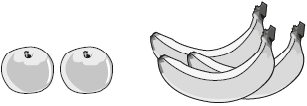

Megan buys 2 apples and 1 banana.  She pays £1.25 | 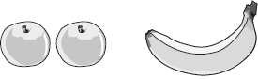

How much does one banana cost?

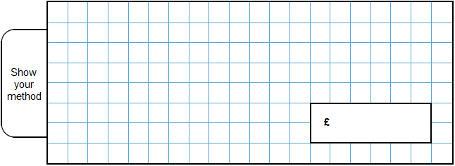
2 marks
Q2.
 | Alfie buys two books, each at the same price.  He pays with a £10 note and gets £2.30 change. | 
What is the cost of one book?

2 marks

Q3.
These are some prices in a fish and chip shop.

 | Fish £2.30 | Peas 35p
 | Sausage £1.80 | Curry sauce 40p
 | Chips (small bag) 60p | Bread roll 30p
 | Chips (large bag) 90p | Pickled onion 28p

Alfie buys one fish, a large bag of chips and a pickled onion.
How much does he pay?
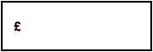
1 mark
Megan buys a sausage and a bread roll.
Chen buys a small bag of chips and a curry sauce.
How much more does Megan pay than Chen?

2 marks

Q4.
A shop sells pairs of socks.
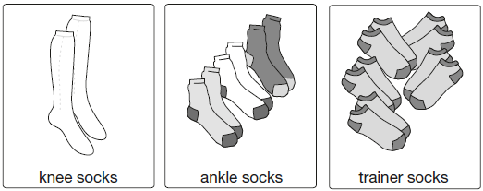
1 pair for £5.45 3 pairs for £7.50 5 pairs for £8. 50

Kirsty buys 1 pair of knee socks and 3 pairs of ankle socks.
She pays with a £20 note.
How much change does she get?

2 marks
Amy spends £25.50 on trainer socks.
How many pairs of trainer socks does she get?
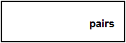
1 mark

Q5.
 | 6 pencils cost £1.68 | 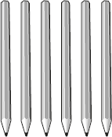
 | 3 pencils and 1 rubber cost £1.09 | 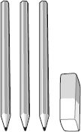

What is the cost of 1 rubber?
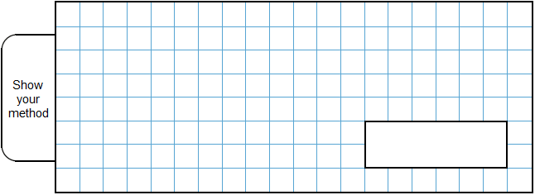
2 marks

Q6.
A bag of 5 lemons costs £1
A bag of 4 oranges costs £1.80
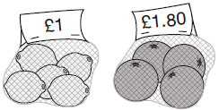
How much more does one orange cost than one lemon?

2 marks
﻿

Q7.
Miss Mills is making jam to sell at the school fair.
Strawberries cost £7.50 per kg.
Sugar costs 79p per kg.
10 glass jars cost £6.90
She uses 12 kg of strawberries and 10 kg of sugar to make 20 jars full of jam.
Calculate the total cost to make 20 jars full of jam.
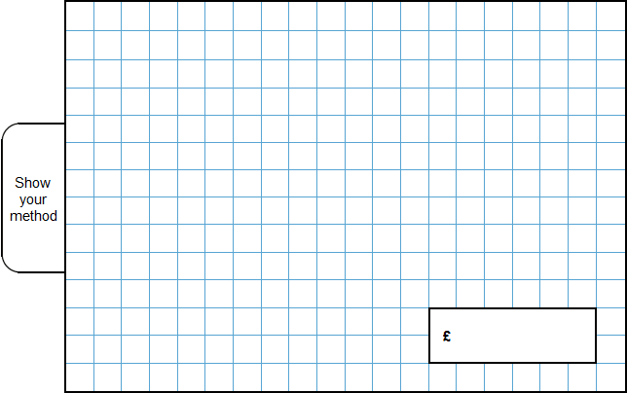
3 marks
Q8.
Lara had some money.
She spent £1.25 on a drink.
She spent £1.60 on a sandwich.
She has three-quarters of her money left.
How much money did Lara have to start with?
2 marks
Q9.
Olivia buys three packets of nuts.

She pays with a £2 coin.
This is her change.
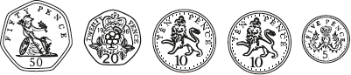
What is the cost of one packet of nuts?
2 marks

M1.Award TWO marks for the correct answer of 55p OR £0.55
If the answer is incorrect, award ONE mark for evidence of appropriate working, eg
■ £2.35 – £1.25 = £1.10
£1.10 ÷ 2 = wrong answer
Accept for ONE mark £55 OR £55p OR 0.55p as evidence of appropriate working.
Working must be carried through to reach an answer for the award of ONE mark.
Up to 2
U1
[2]

M2.Award TWO marks for the correct answer of £3.85
If the answer is incorrect, award ONE mark for evidence of appropriate working, eg
£10 – £2.30 = £7.70
£7.70 ÷ 2 = wrong answer
Working must be carried through to reach an
answer for the award of ONE mark.
Up to 2
[2]

M3.(a) £3.48
1
(b) Award TWO marks for the correct answer of £1.10
If the answer is incorrect, award ONE mark for evidence
of appropriate working, eg:
■ £1.80 + 30p = £2.10
60p + 40p = £1.00
£2.10 – £1.00 = wrong answer
Accept for ONE mark £110 OR £110p as evidence of appropriate working.
Working must be carried through to reach an answer for the award of ONE mark.
Up to 2
[3]

M4.(a) Award TWO marks for the correct answer of £7.05
If the answer is incorrect, award ONE mark for evidence of appropriate working, eg:
■ £20 - £5.45 - £7.50 = wrong answer

OR
■ £5.45 + £7.50 = £12.95
£20 - £12.95 = wrong answer
Accept for ONE mark £705 OR £705p as evidence of appropriate working.
Working must be carried through to reach an answer for the award of ONE mark.
Up to 2
(b) 15
1
[3]

M5.
Award TWO marks for the correct answer of 25p.
If the answer is incorrect, award ONE mark for evidence of an appropriate method, e.g.
• 168 ÷ 2 = 84
109 – 84
OR
• 168 ÷ 6 = 28
3 × 28 = 84
109 – 84
Accept for TWO marks, an answer given in the acceptable notation.
Answer need not be obtained for the award of ONE mark.
Accept for ONE mark an answer of 0.25p OR £25p OR £25 as evidence of an appropriate method.
Up to 2m
[2]

M6.Award TWO marks for the correct answer of 25p or £0.25.
If the answer is incorrect, award ONE mark for evidence of an appropriate method, e.g:
• Lemons £1 ÷ 5 = 20p each
Oranges £1.80 ÷ 4 = 45p each
45p – 20p
Answer need not be obtained for the award of ONE mark.
Up to 2
[2]

M7.
Award THREE marks for the correct answer of £111.70.
If the answer is incorrect, award TWO marks for:
• sight of £90 AND £7.90 AND £13.80 as all multiplication steps completed correctly.
Accept for TWO marks, sight of 9,000p AND 790p AND 1,380p as all multiplication steps completed correctly.
OR
evidence of an appropriate complete method with no more than one arithmetic error, e.g.
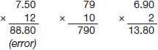
88.80 + 7.90 + 13.80 = 110.50
Award ONE mark for evidence of an appropriate complete method.
Answer need not be obtained for the award of ONE mark.
A misread of a number may affect the award of marks. No marks are awarded if there is more than one misread or if the mathematics is simplified.
TWO marks will be awarded if an appropriate complete method with the misread number is followed through correctly.
ONE mark will be awarded for:
• all multiplication steps completed correctly with the misread number.
OR
• evidence of an appropriate complete method with the misread number followed through correctly with no more than one arithmetic error.
Up to 3m
[3]

M8.
Award TWO marks for the correct answer of £11.40.
If the answer is incorrect, award ONE mark for evidence of an appropriate method, e.g.
• £1.25 + £1.60 = £2.85
£2.85 × 4
Accept for ONE mark an answer of £1,140 OR £1,140p OR £11.4 as evidence of an appropriate method.
Answer need not be obtained for the award of ONE mark.
Up to 2m
[2]

M9.
Award TWO marks for the correct answer of 35p OR £0.35.
If the answer is incorrect, award ONE mark for evidence of an appropriate method, e.g.
• 50p + 20p + 10p + 10p + 5p = 95p
£2.00 − 95p = £1.05
£1.05 ÷ 3
Accept for ONE mark an answer of £35 OR £35p OR 0.35p as evidence of an appropriate method.
Answer need not be obtained for the award of ONE mark.
Up to 2m
[2]

