Fractions of shapes and ordering fractions
Q1.
These diagrams are all made of squares.
Look at each diagram.
Put a tick (✔) if exactly of it is shaded. Put a cross (✘) if it is not.

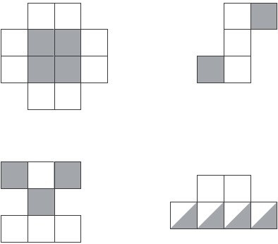
2 marks
Q2.
The diagram shows three regular octagons joined together.
There is a dot at the centre of each octagon.

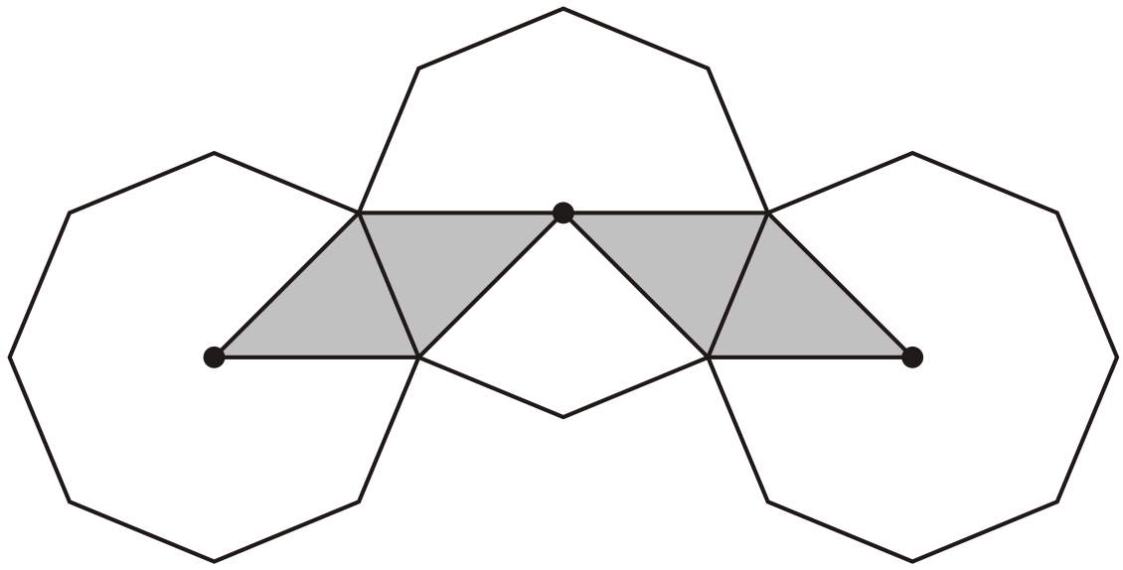
What fraction of the diagram is shaded?
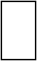
1 mark

Q3.
Here are five diagrams.
Look at each one.
Put a tick (✔) on the diagram if exactly half of it is shaded.
Put a cross (✘) if it is not.

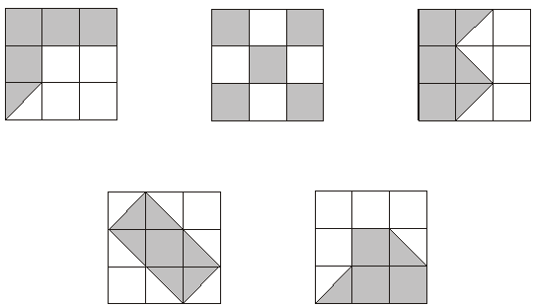
2 marks
Q4.
of this square is shaded.

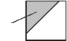
The same square is used in the diagrams below.
What fraction of this diagram is shaded?
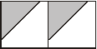
1 mark
What fraction of this diagram is shaded?
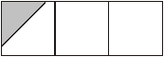
1 mark

Q5.
This diagram shows a shaded rectangle surrounded by squares.

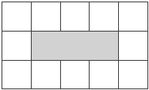
What fraction of the diagram is shaded?
1 mark
Q6.
A fraction of each shape is shaded.
Match each fraction to the correct place on the number line.
One has been done for you.

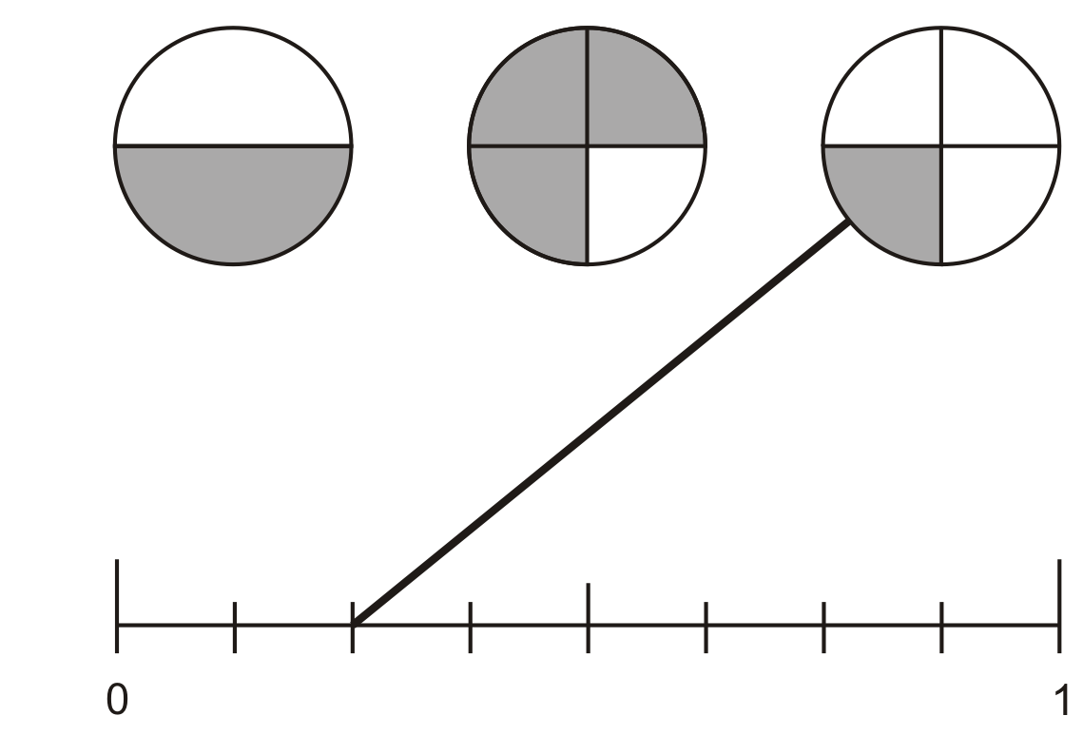
1 mark

Q7.
Write the missing fraction.

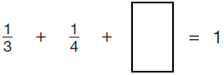
1 mark

Q8.
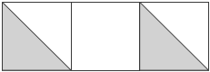
Holly says,
‘One-third of this shape is shaded’.
Is Holly correct?
Circle Yes or No. Yes / No
Explain how you know.
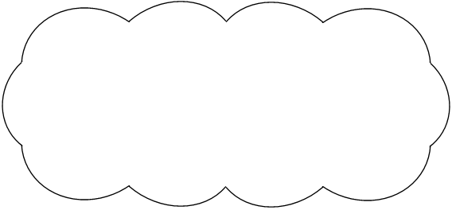
1 mark

Q9.
Is greater than ? Circle Yes or No.
Yes / No Show how you know.

1 mark

Is half of ? Circle Yes or No.
Yes / No
Show how you know.

1 mark
Q10.
Here are three shapes made from regular hexagons.
Write the fraction of each shape that is shaded.
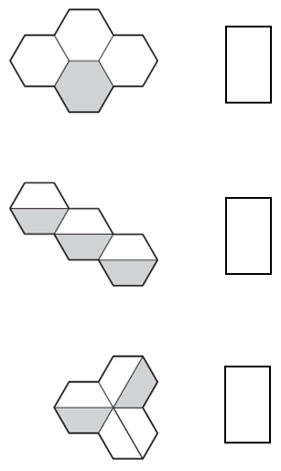
2 marks

Q11.
Shade of this shape.

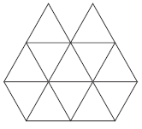
1 mark

Q12.
Tick (✔) each shape that is exactly shaded.

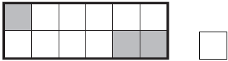

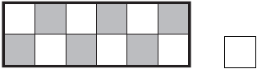

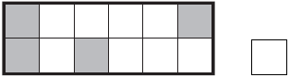

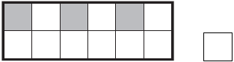
1 mark

Q13.
Each of these diagrams is divided into equal parts.
Some of the parts are shaded.

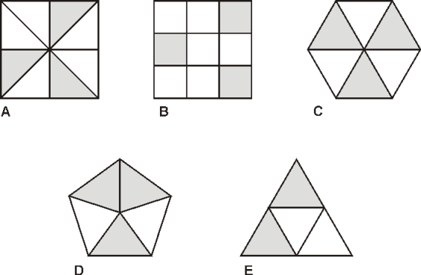
Write the letters of all the diagrams that have exactly shaded.
_________________________
1 mark
Which of the diagrams has exactly shaded?
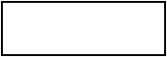
1 mark
Q14.
Shade of this shape.

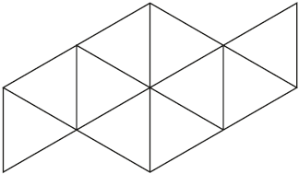
1 mark

Shade more triangles on this shape so that is shaded

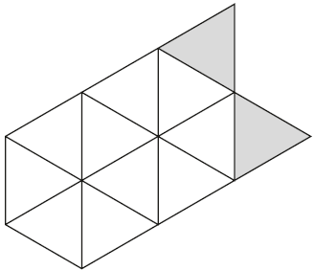
1 mark
Q15.
Each diagram below is divided into equal sections.
Shade three-quarters of each diagram.
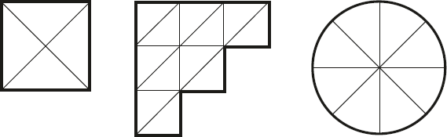
2 marks
Q16.
Here are four fraction cards.

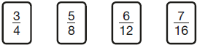
Use any three of the cards to make this correct.

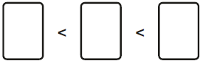
1 mark

Q17.
Here are some shapes made of squares.
A fraction of each shape is shaded.
Match each shape to its equivalent fraction.
One has been done for you.

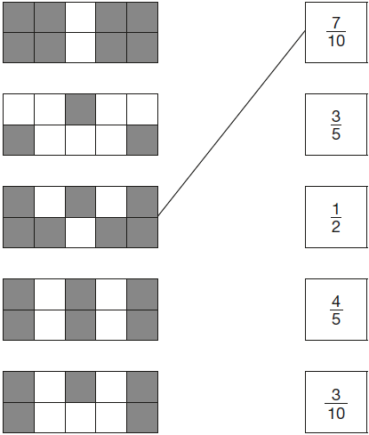
2 marks

M1. Award TWO marks for diagrams ticked or crossed as shown:
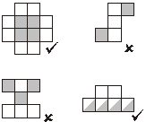
Accept alternative unambiguous indications, eg
Y or N.
For TWO marks, accept:
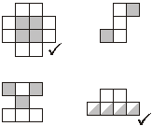
If the answer is incorrect, award ONE mark for three diagrams ticked or
crossed correctly.
Up to 2
[2]

M2.
Accept: equivalent fractions, eg
[1]

M3. Award TWO marks for diagrams ticked or crossed as shown:
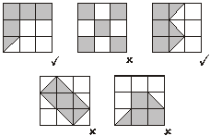

If the answer is incorrect, award ONE mark for four diagrams ticked or crossed correctly.
Accept alternative unambiguous indications such as Y or N.
For TWO marks accept:
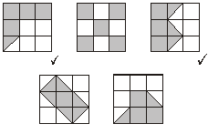
Up to 2
[2]

M4. (a)
Accept equivalent fractions or decimals.
1

(b)
Accept equivalent fractions or decimals.
U1
[2]

M5.
Accept equivalent fractions, eg
Accept 0.2 OR 20%
[1]

M6. Diagram completed correctly as shown:
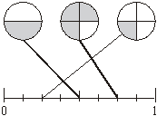
Do not award the mark if additional incorrect lines are drawn.
Lines need not touch the shapes or number line provided the intended accuracy is clear.
[1]

M7.
[1]

M8. An explanation which recognises that the shaded area is
equivalent to one-third, eg:
• ‘ is shaded and that is equivalent to ‘
• ‘2 out of 6 is the same as 1 out of 3’
• ‘2 out of 6’
• ‘ is shaded and is not shaded, which is the same as shaded and not shaded’
• ‘There are 3 squares, and 2 halves are shaded, and 2 halves make one whole’
• ‘The two shaded triangles are the same as one square and that is one out of three squares’
• ’1 square out of 3’
• ‘If you add the shaded parts together it makes one square’
• 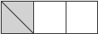
No mark is awarded for circling ‘Yes’ alone.
Do not accept vague or incomplete explanations, eg:
• ’It’s equivalent to ‘
• ‘ is shaded and is not shaded’
• ‘The two parts shaded add up to ‘
• ‘Half of 2 squares are shaded’.
If ‘No’ is circled but a correct, unambiguous explanation is given, then award the mark.
U1
[1]

M9. (a) Indicates Yes and gives a correct explanation, eg:
• = ,
•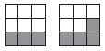
• of 9 is 3 not 4
• should be 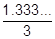, not
• 0.33...
• = ,
• of 27 = 9 and of 27 = 12

Accept minimally acceptable explanation, eg:
•
• ,
• 4 is over a third of 9
• of 9 is 3
• is closer to a half than a third
• 0.33, 0.44
• It is one ninth bigger
• If you divide by a you get
•

! Inaccuracies in diagrams
Throughout the question, condone provided the pupil’s intention to divide into thirds, ninths and/or eighteenths is clearly shown, and the correct sections are shaded

! Indicates No, or no decision made, but explanation clearly correct
Condone provided the explanation is more than minimal
Do not accept incomplete or incorrect explanation, eg:
• If you draw a pie chart for , more than is shaded
• Put them into 27ths and >
• × 3 =
1
U1

(b) Indicates No and gives a correct explanation, eg:
• The fractions are equal; if you multiply the numerator and denominator by the same number the fractions are equivalent
• =
• × 2 = not
• ÷ 2 = which is not
• To double the fraction, you don’t double the numerator and the denominator, you just double the numerator
• To halve the fraction, you don’t halve the denominator, only the numerator

Accept minimally acceptable explanation, eg:
• Equal
• Equivalent
• Same
• is half of
• is half of
• You only double the top number
• You only halve the top number

! Indicates Yes, or no decision made, but explanation clearly correct
Condone provided the explanation is more than minimal

Do not accept Incomplete explanation, eg
• If you double the top and the bottom number of , you get
1
U1
[2]

M10. Award TWO marks for three fractions correct as shown:
AND
AND
If the answer is incorrect, award ONE mark for two fractions correct.
Accept equivalent fractions, eg
for
for
Up to 2
[2]

M11. Diagram completed to show three triangles shaded, or equivalent, eg
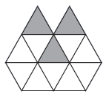
Accept inaccurate shading provided the intention is clear.
[1]

M12.Diagram ticked correctly as shown:
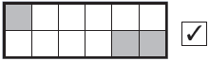
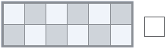

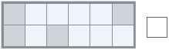
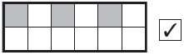
Accept alternative unambiguous indications.
[1]

M13.(a) C AND E
Letters may be given in either order.
1
(b) B
1
[2]

M14.(a) Any two triangles in the shape shaded.
Accept alternative unambiguous indications.
1
(b) Any two more triangles in the shape shaded.
Accept alternative unambiguous indications.
1
[2]

M15.
Award TWO marks for all three diagrams completed to show three-quarters shaded, e.g.
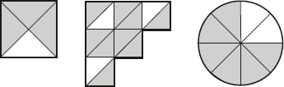
If the answer is incorrect, award ONE mark for two diagrams correct.
Accept alternative unambiguous indications of parts shaded.
Up to 2m
[2]

M16.Award ONE mark for any of the following:
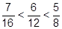
OR
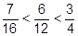
OR
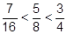

OR
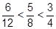
Accept equivalent fractions correctly ordered, e.g:
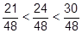
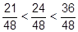
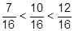
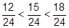
[1]

M17.Award TWO marks for four shapes matched correctly as shown:
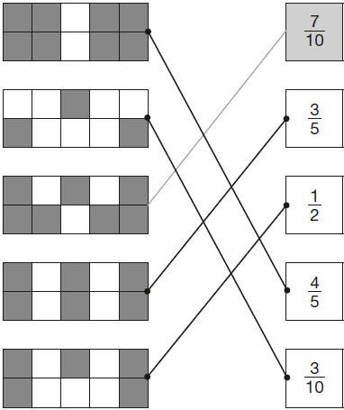
If the answer is incorrect, award ONE mark for three shapes matched correctly.
Lines need not touch shapes or fraction boxes, provided the intention is clear.
Do not credit any shape that has been matched to more than one fraction.
Up to 2
[2]

