Symbols to represent numbers
Q1.
Each shape stands for a number.
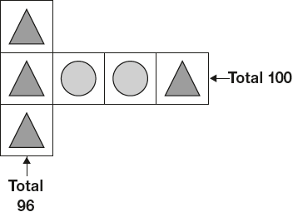
Work out the value of each shape.
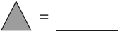
1 mark
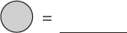
1 mark

Q2.
 and 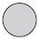 each stand for a different number.
= 34
+ = + +
What is the value of ?
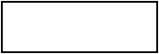
1 mark

M1.
(a) = 32
1
(b) = 18
If the answers to and are incorrect, award ONE mark if
+ = 50 unless = 25
1
[2]

M2. 17
U1
[1]

