Tables of information
Q1.
This table shows the number of people living in various towns in England.

 | Town | Population
 | Bedford | 82,448
 | Carlton | 48,493
 | Dover | 34,087
 | Formby | 24,478
 | Telford | 166,640

What is the total of the numbers of people living in Formby and in Telford?

1 mark

What is the difference between the numbers of people living in Bedford and in Dover?
1 mark

Q3.
Amy did a survey of what time people get up on a Sunday morning.
This table shows her results for 150 people.

 | Time | number of people
 | before 7 am | 13
 | 7:00 am to 7:59 am | 28
 | 8:00 am to 8:59 am | 59
 | 9:00 am to 9:59 am | 36
 | 10 am and after | 14

Look at the table.
How many people get up at 8 am or later?

1 mark

Amy says,
'Two-thirds of the 150 people in the survey get up before 9 am.'
Amy is correct.
Explain how you know.


1 mark

Q4.
This table shows the four most popular names for baby girls born each year from 2004 to 2008.

 |  | 2004 | 2005 | 2006 | 2007 | 2008
 | 1st | Emily | Jessica | Olivia | Grace | Olivia
 | 2nd | Ellie | Emily | Grace | Ruby | Ruby
 | 3rd | Jessica | Sophie | Jessica | Olivia | Grace
 | 4th | Sophie | Olivia | Ruby | Emily | Emily

In how many years was Olivia in the top three most popular names?
1 mark

Write all the years when Emily was a more popular name than Jessica.

1 mark

Q5.
This table shows the opening times of a pet clinic.

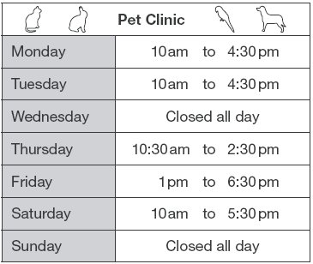

How many hours is the clinic open on Thursday?
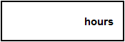
1 mark

On which day is the clinic open for the longest time?
1 mark

Liam takes his dog to the clinic on Saturday.
He arrives at 9:25am.
How many minutes is it before the clinic opens?
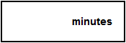
1 mark

Q6.
This table shows when flights take off at an airport.

 | Flight number | Destination | Take-off time
 | AX40 | Paris | 13:35
 | BH253 | Berlin | 14:05
 | CG008 | Rome | 15:25
 | DP369 | Paris | 15:40
 | EZ44 | Lisbon | 16:15
 | FJ994 | Dublin | 17:25

How many flights take off between 3pm and 5pm?
1 mark

How much later does the second flight to Paris take off than the first?
1 mark

The flight to Dublin takes 50 minutes.
What time does it arrive in Dublin?

1 mark

Q7.
Here are the sunrise and sunset times for some days in July.

Date | Sunrise | Sunset
7th  14th  21st  28th | 04:53  05:00  05:09  05:18 | 21:18  21:12  21:05  20:55

How many minutes earlier is the sunset on 28th July than on 7th July?
1 mark

Q8.
In a survey of children’s favourite fruit juices, these were the results.

 | Juice | Apple | Orange | Grape | Mango
 | Percentage  of children | 25% | 14% | 30% | 31%

(a) 20 more children chose grape than chose apple.
How many children took part in the survey?

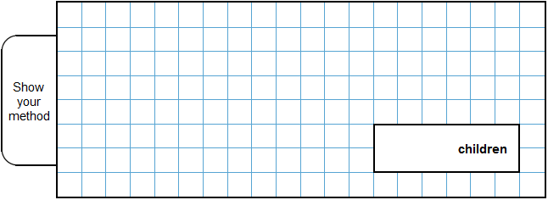
2 marks

(b) Chen makes a pie chart to show the results.
What angle should he use for the children who chose mango?

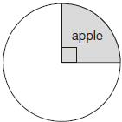

1 mark

Q9.
This table shows the number of things to eat in five children’s lunch boxes.

 |  | sandwiches | apples | bananas | fruit bars
 | Lisa | 1 | 2 | 0 | 2
 | Jack | 2 | 0 | 2 | 1
 | Kemi | 1 | 1 | 0 | 2
 | Nik | 1 | 2 | 1 | 0
 | Ben | 2 | 1 | 2 | 1

Here is a graph of the information for four of the children.
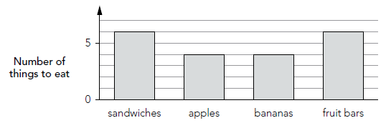
Which child’s information is missing from the graph?
Explain how you know.

1 mark

Q10.
The table below shows five journeys a taxi driver made one day.

journey number | start time | number of passengers | distance | cost
1 | 9:15am | 2 | 8 km | £7.50
2 | 9:40am | 1 | 12 km | £9.90
3 | 10:30am | 3 | 7 km | £7.60
4 | 10:50am | 1 | 21 km | £15.50
5 | 12:10pm | 4 | 15 km | £12.00

On journey number 5, the passengers shared the cost equally.
How much did each passenger pay?
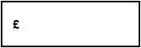
1 mark

How many passengers made journeys of more than 10 km?
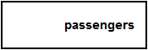
1 mark

The 12 km journey took 40 minutes.
What time did the taxi finish its journey?

1 mark

Q11.
These are the opening times at Black Tower Castle.

 | Monday | Closed
 | Tuesday to Friday | 11am to 6:30pm
 | Saturday | 10am to 6pm
 | Sunday | 10:30am to 4:30pm

How many hours is the castle open on Saturdays?
1 mark
Alfie arrived at the castle at 5pm on a Thursday.
How long could he stay before closing time?
1 mark

Q12.
This weather chart shows the highest and lowest temperatures in a town on five days in March.

 |  | Temperature °C
 |  | highest | lowest
 | Monday | +7 | 0
 | Tuesday | +7 | –2
 | Wednesday | +8 | –2
 | Thursday | +9 | +1
 | Friday | +4 | –5

Which day has the greatest difference between the highest and the lowest temperatures?
_________________________
1 mark

What is the difference between the lowest temperatures on Thursday and Friday?

1 mark

Q13.
Megan likes honey, but not jam.
Alfie likes honey and jam.
Chen does not like honey or jam.
Donna only likes jam.
Write the children’s names in the correct parts of the sorting diagram.

 |  | likes honey | does not  like honey
 | likes jam
does not
like jam

2 marks

Q14.
Here is part of the morning bus timetable from Winton to Yansley.

 | Winton | 9:35 | 9:55 | 10:15 | 10:35
 | Ingham | 9:45 | 10:05 | 10:25 | 10:45
 | Carston | 10:01 | 10:21 | 10:41 | 11:01
 | Dubley | 10:23 | 10:43 | 11:03 | 11:23
 | Yansley | 10:55 | 11:15 | 11:35 | 11:55

How many minutes does the bus take to get from Ingham to Dubley?
1 mark

Megan is in Carston.
She wants to be in Yansley before 11:30
What is the time of the latest bus she can take from Carston?
1 mark
One morning, the 10:35 bus from Winton gets to Carston 3 minutes early.
What time does it get to Carston?
1 mark

M1.
(a) 191,118
1
(b) 48,361
1
[2]

M2.(a) Vertical axis completed correctly as shown.
1
(b) Horizontal axis completed correctly as shown.
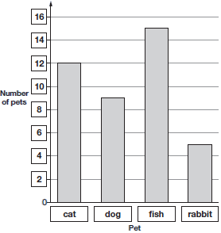
1
Accept unambiguous abbreviations or recognisable misspellings.
[2]

M3. (a) 109
1

(b) An explanation that recognises that 100 people get up before 9am
which is two-thirds of the total (150).
■ ‘13 + 28 + 59 = 100 which is two-thirds of the total’
■ ‘ of 150 = 50 and 2 × 50 = 100’
■ ‘ of 150 is 100’

■ ‘36 + 14 = 50 which is one-third after 9am’
Do not accept vague or incomplete explanations, eg:
■ ‘One-third are 9 o’clock or later’
■ ‘100 got up at 9am’
■ ‘Twice as many got up before 9am.’
■ ‘13 + 28 + 59 = 100’
U1
[2]

M4. (a) 3
Do not accept a list of years.
1

(b) 2004 AND 2007 AND 2008
Years may be given in any order.
U1
[2]

M5. (a) 4 hours
The answer is a time interval
1

(b) Saturday
Accept unambiguous abbreviations or recognisable misspellings.
Accept ‘10am to 5:30pm’.
Accept 7 hours.
1

(c) 35 minutes
The answer is a time interval
1
[3]

M6. (a) 3
1
(b) 2 hours 5 minutes
The answer is a time interval
1
(c) 18:15
The answer is a specific time
Accept 6:15
1
[3]

M7. 23
[1]

M8.(a) 400
2
or
Shows or implies a complete correct method, eg:
• 30% − 25% = 5%
5% = 20
100% = 20 × 20
1
(b) 111.6 or 112
Do not accept 111
1
[3]

M9. Indicates Nik and gives a correct explanationeg
• 1 sandwich, 2 apples and 1 banana is missing from the graph and that is what Nik had in his lunch box
• The graph shows the correct number of fruit bars and Nik is the only one who does not have a fruit bar in his lunch box so his must be the missing one
• The totals from the table are 7, 6, 5, 6, and from the graph 6, 4, 4, 6, and the difference is Nik
Accept minimally acceptable explanation eg • 1 sandwich, 2 apples, 1 banana • Because the number of fruit bars is correct • 1 banana missing • 7, 6, 5, 6 and 6, 4, 4, 6 seen
Do not accept incorrect or incomplete explanation eg • 1 sandwich, 2 apples • There are 6 fruit bars • 2 apples are missing
U1
[1]

M10. (a) £3.00
1
(b) 6
1
(c) 10:20 am
The answer is a specific time.
1
[3]

M11.(a) 8 hours
1
The answer is a time interval

(b) 1 hour 30 minutes
The answer is a time interval
1
[2]

M12.Wednesday
Accept unambiguous abbreviations or recognisable misspellings.
1
6
Do not accept −6
1
[2]

M13.Award TWO marks for four names correctly placed on the diagram as shown:

Alfie | Donna
Megan | Chen

If the answer is incorrect, award ONE mark for three names correctly placed.
Accept unambiguous abbreviations or recognisable misspellings.
Do not accept names written in more than one section.
Up to 2
[2]

M14.(a) 38
The answer is a time interval.
1
(b) 10:21
The answer is a specific time.
1
(c) 10:58
1
[3]

