Temperature differences (use a number line)
Q1.
This thermometer shows temperatures in both °C and °F.
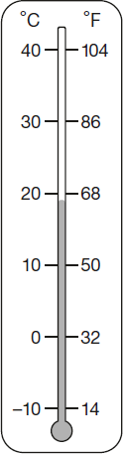
Work out what 25°C is in °F.
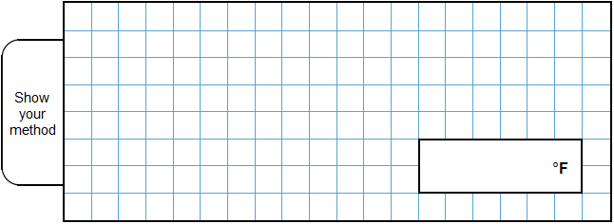
2 marks

Q2.
This table shows the temperature at 9 am on three days in January.

 | 1st January | 8th January | 15th January
 | +5°C | –4°C | +1°C

What is the difference between the temperature on 1st January and the temperature on 8th January?
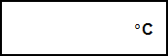
1 mark
On 22nd January the temperature was 7 degrees lower than on 15th January.
What was the temperature on 22nd January?
1 mark

M1.
Award TWO marks for the correct answer of 77°F.
If the answer is incorrect, award ONE mark for evidence of an appropriate method, e.g.
• 86 – 68 = 18
18 ÷ 2 = 19
9 + 68
OR
• 86 – 68 = 18
18 ÷ 2 = 9
86 – 9
OR
• 86 + 68 = 154
154 ÷ 2
Answer need not be obtained for the award of ONE mark.
Up to 2m
[2]

M2.
(a) 9
Do not accept –9 or 9–
1
(b) –6
Do not accept 6–
1
[2]

