Thinking of a number… (Inverse operations)
Q1.
Lara chooses a number less than 100
She divides it by 3 and then subtracts 11
She then divides this result by 2
Her answer is 10.5
What was the number she started with?

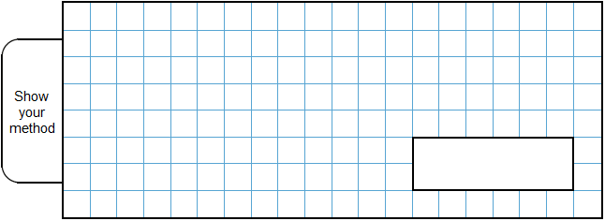
2 marks
Q2.
Ben thinks of a number.


He adds half of the number to a quarter of the number.
The result is 60
What was the number Ben first thought of?

2 marks
Q3.
Liam thinks of a number. 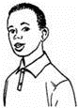
He multiplies the number by 5 and then subtracts 60 from the result.
His answer equals the number he started with.
What was the number Liam started with?

2 marks
Q4.
Josh thinks of a number.

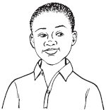
He adds 4
He multiplies his result by 3
Then he takes away 9
His final answer is 90
What number did Josh start with?
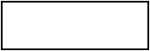
1 mark

Q5.
Emily chooses two numbers.

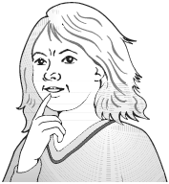
She adds the two numbers together and divides the result by 2
Her answer is 44
One of Emily’s numbers is 12
What is Emily’s other number?

2 marks

Q6.
Amy thought of a number.
She added 0.5 to her number and then doubled the result.
Then she subtracted 0.5 and doubled the new result.
Her final answer was 61
What number did Amy start with?

2 marks
Q7.
Liam thinks of a number.

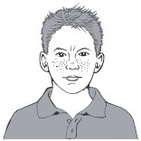
He divides it by 9 and then adds 25 to the result.
His answer is 36
What number did Liam start with?

2 marks
Q8.
5,542 ÷ 17 = 326
Explain how you can use this fact to find the answer to 18 × 326
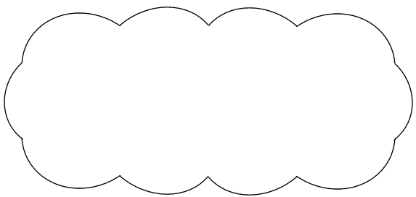
1 mark
Q9.
Lara had some money.
She spent £1.25 on a drink.
She spent £1.60 on a sandwich.
She has three-quarters of her money left.
How much money did Lara have to start with?
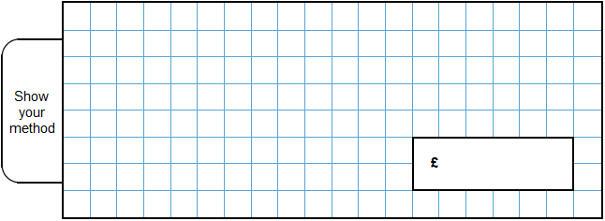
2 marks

Q10.
Lara chooses a number less than 20
She divides it by 2 and then adds 6
She then divides this result by 3
Her answer is 4.5
What was the number she started with?
2 marks

M1.Award TWO marks for the correct answer of 96
If the answer is incorrect, award ONE mark for evidence of an appropriate method, e.g:
• 10.5 × 2 = 21
21 + 11 = 32
32 × 3
Answer need not be obtained for the award of ONE mark.
Up to 2
[2]

M2. Award TWO marks for the correct answer of 80
If the answer is incorrect, award ONE mark for evidence of appropriate
working, eg:
• 60 ÷ 3 × 4 = wrong answer
OR
• 40 + 20 = 60
• 40 × 2 = wrong answer
Working must be carried through to reach an answer for the award of ONE mark.
OR
• a ‘trial and improvement’ method, eg
( × 60) + ( × 60) = 45
( × 120) + ( × 120) = 90
( × 100) + ( × 100) = 75
A ‘trial and improvement’ method must show evidence of improvement, but a final answer need not be reached for the award of ONE mark.
OR
• x + x = 60
x = 60
x = wrong answer
Up to 2 (U1)
[2]

M3. Award TWO marks for the correct answer of 15
If the answer is incorrect, award ONE mark for
evidence of appropriate working, eg
• 60 ÷ 4 = wrong answer
Calculation must be performed for the award of ONE mark.
OR
• a ‘trial and improvement’ method.
eg
30 × 5 – 60 = 90
10 × 5 – 60 = –10
20 × 5 – 60 = 40
OR
• 5x – 60 = x
x = wrong answer
A ‘trial and improvement’ method must show evidence of improvement, but a final answer need not be reached for the award of ONE mark.
Up to 2 (U1)
[2]

M4. 29
[1]

M5. Award TWO marks for the correct answer of 76
If the answer is incorrect, award ONE mark for evidence of appropriate
method, eg
44 × 2 = 88
88 – 12
Answer need not be obtained for the award of ONE mark.
Up to 2
[2]

M6.Award TWO marks for the correct answer of 15
If the answer is incorrect, award ONE mark for evidence of appropriate working, eg:
■ 61 ÷ 2 = 30.5
30.5 + 0.5 = 31
31 ÷ 2 = 15.5
15.5 − 0.5 = wrong answer

OR
■ 61 ÷ 2 = 30.5
30.5 – 0.5 = 30 (step error)
30 ÷ 2 = 15
15 − 0.5 = 14.5 (wrong answer)
Working must be carried through to reach an answer for the award of ONE mark.
Up to 2m
[2]

M7. Award TWO marks for the correct answer of 99
If the answer is incorrect, award ONE mark for evidence of appropriate
method, eg
36 – 25 = 11
11 × 9
OR
(36 – 25) × 9
Answer need not be obtained for the award of ONE mark.
Up to 2
[2]

M8.
An explanation that shows that 5,868 can be made by adding 326 to 17 × 326, e.g.
• '5542 + 326 = 18 × 326'
• '18 × 326 is 326 more than 5,542'
• 'Because this is the same as 17 × 326 = 5542 so add one more 326 to get the answer'
• 'You add 326 to 5,542 and your answer will be correct'
• 'Because you can add 326 to the answer of 17 × 326'
• '5542 + 326'.
Do not accept an explanation that simply calculates
326 × 18 = 5,868.
Do not accept vague or incomplete, or incorrect explanations, e.g.
• 'You could add another 326'
• 'The difference between 17 and 18 is 1 so you add 326 and that is one more'
• 'Because if you turn the question around you would see that 17 × 326 = 5542 so all you need to do is times the number one more time'
• '5,542 + 326 because it is one more'.
• 5868 − 326 = 5542.
[1]

M9.
Award TWO marks for the correct answer of £11.40.
If the answer is incorrect, award ONE mark for evidence of an appropriate method, e.g.
• £1.25 + £1.60 = £2.85
£2.85 × 4
Accept for ONE mark an answer of £1,140 OR £1,140p OR £11.4 as evidence of an appropriate method.
Answer need not be obtained for the award of ONE mark.
Up to 2m
[2]

M10.
Award TWO marks for the correct answer of 15.
If the answer is incorrect, award ONE mark for evidence of an appropriate method, e.g.
• 4.5 × 3 = 13.5
13.5 – 6 = 7.5
7.5 × 2
Answer need not be obtained for the award of ONE mark.
Misreads are not allowed.
Up to 2m
[2]

