Weight word problems
Q1.
Chen is cooking some pasta.  The recipe says he needs 350 grams of pasta for 4 people. | 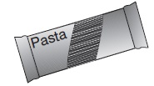

How many kilograms of pasta does he need for 12 people?

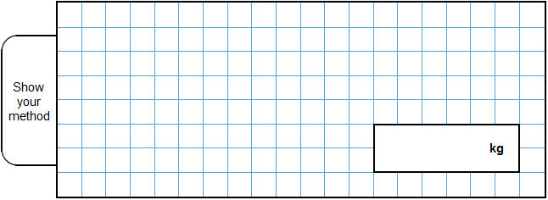
2 marks

Q2.
Chen and Megan each have a parcel. Chen’s parcel weighs 1 kg.
Megan’s parcel weighs 1.2 kg
How many more grams does Chen’s parcel weigh than Megan’s parcel?

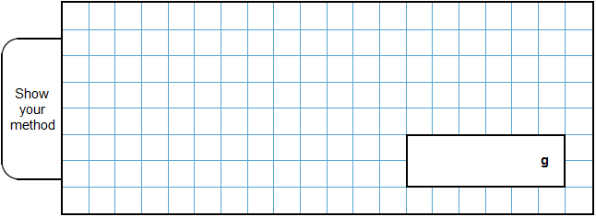
2 marks

Q3.
Lin has five blocks which are all the same.
She balances them on the scale with two weights.

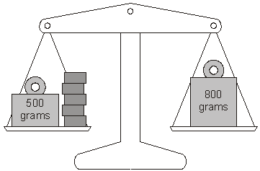

Calculate the weight of one block.

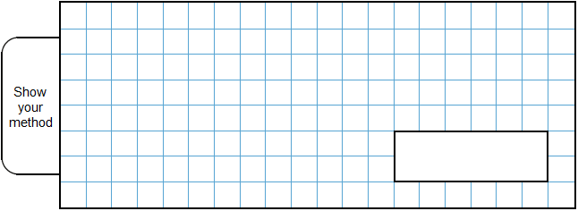
2 marks

Q4.
Amir has three parcels.
Parcels A and B together weigh the same as parcel C.
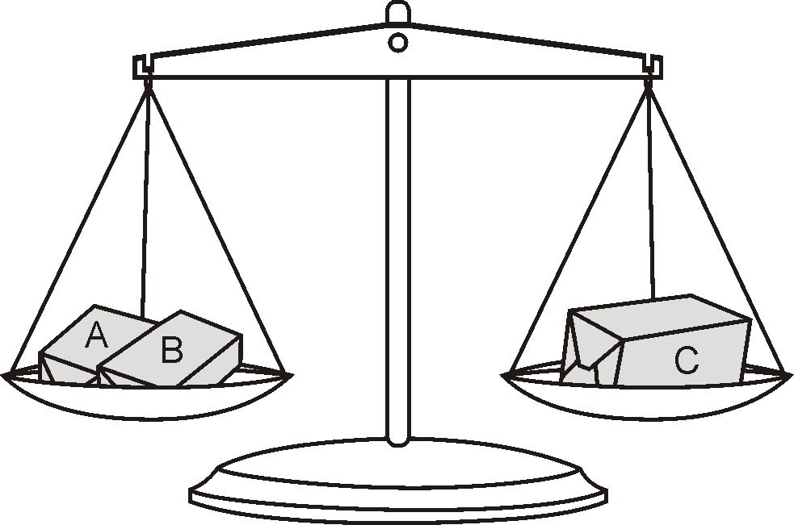

The three parcels weigh 800 grams altogether.
Parcel A weighs 250g.
How much does parcel B weigh?

2 marks
﻿

Q5.

 | One toffee apple needs:  1 stick,  100 g of sugar,  1 apple. | 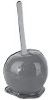

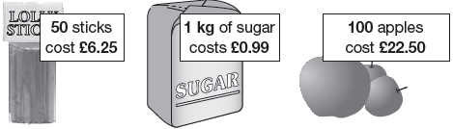
Children buy just enough sticks, sugar and apples to make 100 toffee apples.
They sell all 100 toffee apples for £1 each.
The profit goes to charity.
Work out how much money goes to charity.

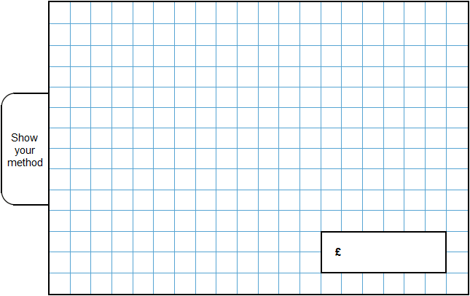
3 marks

Q6.
A packet contains 1.5 kg of oats.
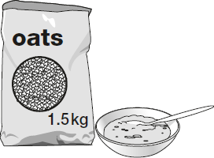
Every day Maria uses 50 g of oats to make porridge.
How many days does the packet of oats last?
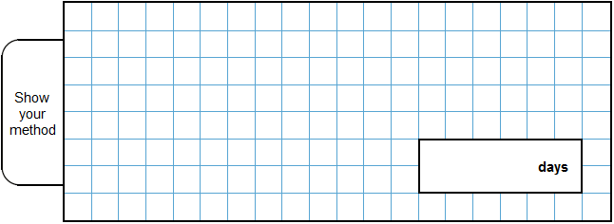
2 marks

Q7.
One gram of gold costs £32.94
What is the cost of half a kilogram of gold?

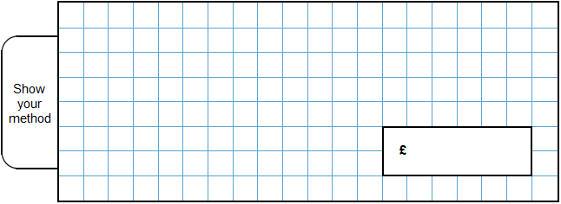
2 marks
Q8.
Miss Mills is making jam to sell at the school fair.
Strawberries cost £7.50 per kg.
Sugar costs 79p per kg.
10 glass jars cost £6.90
She uses 12 kg of strawberries and 10 kg of sugar to make 20 jars full of jam.
Calculate the total cost to make 20 jars full of jam.
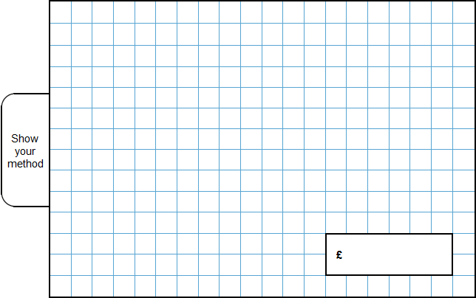
3 marks

M1.Award TWO marks for the correct answer of 1.05 kg.
If the answer is incorrect, award ONE mark for evidence of appropriate working, eg:
■ 12 ÷ 4 = 3
350 × 3 = 1050
1050 ÷ 1000 = wrong answer
Do not accept 1050 g
Accept for ONE mark 10.5 or 105 as evidence of appropriate working.
Working must be carried through to reach an answer for the award of ONE mark.
Up to 2m
[2]

M2.Award TWO marks for the correct answer of 300
If the answer is incorrect, award ONE mark for
evidence of appropriate working, eg
kg = 1500 g
1.2 kg = 1200 g

1500 g – 1200 g = wrong answer
Answer must be in grams for the award of TWO marks.
Do not accept 0.3 kg.
Working must be carried through to reach
an answer for the award of ONE mark.
Up to 2
[2]

M3. Award TWO marks for the correct answer of 60
If the answer is incorrect, award ONE mark for evidence of appropriate
method, eg
800 – 500 = 300
300 ÷ 5
Answer need not be obtained for the award of ONE mark.
Up to 2 (U1)
[2]

M4. Award TWO marks for the correct answer of 150
If the answer is incorrect, award ONE mark for evidence of appropriate
working, eg
800 ÷ 2 = 400
400 – 250 = wrong answer
Working must be carried through to reach an answer for the award of ONE mark.
Up to 2 (U1)
[2]

M5. Award THREE marks for the correct answer of £55.10
Award TWO marks for a complete correct method with one arithmetic error, eg
■ Sticks £12.50
Sugar £ 9.99 (error)
Apples + £22.50
Total £44.99
Profit £100.00
– £ 44.99
£ 55.01
OR
If the answer is incorrect, award TWO marks for evidence of a correct total
for all the ingredients, eg
■ Sticks £12.50
Sugar £ 9.90
Apples + £22.50
Total £44.99
OR
Award ONE mark for sight of £12.50 and £9.90
Up to 3
[3]

M6.
Award TWO marks for the correct answer of 30.
If the answer is incorrect, award ONE mark for evidence of an appropriate method, e.g.
• 1.5 kg = 1,500 g
1,500 ÷ 50
Answer need not be obtained for the award of ONE mark.
Units must be converted correctly for the award of ONE mark.
Up to 2m
[2]

M7.Award TWO marks for the correct answer of £16,470
If the answer is incorrect, award ONE mark for evidence of an appropriate method, e.g:
• £32.94 × 1000 = £32,940
£32,940 ÷ 2
OR
• £32.94 × 500
= £3294 × 5
Answer need not be obtained for the award of ONE mark.
Up to 2
[2]

M8.
Award THREE marks for the correct answer of £111.70.
If the answer is incorrect, award TWO marks for:
• sight of £90 AND £7.90 AND £13.80 as all multiplication steps completed correctly.
Accept for TWO marks, sight of 9,000p AND 790p AND 1,380p as all multiplication steps completed correctly.
OR
evidence of an appropriate complete method with no more than one arithmetic error, e.g.
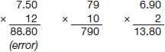
88.80 + 7.90 + 13.80 = 110.50
Award ONE mark for evidence of an appropriate complete method.
Answer need not be obtained for the award of ONE mark.
A misread of a number may affect the award of marks. No marks are awarded if there is more than one misread or if the mathematics is simplified.
TWO marks will be awarded if an appropriate complete method with the misread number is followed through correctly.
ONE mark will be awarded for:
• all multiplication steps completed correctly with the misread number.
OR
• evidence of an appropriate complete method with the misread number followed through correctly with no more than one arithmetic error.
Up to 3m
[3]

