Physical Development

On Monday, the children will be working on their ball skills in games and on Wednesday they will be working on their dance skills.

Communication and Language

This week we will be looking at the Moon and the moon landing. We will be sharing books, video clips and PPP to help us answer our own questions about the moon. The children will be collecting moon vocabulary and using them in their non-fiction writing. The children will be listening and responding to ideas expressed by others during conversations.

Personal, Social and Emotion

This week we will be talking about staying safe and how the children know they are safe and what they should do if they feel unsafe. We will look at our Golden Rules and talk about which ones keep us safe.

**Hatchmere planning**

**4.3.2019**

Understanding of the World

We will be looking at the patterns of change that moon goes through and why. We will be taking about why the moon has so many craters and how they occurred. The children will be using the computer to research information about the moon.

Literacy

We will be learning the sounds oi, ure and oa. The children will recap on the sounds already learnt and building simple words. The children will be writing about what it would be like to be on the moon. We will be reading non-fiction texts about the moon and collecting moon/space words.

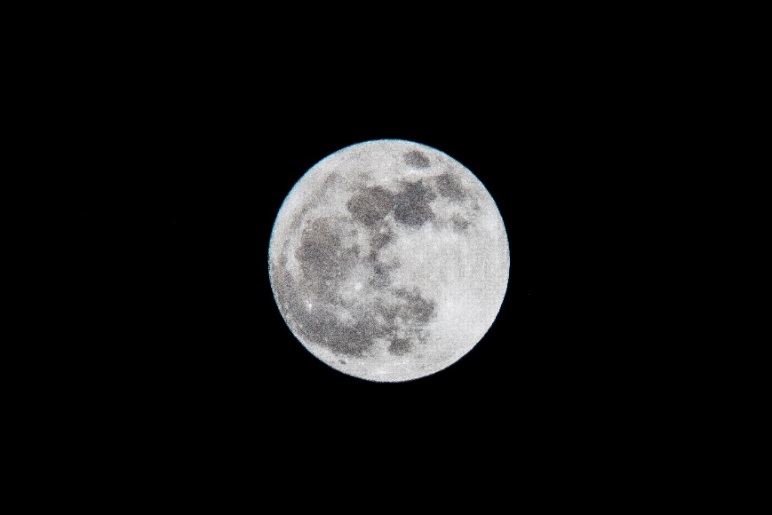

Mathematics

This week we will recap on numbers to ten and start to move onto numbers to fifteen. The children will work on recognising them and forming them. We will be looking at how teen numbers are made of a ten and ones. We will be using this knowledge to help us with takeaways.

We will be introducing estimation and the children will be guessing how many aliens in the jar.

The Moon [](https://www.google.co.uk/url?sa=i&rct=j&q=&esrc=s&source=images&cd=&cad=rja&uact=8&ved=0ahUKEwiTwvKGgo7KAhUD7xQKHS6CAMcQjRwIBw&url=http://www.clipartsheep.com/snow-scene-clipart.html&bvm=bv.110151844,d.d24&psig=AFQjCNGRcnr4ks_bifxpmVuaz3jmMkRbfQ&ust=1451923320794434)

Expressive Arts and Design

This week the children will be making their own space vehicle using found material. We will be listening to the Planet Suite by Gustav Holst and Space Odyssey by David Bowie.

Parental Involvement Ideas

This week we are talking about the moon. During the week when it is dark try to find the moon and look at how it changes. On Monday and Tuesday, the moon is waning crescent and on Wednesday there will be a new moon. This change from a slim crescent to a full moon should be quite interesting to the children. Ask the children what they have noticed about the moon. What has changed? Why has it changed? What do you think will happen next? Can they find the moon during the day? What else can you see in the night sky?