Physical Development

The children will be working on their throwing and aiming with beanbags and small balls with me on Monday and Dance with Mrs Winder on Wednesday.

Personal, Social and Emotion

This week we will be talking about how to stay healthy and which foods are healthy for us and which we should eat in moderation.

Communication and Language

We will be going on a walk around school looking for the first signs of spring. Hopefully the children will be able to relate this experience to our discussion about Spring. We will be asking questions about what happens in Spring and then researching the answers using a range of non-fiction books and the computer. We will be collecting spring words to use in our writing.

Understanding of the World

This week we are going to be looking at the seasonal changes in the world around us. We will be asking and answering questions about why these changes occur. We will be looking at plant growth and collecting signs of spring from the world around us.

Literacy

We will be looking at a number of non-fiction books about Spring. The children will be going on a Spring walk and will be writing about that experience. In writing we are looking at finger spaces, capital letters and full stops. We will be learning the sounds for phase 3.

Hatchmere Spring Plan

18.3.19[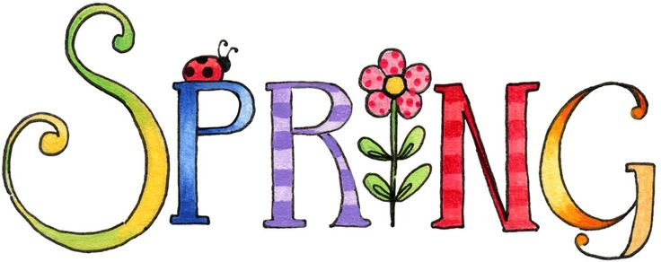](https://www.google.co.uk/url?sa=i&rct=j&q=&esrc=s&source=images&cd=&cad=rja&uact=8&ved=0ahUKEwianoiDtOPSAhWoAMAKHWogCCUQjRwIBw&url=http://www.clipartpanda.com/categories/spring-clip-art-free-images&bvm=bv.149760088,d.cGc&psig=AFQjCNHeRMBNSAlbAp7GFM91q3uxcUktcg&ust=1490041686127465)

[](https://www.google.co.uk/url?sa=i&rct=j&q=&esrc=s&source=images&cd=&cad=rja&uact=8&ved=0ahUKEwiTwvKGgo7KAhUD7xQKHS6CAMcQjRwIBw&url=http://www.clipartsheep.com/snow-scene-clipart.html&bvm=bv.110151844,d.d24&psig=AFQjCNGRcnr4ks_bifxpmVuaz3jmMkRbfQ&ust=1451923320794434)

Expressive Arts and Design

This week the children will be making observational drawings of various spring flowers. The children will be using pastels. We will be starting to learn our Easter song.

Mathematics

This week we will be looking at time. We will be looking at the days of the week, months of the year and using the different timers in the classroom to time how long it takes us to do different things. We will be looking at the clock and talking about how we use an analogue clock to tell the time.

Parental Involvement Ideas

This week we will be looking at the objective ‘They make observations of animals and plants and explain why some things occur and talk about changes’. As we are talking about Spring this week look at the world around you, in your garden, as you walk to and from school and see if you can spot any signs of Spring.