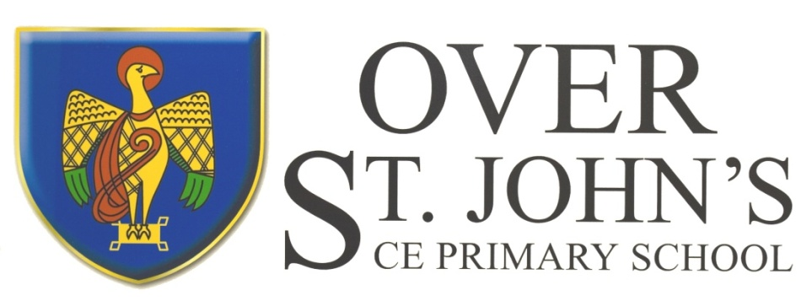

Over St. John’s C.E. Primary School

Charging Policy

1 Introduction

1.1 All education during school hours is free. We do not charge for any activity undertaken as part of the National Curriculum, with the exception of some individual or small-group music tuition.

2 Voluntary Contributions

2.1 When organising school trips or visits to enrich the curriculum and the educational experience of the children, the school invites parents to contribute to the cost. All contributions are voluntary. If we do not receive sufficient voluntary contributions, we may cancel a trip. If a trip goes ahead, it may include children whose parents have not paid any contribution. We do not treat these children differently from any others.

2.2 If a parent wishes their child to take part in a school trip or event, but is unwilling or unable to make a voluntary contribution, we do allow the child to participate fully in the trip or activity. Sometimes the school pays additional costs in order to support the visit. Parents have a right to know how each trip is funded. The school provides this information after each trip.

2.3 The following is a list of additional activities, organised by the school, which require voluntary contributions from parents. These activities are known as ‘optional extras’. This list is not exhaustive:

* visits to museums;
* sporting activities which require transport expenses;
* outdoor adventure activities;
* visits to or by a theatre company;
* musical events.

3 Music Tuition

3.1 All children study music as part of the normal school curriculum and children in Year 5 receive violin tuition as a class. We do not charge for this.

3.2 There is a charge for individual or small-group music tuition, since this is an additional curriculum activity, and not part of the National Curriculum. These individual or small-group lessons are taught by peripatetic music teachers. We make a charge for these lessons. We give parents information about additional music tuition when available.

4 Swimming

4.1 The school organises swimming lessons for all children in Year 2. These take place in school time and are part of the National Curriculum. We therefore make no charge for this activity. We inform parents when these lessons are to take place. We use Sports Premium to pay for some of these lessons.

4.2 In the summer term, pupils in Year 6 attend ‘top up’ swimming lessons. We use Sports Premium to pay for this and therefore make no charge for this activity. We inform parents when these lessons are to take place.

5 After School Clubs

5.1 The school offers a number of after school clubs run by members of staff for which there is no charge. School also runs some Sports Clubs which are staffed by outside providers. These are funded through the Sports Premium, and as such, we do not charge for these clubs. We may ask for a donation towards the cost of ingredients if we run a Cookery Club.

Privately run clubs which use the school facilities will make charges which are payable directly to the club by parents.

**6 Residential Visits**

6.1 Children in Key Stage 2 have the opportunity to take part in residential visits. These activities are in school time and linked to the National Curriculum, so we do not make any charge for the education. We do, however, make a charge for board and lodging, insurance and specialist instruction for certain activities and for transport.

**7 Monitoring and review**

7.1This policy is monitored by the Governing Board, and will be reviewed annually, or earlier if necessary.

Signed: H Rogers **Chair of Governors**

Signed: E Snowdon **Head Teacher**

Date: January 2025

Review Date: January 2026