Physical Development

The children will need their PE kits for Monday. Please check that everything fits. We will be going outside this term so if you wish to you can send in a warmer PE jumper. The children will be working on Hoops and Quoits with me on a Monday morning and Dance with Mrs Pile on Wednesday morning.

Personal, Social and Emotion

We will be talking about how to stay healthy and which foods are healthy for us and which we should only eat a little bit of.

Communication and Language

The children will be talking about what they did over the holidays and any Easter activities they have got involved with outside school. We will be working on using the correct tense in speech and in our writing. The children will collect Easter words.

Understanding of the World

We are going to look at family traditions associated with Easter. The children will look at how different communities celebrate Easter and discuss the similarities and differences.

Literacy

The children will be looking at the Easter story and retelling it in their own words. The children will be using a simple story map to help them organise the story. We will be talking about full stops and capital letters.

Hatchmere Easter Plan

[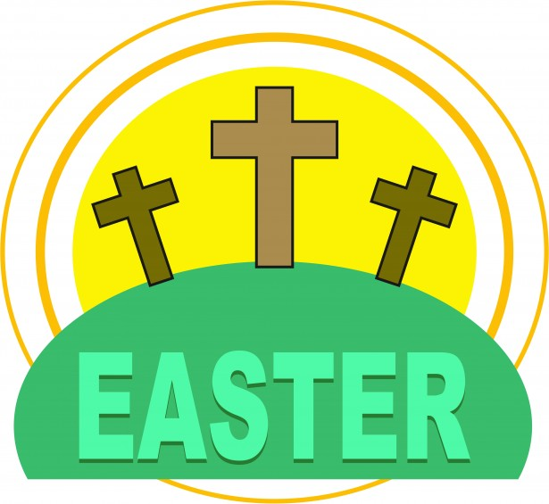](https://www.google.co.uk/url?sa=i&rct=j&q=&esrc=s&source=images&cd=&cad=rja&uact=8&ved=0ahUKEwianoiDtOPSAhWoAMAKHWogCCUQjRwIBw&url=http://www.clipartpanda.com/categories/spring-clip-art-free-images&bvm=bv.149760088,d.cGc&psig=AFQjCNHeRMBNSAlbAp7GFM91q3uxcUktcg&ust=1490041686127465)

[](https://www.google.co.uk/url?sa=i&rct=j&q=&esrc=s&source=images&cd=&cad=rja&uact=8&ved=0ahUKEwiTwvKGgo7KAhUD7xQKHS6CAMcQjRwIBw&url=http://www.clipartsheep.com/snow-scene-clipart.html&bvm=bv.110151844,d.d24&psig=AFQjCNGRcnr4ks_bifxpmVuaz3jmMkRbfQ&ust=1451923320794434)

Expressive Arts and Design

The children will be performing their Easter song in the Church on Wednesday. The children will be given the opportunity to create their own Easter cards and Easter baskets.

Mathematics

The children will be looking at capacity and using words to describe the capacity-full, half full, empty and nearly full. They will be going on an Easter egg hunt and order the eggs from 1-20. The children will use the Easter eggs to make patterns.

Parental Involvement Ideas

This week we will be looking at how the children celebrate Easter at home. What Easter traditions do you have? Do you go for an Easter Egg hunt? Do you have a special family meal? Do you go to church or visit friends and family? Please talk with your child about your Easter traditions and write down your traditions.