Personal, Social and Emotion

This week is Parliament week, and the children will be talking about how our political system works and why a democracy is important. The children will be voting on a range of activities during the week. We will also be talking about firework and Bonfire safety.

Physical Development

Our fine motor control activity this week will the making an autumn leaf garland by threading their finds together. The children will be going for an Autumn walk on Wednesday, weather permitting. Please send your PE kits back in as soon as possible.

Communication and Language

This week we will continue to work on recognising rhyme and rhyming word. The children will be sharing a Bonfire poem. We will be collecting Autumn words and using them in our conversations. The children will be sharing their news about what they got up to over the half term break.

Understanding of the World

We will be talking about why we celebrate Bonfire Night and in particular looking at the action of Guy Fawkes and why he tried to blow up the King. This will tie in with our work on Parliament week. The children will be exploring the local area and exploring the changes in the season.

Literacy

The children will be sharing a selection of Autumn non-fiction and fiction books and relating them to our experiences. They will write a list of the things they found of the Autumn walk. In phonics we will be looking at the sounds c, k and ck.

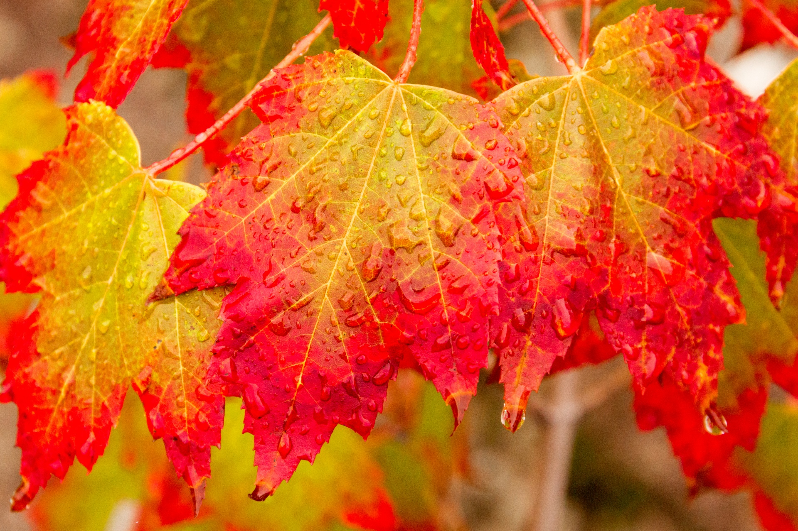

Hatchmere Parents planning 2.11.21

Mathematics

In maths we are going to be looking at how we recognise and make five. The children will be learning a new counting rhyme and using different resources to make five. They will be working on finding different ways of making five.

Expressive Arts and Design

This week we will be using our Autumn walk finds to print with and exploring colour mixing and paint effects. The children will be moving like a fire work and listening to different firework music. In music they will be exploring the sounds the different musical instruments make.

Parental Involvement Activity

We are introducing our topic of Autumn this week and I would like you to talk to your child about what is happening in the world around them. As you walk to school and back or at home in your garden look for the changes. What can your child see that is different to a month ago? Ask why do they think the world is changing? Perhaps use the internet to research an aspect of Autumn that they find interesting. How are the changes affecting them? What has changed and why? Compare this season to Summer and talk about the differences. Perhaps you could make a leaf collection and identify the trees they come from or talk about the different seed heads or berries they see. Can they spot any animals preparing for the winter? If your child would like to bring something in to share on this topic or anything else they are interested in, we try to do ‘Show and Tell’ every Wednesday with the whole class.