Personal, Social and Emotion

The children will be talking about how we stay safe in certain situations. The children will be watching a simple ‘Stranger Danger’ programme.

Communication and Language

This week the children will develop their own narrative story based on the Snail Trail book. They will create and retell their story orally first. We will be looking at using the correct tense when we talk.

Physical Development

This week the children will be practising for Sports day. We will be focussing on the egg and spoon race this week.

Hatchmere planning 10.6.19

Literacy

This week in Phonics we will continue with some aspects of phase three but also start introducing phase four sounds. The children will be writing their own Snail Trail story.

Understanding of the World

The children will go on a minibeast hunt around our school and discuss what they find. We will be looking at ways to improve our environment to encourage insects and other minibeast.

[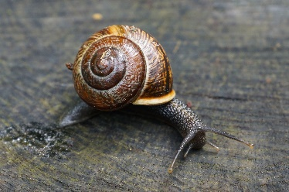](https://www.google.co.uk/url?sa=i&rct=j&q=&esrc=s&source=images&cd=&cad=rja&uact=8&ved=0ahUKEwi8kYWAjN3MAhWlK8AKHQjzCHoQjRwIBw&url=http://www.amazon.com/Jaspers-Beanstalk-Nick-Butterworth/dp/0340945117&psig=AFQjCNFUB4mOYw9yxTO51tpMKoJSraQmgQ&ust=1463436510334297)

Expressive Arts and Design

The children will be singing and moving along to the mini beast song in Music. The children will be making observational drawings of snail using pastels. The children will be blending the colours.

Mathematics

We will be introducing sharing and half of amounts. The children will be counting in twos and tens.

[](https://www.google.co.uk/url?sa=i&rct=j&q=&esrc=s&source=images&cd=&cad=rja&uact=8&ved=0ahUKEwiTwvKGgo7KAhUD7xQKHS6CAMcQjRwIBw&url=http://www.clipartsheep.com/snow-scene-clipart.html&bvm=bv.110151844,d.d24&psig=AFQjCNGRcnr4ks_bifxpmVuaz3jmMkRbfQ&ust=1451923320794434)

Parental Involvement Activity

This week we are going on a mini beast hunt around the school to see what we can find. Have a look around your garden and home and see if you can find any insects. Talk about what the insects eat, where they live etc. Perhaps if your child is particularly interested in an insect do some research on the internet or in a book. Ask your child to write a sentence or two that they can share about their insect of choice with the rest of the class.