Personal, Social and Emotion

This week we will talking about change and growing up. The children will be talking about what they think will change when they go up to Sandymere and how it will affect them.

Communication and Language

This week we are going to be collect descriptive words to help us write a character description. The children will be listening to the story and using their own words to retell the events. The children will be instructing the children on how to play their game from home

Physical Development

The children will be having Sports Day on Monday and if not Monday then it will be on Thursday. Keep your fingers crossed for good weather.

Superworm Planning

1.7.19

Understanding of the World

We will be setting up our Wormery and then observing it throughout the next two weeks. The children will be researching the questions we have asked about worms using the internet and books to find the answers. Hopefully if the weather is sunny we will be able to talk about the season of Summer.

Literacy

We are starting our book ‘Superworm’ by Julia Donaldson and Alex Schaffer. We will be looking at the rhyming element and the characters in the book. The children will continue to work on Phase three and Four in their phonics.

Mathematics

We will be recapping on addition and subtraction using numicon. The children will be working on recognising the different symbols we use in sums and how that effects our working out. The children will be looking at number bonds to ten and how knowing this will help them with their addition and subtraction sums.

Expressive Arts and Design

The children will be working on their song for the leavers assembly which is Count on Me’ by Bruno Mars if you would like to practice at home. The children will also be using their imaginations to act out our Superworm story.

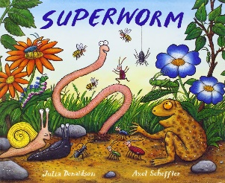

[](https://www.google.co.uk/url?sa=i&rct=j&q=&esrc=s&source=images&cd=&cad=rja&uact=8&ved=0ahUKEwiTwvKGgo7KAhUD7xQKHS6CAMcQjRwIBw&url=http://www.clipartsheep.com/snow-scene-clipart.html&bvm=bv.110151844,d.d24&psig=AFQjCNGRcnr4ks_bifxpmVuaz3jmMkRbfQ&ust=1451923320794434)

Parental Involvement Task

This week we will continue with the children bringing in a game they can teach to other children. We have had great fun with this task and the children have been excellent teachers explain the rules and sorting out any disagreements. If your child has not brought in a game to share please send one in this week.

Parental Involvement Ideas

This week we are going to continue with the children teacher the class hoe to play their game.