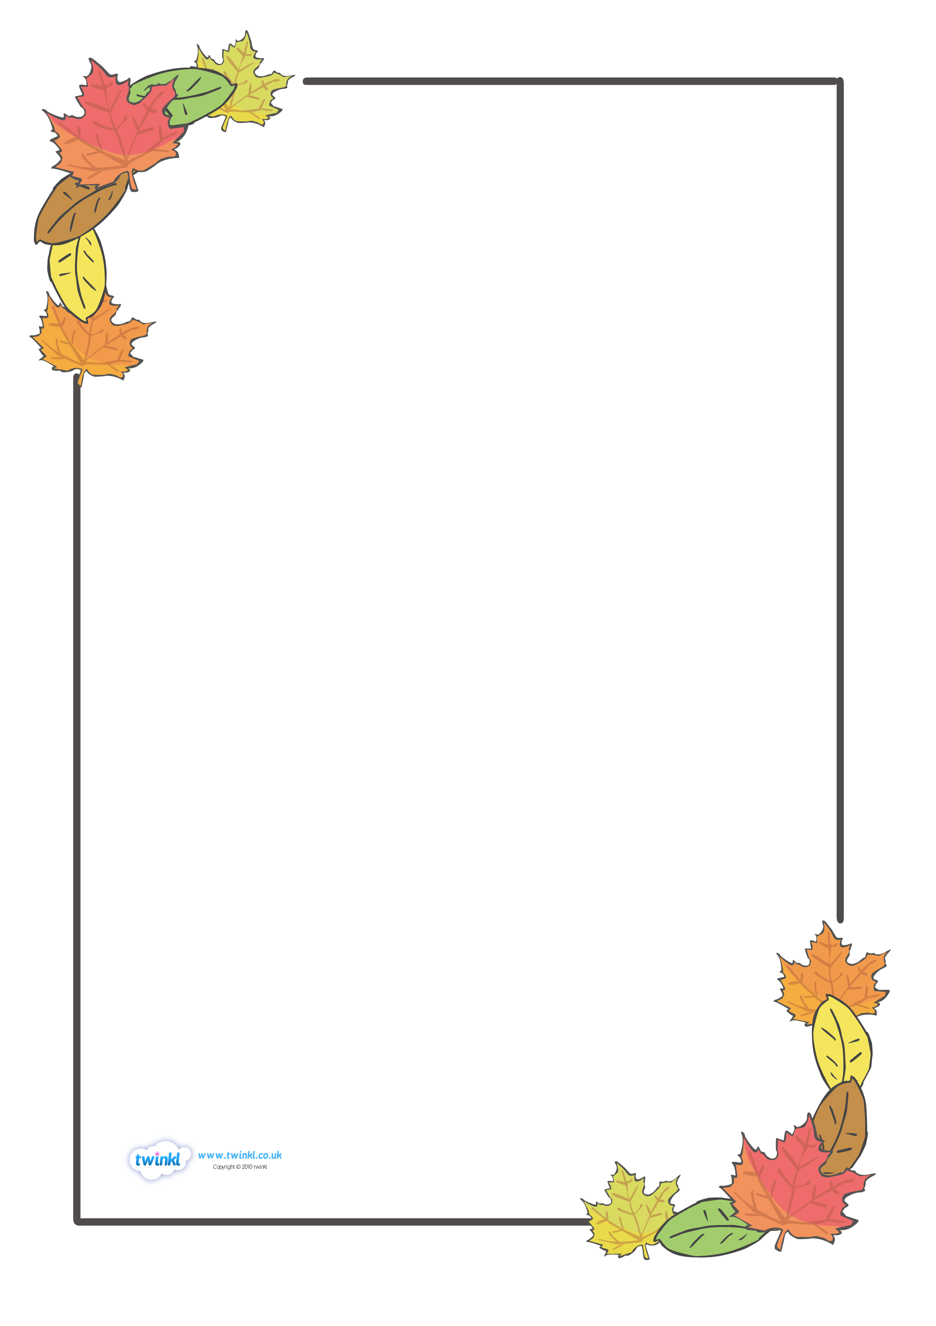
LABEL HERE
LABEL HERE
Wednesday 3rd November 2021
I can use language with increasing effect: choices of nouns,
adjectives and verbs, alliteration, repetition and rhyme.

Autumn is…
Going back to school and leaves in every shade,
Beautiful colours like orange pumpkins – my favourite!
Orange and red crunchy leaves underneath my feet
Bright fiery leaves descending onto the footpath

Autumn is…
Cold, crisp mornings
Crunching leaves as you kick them on your way to school
crunchy, fiery-red leaves swirling around me
Golden, crispy leaves crunching under my feet as I walk

Autumn is…
Freezing cold mornings when my scarf tickles my neck
Leaves of copper, fiery-red, orange, yellow and gold
Crispy, crunchy leaves breaking as I walk
Trick or treating on a cold, windy evening

Autumn is…
Back to school and kicking leaves of different shades
When leaves fall gracefully from the trees
Fiery-red leaves falling in the morning
Children trick or treating as leaves fall around them

Autumn is…
Cold mornings when my scarf tickles my nose
Going back to school wearing my black wellies
Fiery-red autumn leaves crunching under my freezing feet
Trick or treat for something sweet

Autumn is…
The colour orange
The smell of pumpkin pie and the carpeted ground
The colour of my pumpkin as I carve it carefully
My spooky Halloween pumpkin!

