Personal, Social and Emotion

This week we will be exploring why we wear poppies. The children will be learning about the history of Remembrance Day through sharing stories, watching videos and creating artwork.

Physical Development

The children will be doing PE in the hall twice this week. They have PE on Tuesday and Wednesday morning. The children will be working on their fine motor control by using scissors and playing our Hedgehog balancing game.

Communication and Language

This week we will be introducing our new book ‘The Squirrels that Squabbled’ which is closely linked to our topic of Autumn. The children will explore the vocabulary in the book and ensure they understand the words.

Understanding of the World

We will be talking about the history of Remembrance Day and why it is so important we still talk about it and how we commemorate it. The children will continue to explore the season of Autumn and how the world around us changes with the season.

Literacy

The children will be starting our new book and predicting what will happen using the clues from the front cover. In their writing they will be using their letter knowledge to write simple three letter words. In phonics we will be looking at the sounds r, e and u.

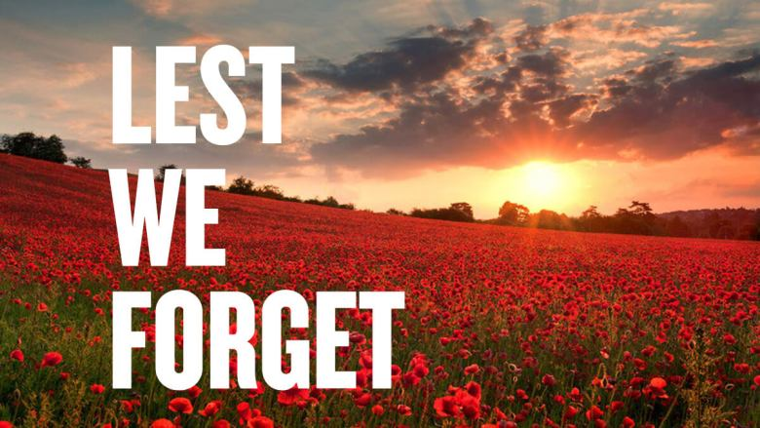

Hatchmere Parents planning 8.11.21

Mathematics

In maths we are going to be looking at how we recognise and make five. The children will be learning a new counting rhyme and using different resources to make five. They will be working on finding different ways of making five. The children will be using their subitising skills to recognise five.

Expressive Arts and Design

This week we will be using collage and loose parts to make a poppy picture. The children will make an observational painting of a poppy. In music they will be exploring the sounds the different musical instruments make.

Parental Involvement Activity

We are talking about Remembrance Day and why we wear Poppies. We will be talking about the armed forces and how they work to keep us safe. If you have anyone in your family who has been in or is in the armed forces, perhaps your child could talk to them and ask them some questions. It may be that one of your great-grand parents served during WWII and you can talk to your child about this. If you are in the town centre you could go and visit the war memorial and talk to your child about what it is. We have Show and Tell on a Wednesday and it would be lovely if your child could bring in something to show the rest of the class and the tell them all about it. This might be a photograph, an artifact or a family story to share.