Personal, Social and Emotion

The children will share resources’ and take turns with the different activities.

The children will explain their own knowledge and understanding and ask appropriate questions of each other.

Communication and Language

The children will sit and listen to information on Bonfire Night. They will share experiences and respond appropriately to ideas expressed by the other children. We will be exploring onomatopoeic firework words in poems and use them on our bonfire pictures. The children will use the language explored this week to recreate roles and experiences.

Physical Development

The Children will be working on their dances skills with Mrs Smith on a Wednesday morning and Gymnastics on a Thursday afternoon. We will be talking about how to stay safe on Bonfire night.

# Expressive Arts and Design

# The children will listen to George Handels Music for the Royal Fireworks and watch a firework display. They will be creating Bonfire pictures and working with junk material to create rockets and other fireworks.

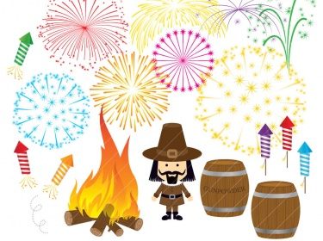

Bonfire Night

Hatchmere Planning 11.2.15

Literacy

They will be working on recognising the initial sounds and building simple CVC words. They will be working on creating a set of Bonfire Night safety rules. The children will be learning how to recognise and write the letters r, j, y and w. We will be looking at high frequency and simple words in our text.

Mathematics

The children will work a Bonfire Night number recognition game. We will be working on recognising numerals to ten and twenty. The children will be talking about the shape of the fireworks they make and see.

Understanding of the World

We will be looking at the traditions and family customs that surround Bonfire night. The children will be encouraged to share and compare what they do on Bonfire night.