Communication and Language

We will be looking carefully at the story of Rama and Sita. The children will be using the puppets and props from the story to retell the story. They will use language to imagine and create roles and experiences in play. They will respond to instructions involving a two part sequence. The children will also talk about why we wear poppies and remember those that fought and died.

Physical Development

The Children will be continuing to work on their dance skills with Mrs Smith on a Wednesday morning and Gymnastics on a Thursday afternoon. We will also be working on our pencil grip and manipulation. The children will manipulate clay to make a Diva lamp.

Personal, Social and Emotion

The children will share resources’ and take turns with the different activities.

The children will explain their own knowledge and understanding and ask appropriate questions of each other. Our circle time this week will be on understanding that their actions affect other people.

Expressive Arts and Design

The children will make a Diva lamp working with clay. The children will be acting out the story of Rama and Sita. The children will be also be making a large poppy for Remembrance Sunday.

Literacy

They will be working on recognising the initial sounds and building simple CVC words. The children will be learning how to recognise and write the letters x, y, z and qu. We will be looking at high frequency and simple words in our text.

Mathematics

The children will be looking at number recognition to twenty. They will be looking and at learning about 2D shapes.

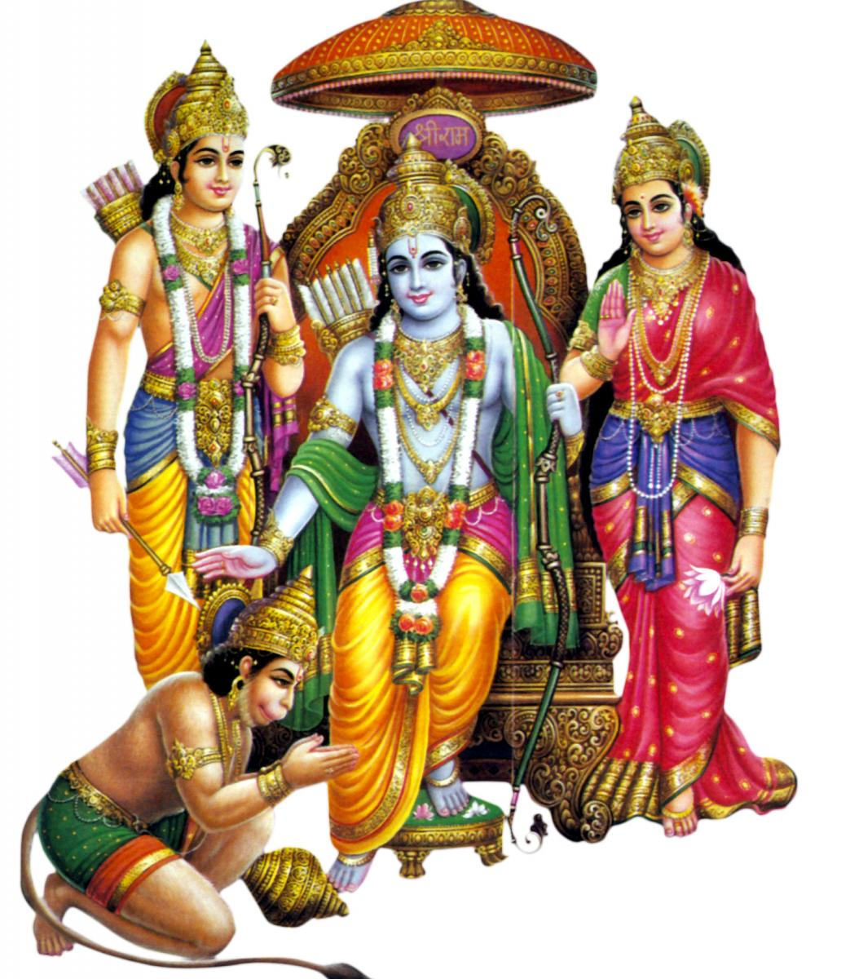

Rama and Sita

Hatchmere Planning 9.11.15

Understanding of the World

The children will look at the routines and family traditions of those that celebrate Divali. They will talk about the similarities and differences of this festival of light and our Bonfire Night.