Communication and Language

This week we will be talking about the Hindu festival of Diwali. We will be watching clips on how it is celebrated and we will compare it to our festival and celebrations. They will listen carefully and follow instructions on how to make Diwali sweets, Rangoli patterns and Diva lamps

Physical Development

The children will be continuing to work on their dance skills with Mrs Smith on a Wednesday morning and Gymnastics on a Thursday afternoon. We will also be working on our pencil grip and manipulation.

Personal, Social and Emotion

The children will share resources’ and take turns with the different activities.

The children will explain their own knowledge and understanding and ask appropriate questions of each other. Our circle time this week will be on anti-bullying and what to do if someone is being unkind.

Literacy

They will be working on recognising the initial sounds and building simple CVC words. The children will be learning how to recognise and write double letter sounds ff, ss, ll and ck. We will be looking at high frequency and simple words in our text.

Mathematics

The children will be looking at number recognition to twenty. They will be looking and at learning about 2D and 3D shapes. They will be using 2D shapes to create Rangoli patterns. The children will be learning to form the numbers 0-4.

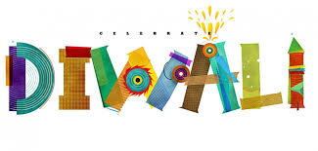

Hatchmere Planning 12.11.15

Expressive Arts and Design

The children will listen to some Indian music and watch a video clip on traditional Indian dance. We will watch and dance along to the five a day Bollywood dance. The children will be decorating their Diva lamp.

Understanding of the World

The children will look at the routines and family traditions of those that celebrate Divali. The children will work on using the mouse to complete the adventure programme Mouse Island.